(Mr. Tenkey's Tips #320) www.mrtenkey.com

June 1, 2020

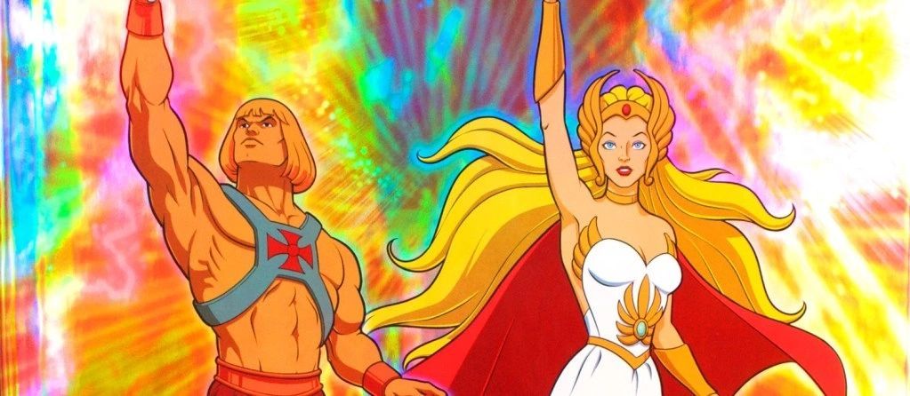

Dear Management: Yes, yes... you're the top dog... the ultimate leader, the most-awesome manager, the super-duper supervisor, etc...  
  
And yes, just like He-man or She-ra... you "HAVE THE POWER!"  
  
Blah, blah, blah... that's not being questioned right now.  
  
What is... is YOU, wanting of an honest answer to the questions you pose.  
  
Well, if you use that power of yours, to destroy villages and pillage the little people that question or disagree with you...  
  
You will get the answers they believe you want to hear.  
  
But, if you use your power as a shield... that protects valid dissent and ingenuity...  
  
You will get the answers that need to be said.  
  
NOW...  
  
Are you able to power down that ego?  
  
That is REAL POWER!