(Mr. Tenkey's Tips # 325) www.mrtenkey.com

June 8, 2020

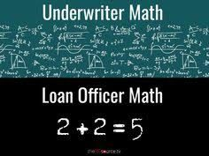

Dear Management: Forever the great divide...  
  
Between how a loan officer thinks... versus that of an underwriter... (and the rest of us in ops, lol... I crack myself up).  
  
But seriously, there is a difference... and I think it comes down to duty.  
  
LO's have a duty to feed the engine. So they press the gas pedal... and push the limits of the engine.  
  
While U/W's have a duty to make sure bad gas doesn't in, resulting in the engine running like crap.  
  
So what can a company do???  
  
Bridge this divide!  
  
Yes, create a position for someone(s) that can interpret the two maths... and promote company beneficial outcomes.  
  
I like to think of the position as that of an "internal" account executive... similar to that of an AE, from my time in the TPO (third party origination) world.  
  
Now go!  
  
Build your bridge... and get over it!