(Mr. Tenkey's Tips # 334) www.mrtenkey.com

June 19, 2020

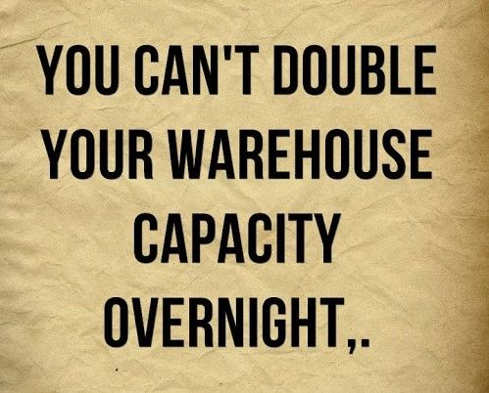

Dear Management: Warehouse line capacity is top of mind these days.  
  
Volumes are through the roof... causing all the W/H providers to be stingy with their excess capacity.  
  
As well as, no more waiving of non-use fees... and no more excess amounts being thrown around, as they were... just a year ago.  
  
Are you concerned???  
  
Well you should be... unless you are a bank with deep deposit pockets to fund your loan originations.  
  
For the rest of us... it's strategy time.  
  
I've never been a proponent of just having 1 W/H line anyway... that whole "all your eggs in one basket" line of thought and all.  
  
Yet only having two lines during these times is not giving you the most accessibility to that "all important" excess capacity, at this most crucial time and at the most beneficial price.  
  
My recommendation would be 3 or 4 lines in variable amounts, depending on your peak volume estimations.  
  
This gives you 3 things:  
  
Access to excess funds,  
At the lowest cost,  
With the greatest flexibility.  
  
And if Martha Stewart was explaining this to Snoop Dogg, she would tell him, "These are good things."