(Mr. Tenkey's Tips # 340) www.mrtenkey.com

June 29, 2020

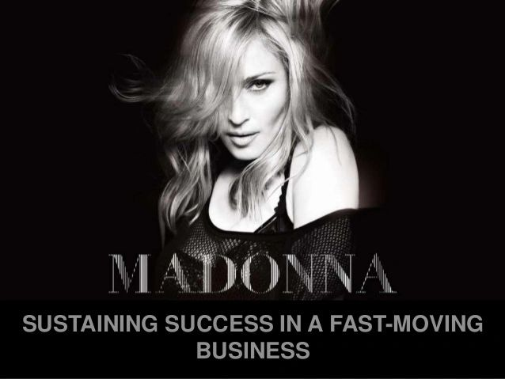

Dear Management: Are you a one-hit wonder? Or a legend?  
  
During this time of record-breaking volumes... one month after the other.  
  
Are you thinking about the next iteration of your company?  
  
When refi's are gone, rates FINALLY go the other direction? When competition will be at all-time highs? When possibly, another Covid hits the fan?  
  
What then???  
  
ONLY focusing on the market you're in today is the EXACT way to become the next Timbuk 3... and fyi, their future wasn't so bright.  
  
So you're cool now, being being Madonna version 1 (laced gloves and hair ribbon).  
  
But be thinking about the next steps...  
  
Madonna version 2 (sporting diamonds and channeling Marilyn Monroe)  
  
and after that...  
  
Madonna version 3 (70's inspired waves and sculptured arms).  
  
Be here now, be here tomorrow... be a legend baby!