(Mr. Tenkey's Tips # 369) www.mrtenkey.com

August 7, 2020

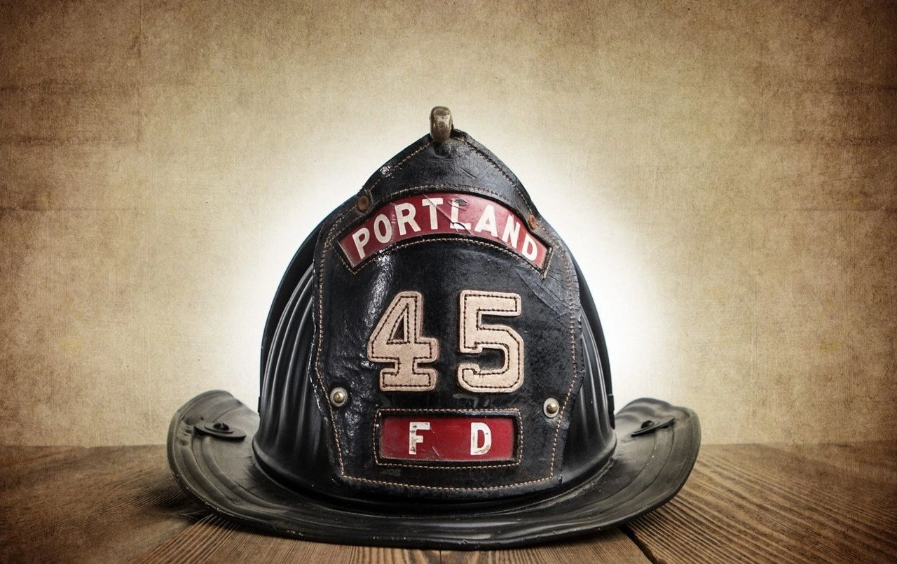

Dear Management:  Ok... so let's say the "powers to be"... don't want to hear an "operations" voice, when decisions are made.  
  
Cause, let's say the company is overly sales-y leaning... or shoots from the hip... or would just rather deal with things, after the fire is blazing away.  
  
So... what do YOU do?  
  
Well... YOU, in-efficiently staff up the back office... get as many of those snappy fireman outfits that you can find...  
  
And run fire drills day and night, for all those flare-ups... you know are coming.  
  
OR  
  
You go back to the beginning of this scenario... and fight to get all voices to the table... and do some fire prevention UPFRONT!