(Mr. Tenkey's Tips # 371) www.mrtenkey.com

August 11, 2020

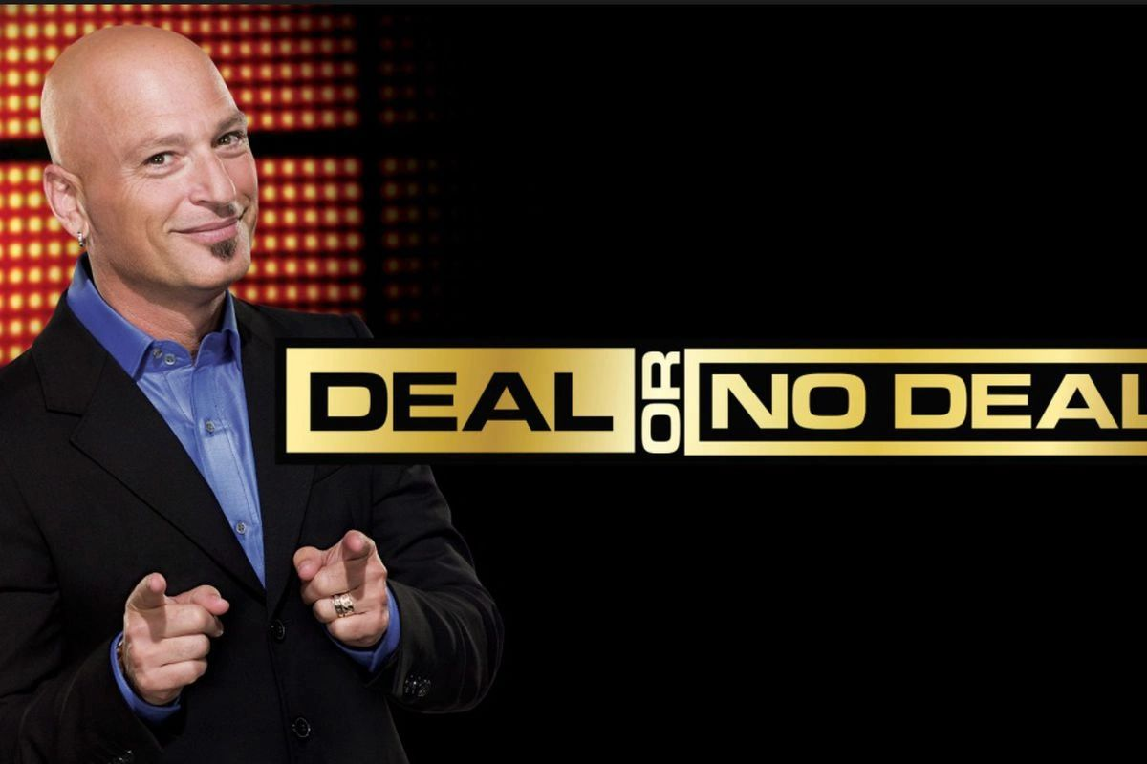

Dear Management: Ever hear this one? Do I have a GREAT deal for you...  
  
I'll make 175 bps on all the deals I fund on this (insert venture or one-off loan product here)... and the company (your pocket) will break even (AT BEST)...  
  
Deal?  
  
Well...  
  
THAT'S exactly what you're saying yes to, when you agree to do those one-off loan products, sideways marketing ventures, etc... that the Loan Officers just "HAVE TO HAVE!".  
  
Now is it a deal?  
  
And if you still say yes, you better have some MAJOR mitigating factor to make it worth your time and $'s.  
  
Like the LO is the child of some wealthy benefactor that slips you money under that table to keep the kid employed...  
  
Just sayin'