(Mr. Tenkey's Tips # 380) www.mrtenkey.com

August 24, 2020

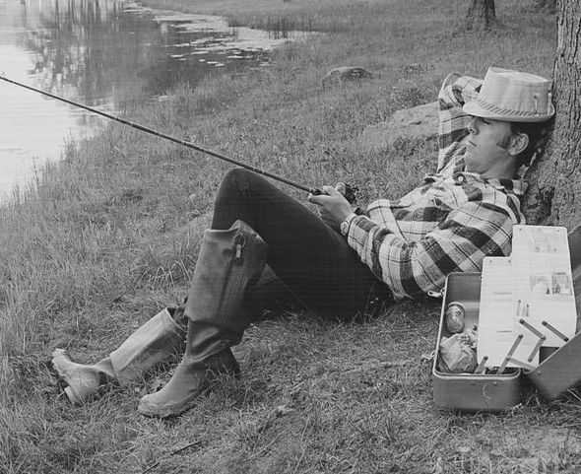

Dear Management: Are you currently hiring?  
  
And using the same old tired methods... of posting an ad on some electronic billboard? And then weeding and interviewing, over and over?  
  
Well, that's adequate... I mean, even a sleeping fisherman's hook catches a keeper... everyone now and then.  
  
But FYI - In general, the best will not come and jump on a hook for you. You'll need to go get them.  
  
How?  
  
By leveraging... the (groups, contacts, relationships, etc.) of you and your fellow co-workers.  
  
Use the herding concept of your "very best"... to naturally group with like minded, and like quality individuals...  
  
Use THEM, to refer the very best.  
  
Or at a minimum, use THEM to let you know (sooner vs later) when a bad choice was made.  
  
My couple pennies.