(Mr. Tenkey's Tips # 386) www.mrtenkey.com

September 1, 2020

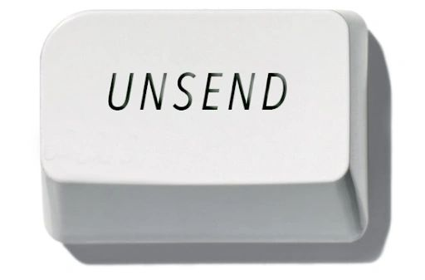

Dear Management: You pressed the "send" button, huh?  
  
On that email... you wish you could now "un-send"?  
  
The one where you jumped to a conclusion...  
  
Without getting the full picture... the facts of the situation?  
  
Yah, that one...  
  
We've all been there.  
  
Just try and do less of that, ok?  
  
Enough said.