(Mr. Tenkey's Tips # 387) www.mrtenkey.com

September 2, 2020

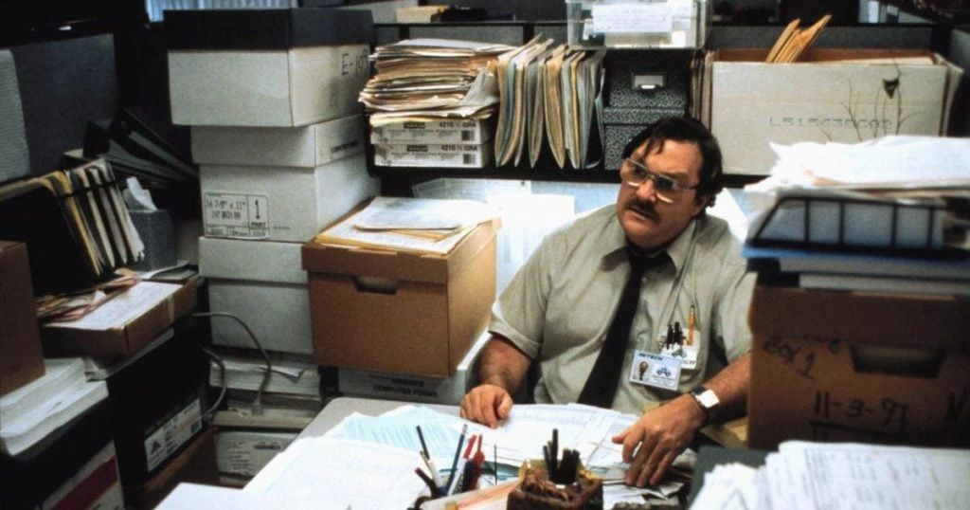

Dear Management: This is my tech moment of the week...  
  
FYI - I LOVE!!!! my desktop scanner!  
  
It has allowed me to scan and save PRETTY MUCH every itty-bitty piece of paper I held so close to my vest...  
  
Contracts, agreements, correspondence, tax stuff, audit stuff, licensing stuff, etc...  
  
Things that, having the originals just no longer matter.  
  
And because I have given up on this final gasp at my old ways... I have eliminated all that was... in my now EMPTY file cabinets and drawers.  
  
Or as I call them now... my plant stands and snack holders.  
  
The freedom I have to grab my laptop and go from office to home... to wherever...  
  
And all my "most important papers" are at the click of my mouse...  
  
Is life changing.  
  
Purge those final holdouts of the old ways.  
  
You'll be glad you did.  
  
Signed - "Old fart who learned a new thing"