(Mr. Tenkey's Tips # 393) www.mrtenkey.com

September 11, 2020

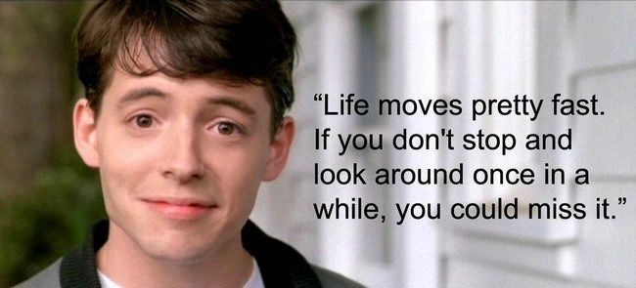

Dear Management:  I'm with Ferris...

Life is truly missed by so many people.

So how about you?  Do you disconnect?  Or are you just TOO BUSY?

Well, if you JUST CAN'T take a day off... then 1 of 2 things is happening:

1) You don't have the right people backing you up...

or

2) Your ego won't let you... let go.

Either way, your work life balance probably sucks.

I choose not to be that way.

So today I'm taking the day off, I have great people backing me up and I am letting myself disconnect from the office.

And sidenote, I DO NOT have work email on my phone, never have.

If it's a true emergency I can always be texted.

And as I say to my co-workers... you have my cell number, call me anytime you need me... BUT DON'T.

A little funny,  but MOSTLY true.

How else can you truly draw that line in the sand... and enjoy your toes in it on the other side?

My couple pennies...