(Mr. Tenkey's Tips # 408) www.mrtenkey.com

October 2, 2020

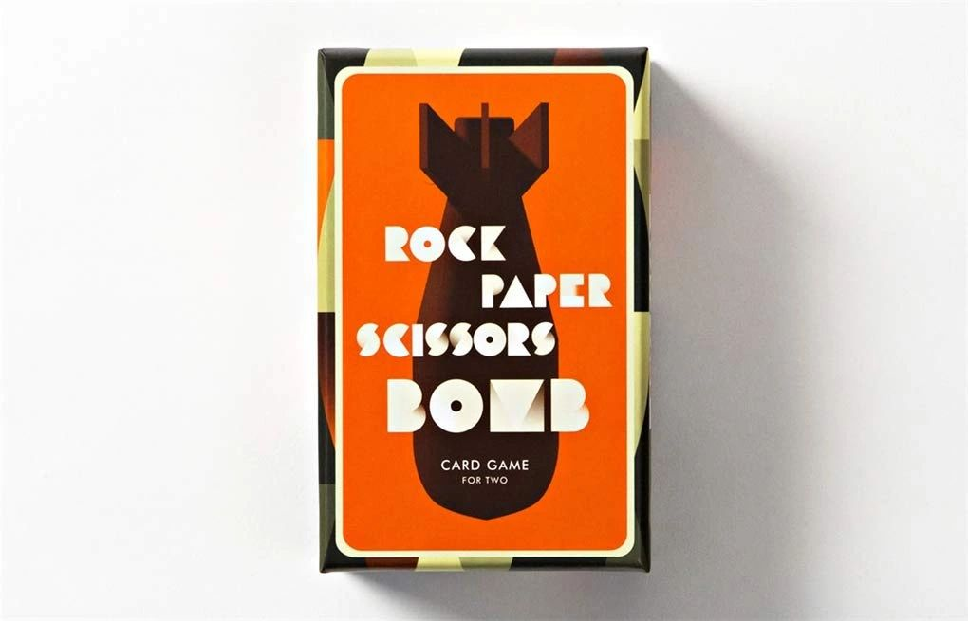

Dear Management: As a leader/supervisor... be careful when battling with a subordinate...  
  
One... that you will not allow them to win.  
  
One... that will never be a fair fight, as long as you wear the "paper" pink slip card, like a badge.  
  
Why?  
  
First, you will NEVER hear a truthful answer.  
  
Second... that card is only your shield, as long as THEY allow you to employ them.  
  
And their "scissors" quit card... beats paper.  
  
As everyone knows... no competent soldier goes into battle, without an exit strategy.