(Mr. Tenkey's Tips # 412) www.mrtenkey.com

October 8, 2020

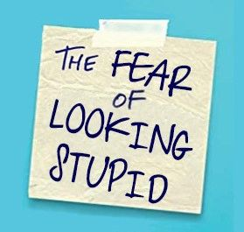

Dear Management: The fear of looking stupid, has a crippling effect beyond your own insecurities...  
  
It stifles the people around you, as you end up closing down... not wanting to share.  
  
And sadly... when you could well have valid and helpful points to bring to the table.  
  
But instead, your insecurities bring on intimidating behaviors, that end up stifling others.  
  
And the funny thing about it...  
  
Is that, the act of asking for advice, help, directions...  
  
Actually makes other people believe you’re MORE competent.  
  
My couple pennies...