(Mr. Tenkey's Tips # 419) www.mrtenkey.com

October 19, 2020

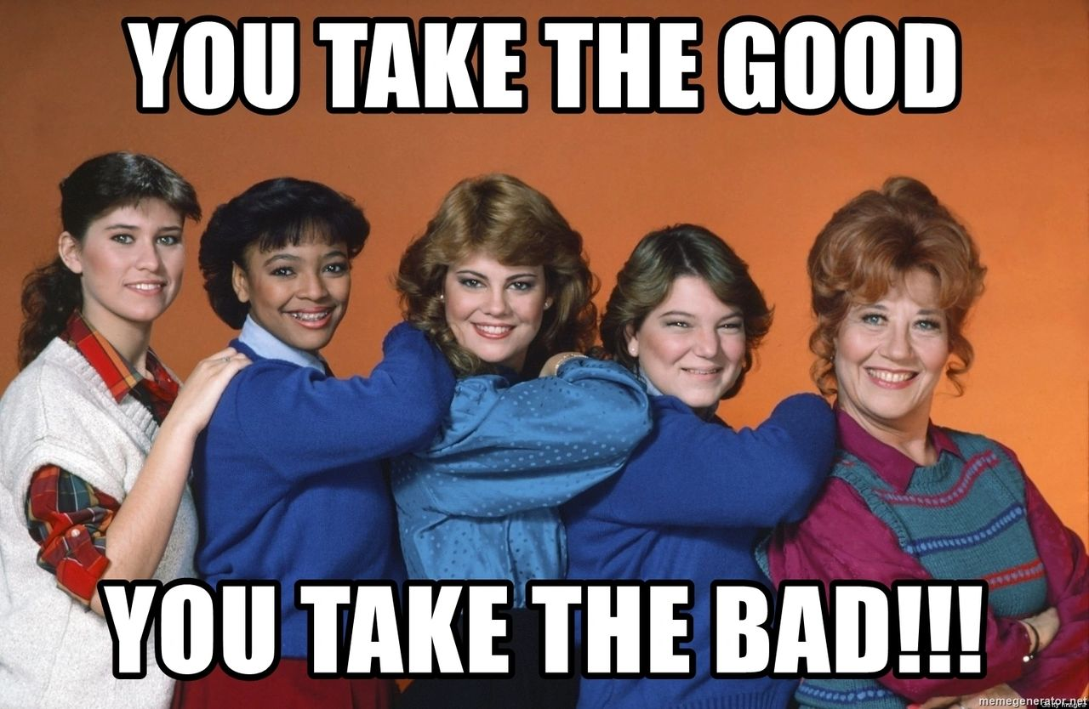

Dear Management: If you share in the ownership of the errors that occur...  
  
From those under your command.  
  
As equally as you do...  
  
From the good things that come from their efforts.  
  
Then bravo! to you.  
  
If not... YOU might be part of the errors.