(Mr. Tenkey's Tips # 444) --- book available @ www.mrtenkey.com

November 23, 2020

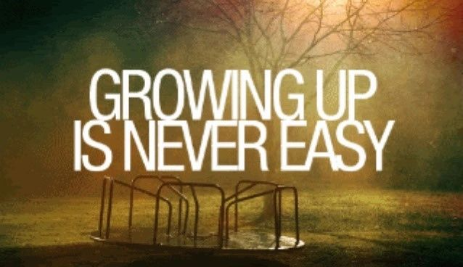

Dear Management: A MUST grow, grow, grow, infinitum strategy...  
  
WORKS BEST, when you first look inward and make sure...  
  
That the company you are growing, is ready.  
  
That readiness... involving the "taking stock" of the necessary structural needs... and processes/procedures to make it happen.  
  
Without it... any growth that comes, will also bring wasted energy.  
  
With it... the growth that follows will bring ease, less waste and far less expenses.  
  
But better yet... MORE profits to your pocket.  
  
That last one got your attention, didn't it.  
  
I figured.