(Mr. Tenkey's Tips # 447) --- book available @ www.mrtenkey.com

November 30, 2020

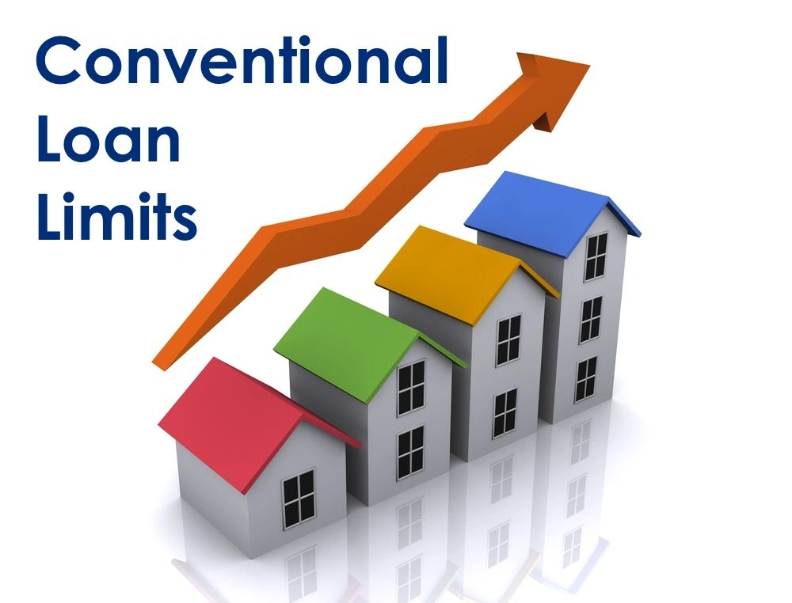

Dear Management: For yet another year... FNMA and Freddie Mac have raised conforming loan limits.  
  
Where they will stop, nobody knows...  
  
But what we do know, is the base limit for 2021 has increased to $548,250... from $510,400, just last year.  
  
And do you know what the high-cost limit is?  
  
It's now $822,375 for certain areas... so know your geography people.  
  
Like did you know that:  
  
Fairbanks North Star Borough(AK)  
Guam(GU)  
Spotsylvania County(VA)  
and  
Queens(NY)...  
  
Are all in a high-cost area?  
  
Neither did I.  
  
But now we both know.  
  
And knowing is half the battle!