(Mr. Tenkey's Tips # 453) --- book available @ www.mrtenkey.com

December 8, 2020

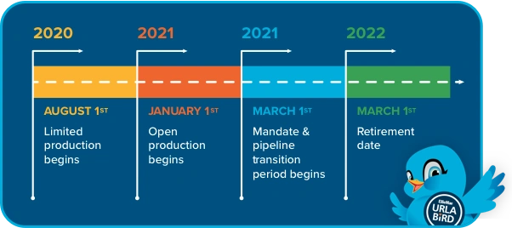

Dear Management: The new URLA is coming March 2021... no really, it should really happen this time.  
  
So you ready?  
  
But first, do you even know what the new URLA is?  
  
Well it's the universal residential loan application or form 1003... that has been redesigned by the GSEs (Fannie Mae and Freddie Mac) to improve the borrower and lender experience.  
  
That's a mouthful... feel improved yet?  
  
Well the application has been around 20 years old now... things were bound to be changed.  
  
The hope of which... is to capture better borrower data points and help continue the push to a "pure" digital mortgage.  
  
The challenge is to have your ducks in a row... to transition your current system(s) and procedures to accept the new format.  
  
So I ask you again...  
  
You ready?