(Mr. Tenkey's Tips # 458) --- book available @ www.mrtenkey.com

December 15, 2020

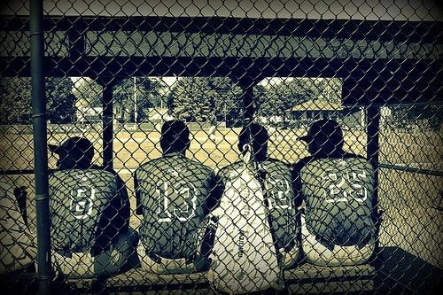

Dear Management: If the only news you want to hear, is that which is "good"...  
  
Ok... then continue sleeping at the wheel.  
  
But there is a ditch out there with your name on it.  
  
You'll wake up then.  
  
And my hope for you, is that when you do...  
  
You have a team around you to fix the car (and you).  
  
A team... that is just sitting on the bench.  
  
A team that gave you "bad" news once.