(Mr. Tenkey's Tips # 462) --- book available @ www.mrtenkey.com

December 21, 2020

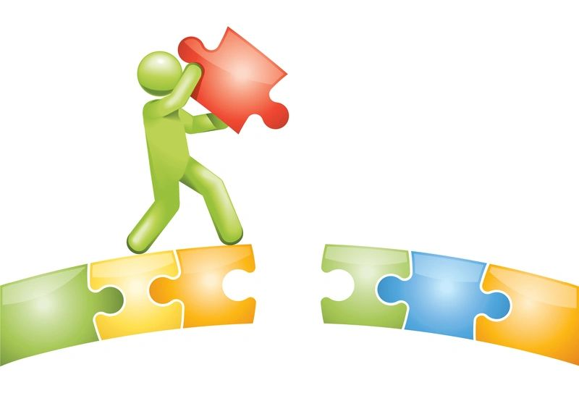

Dear Management: In our current world... where interaction with employees DOESN'T come through personal interaction...  
  
What are you doing to bridge that gap?  
  
Emails and Zoom meetings DON'T truly replace it.  
  
Are you thinking of ways to connect on a more "real" basis?  
  
Well, you should!  
  
This isn't a problem that can be solved by just WAITING it out... Taking a "Things will be better then!" approach.  
  
Because in the world BEYOND COVID... how many people will even be in the office?  
  
Perspectives on people's lives and lifestyles have changed... FOREVER... on what work and the work environment is.  
  
Adapt with that...  
  
Or for that gap, you'll never find a bridge.