(Mr. Tenkey's Tips # 463) --- book available @ www.mrtenkey.com

December 22, 2020

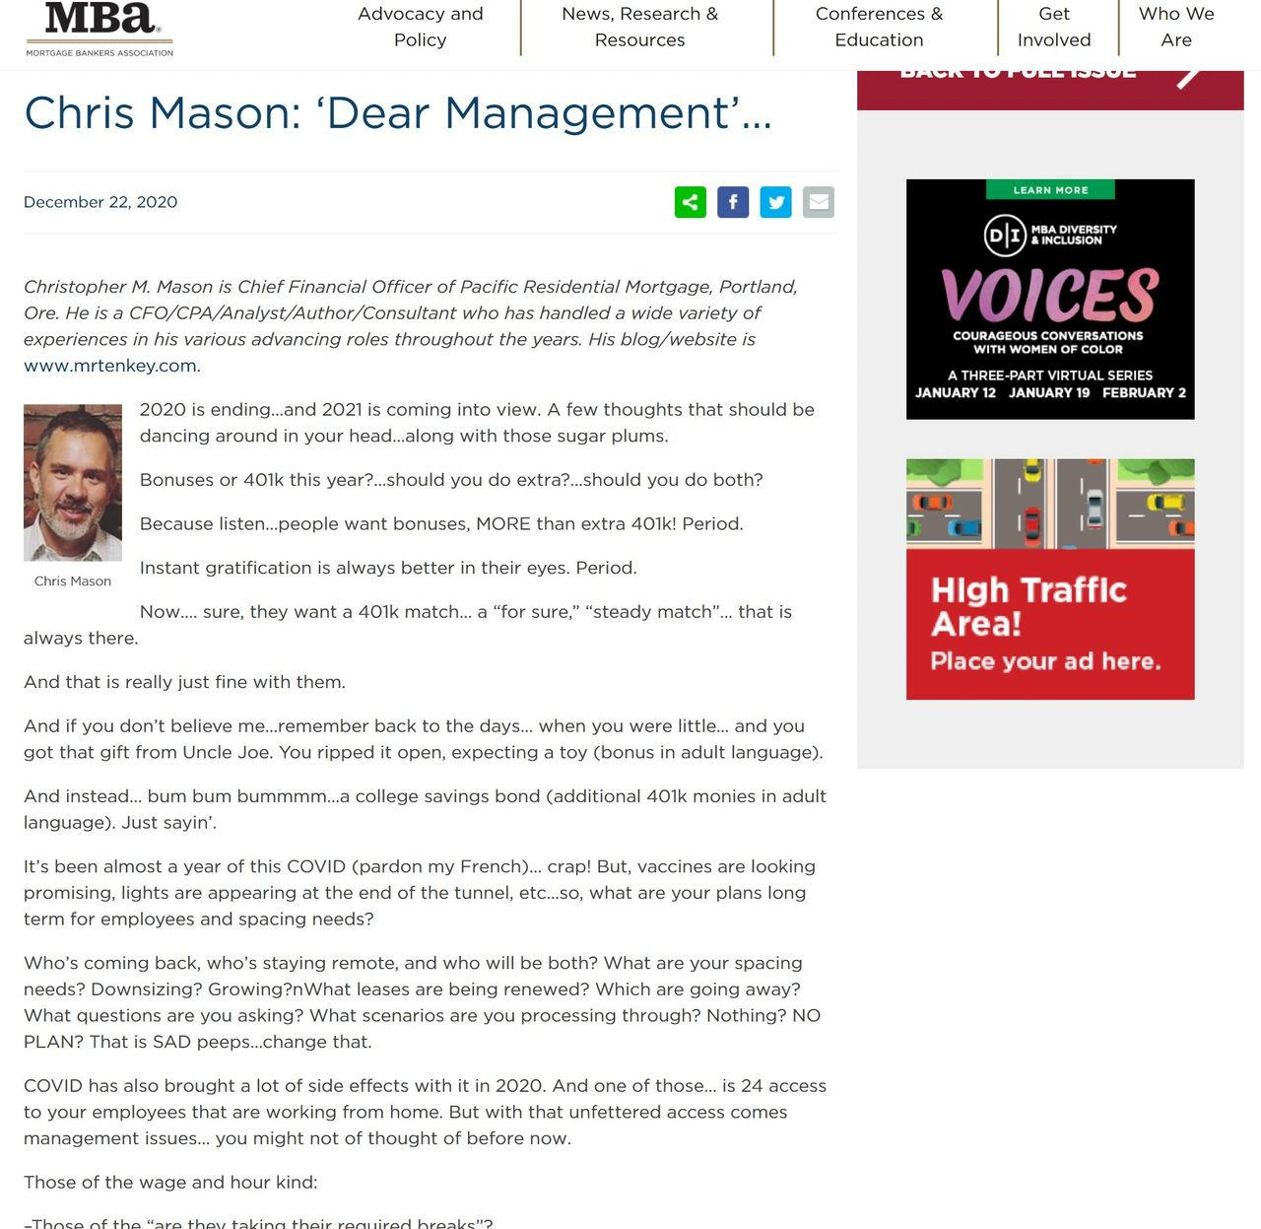

Dear Management: It's at this moment... I take a moment... to see what I've done.  
  
From simple posts about the industry... to a remark from a man I highly admire.  
  
Who said, "these are great... when you get to 100, you should write a book. And I'll write the foreword for you."... and he did... and I DID write that book.  
  
And that guy was Joe Garrett (of Garrett, McAuley & Co.).  
  
From there to a mention in Rob Chrisman's Report...  
  
To a great critique and advice from another man I admire in the industry... Jeff Babcock (of The Stratmor Group).  
  
Which has led me to another milestone... a posting in today's MBA Newslink under my ongoing "Dear Management" byline...  
  
And on that HIGH for the day...  
  
I sign off for the holidays, and wish you and yours a wonderful holiday season!