(Mr. Tenkey's Tips # 486) --- book available @ www.mrtenkey.com

January 28, 2021

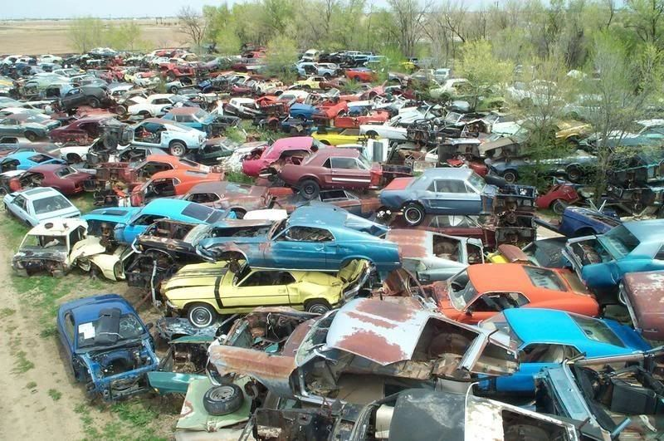

Dear Management: Here's an example of the inefficiencies, some of you are subjecting your companies to...  
  
When you shoot from the hip with ideas and don't work through the concepts... BEFORE you throw out commands.  
  
As for that example now... let's say, your company builds cars.  
  
The fields beside your warehouse would be littered with carcass upon carcass of partially completed models.  
  
Yep... half done, uncompleted, and discarded ideas that went no where...  
  
OR maybe worse, completed with 2 to 3 times the energy and manpower that was truly needed.  
  
All the while... your competitors, modeled new designs through their relevant staff... and a simple CAD program to test viability.  
  
Simply... they let their employees and systems test the idea(s), give feedback and poke holes where needed.  
  
And wait for it... had less waste, happier employees, more efficiency, and... MORE profit.  
  
Hint - Replace loans, for cars... relevant to you yet?