(Mr. Tenkey's Tips # 512)

March 8, 2021

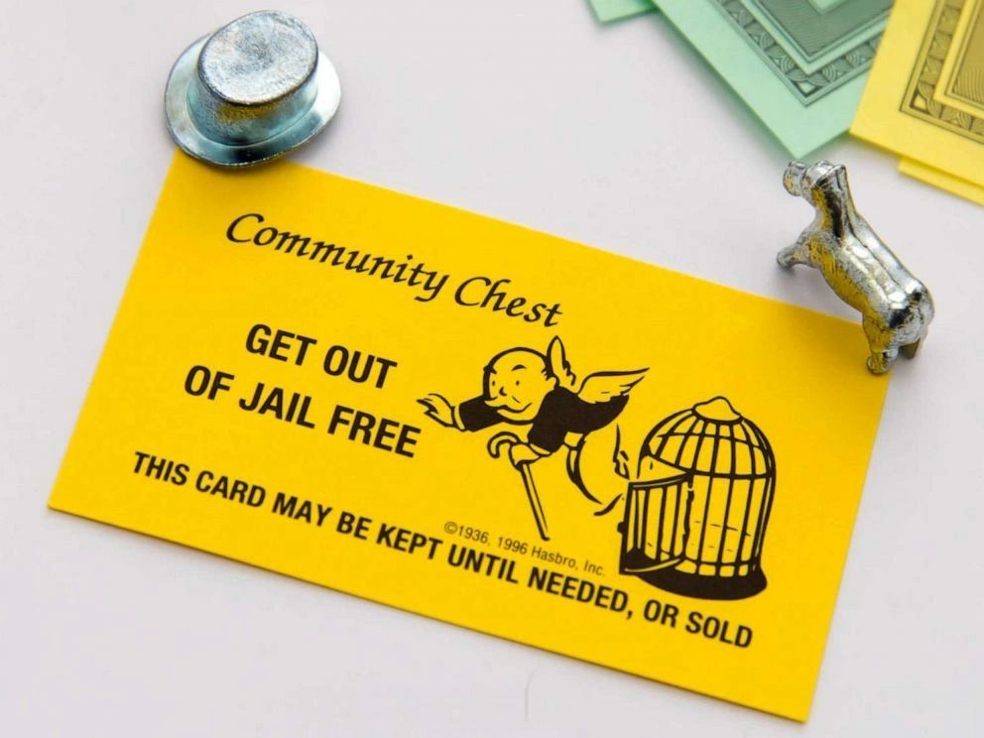

Dear Management: So, covid has dictated necessary workplace changes... with working from home being the biggest.  
  
BUT did your company's compliance change with it?  
  
And while there may have been leniency by regulators up until now... that "get out of jail free card" will shortly be used up.  
  
Even the simple rules will be scrutinized, once again... now with less forgiveness of this new normal.  
  
So, let's take Reg Flag Rules for instance.  
  
Can you PROVE that you have developed, implemented, and administered an Identity Theft Prevention Program... that meets the demands of this new world, where a majority of your employees remain working from home?  
  
Have you:  
1) Identified likely business-specific identity theft red flags?  
2) Defined procedures to detect red flags in day-to-day operations, especially in a work from home environment?  
3) Acted to prevent and mitigate harm when red flags are identified?  
4) Maintained (and updated) the red flag program, including educating operational staff?  
  
You answered no to any of those?  
  
Well then... it might be time to revisit this stuff.  
  
Just sayin'  
  
(More blog posts or buying my book @ www.mrtenkey.com)