(Mr. Tenkey #527)
March 29, 2021
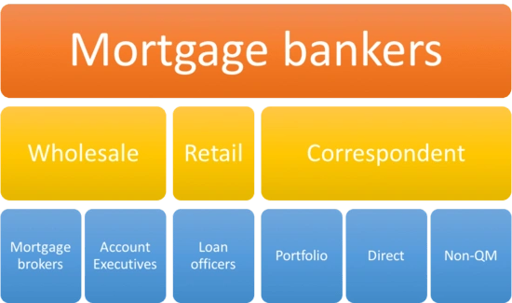
Dear Management: Whether you're starting a mortgage company... or already have one established.
Which lending channel(s) should you choose or continue with?
Retail?
Correspondent?
Wholesale?
Consumer direct?
There's many others... but you get the point.
ALL channels CAN make your company money... and ALL can lose it just as same.
One channel or mix of channels... is not better than the other, just DIFFERENT.
So, the way to "win" with your choice(s), is to LEAN into the uniqueness of each channel... as you design, implement and structure the operational support behind it.
THEY ARE NOT THE SAME!
For example...
Consumer direct thought points - Direct contact to borrowers, higher marketing costs, hefty high tech setup cost upfront, lower comm costs than other channels, streamlined ops efficiency needed, easy access point to ANY region-(anytime)(anywhere), etc.
Wholesale thought points - No direct contact to borrowers, different referral base needed in an AE than LO, high efficiency on ops side needed, you should be more selective with whom you do business, low cost entry point to new regions, possible feeding of retail channel once relationship/name recognition takes hold, etc.
My couple pennies.
(More blog posts or find my book @ www.mrtenkey.com)

