(Mr. Tenkey #533)
April 6, 2021
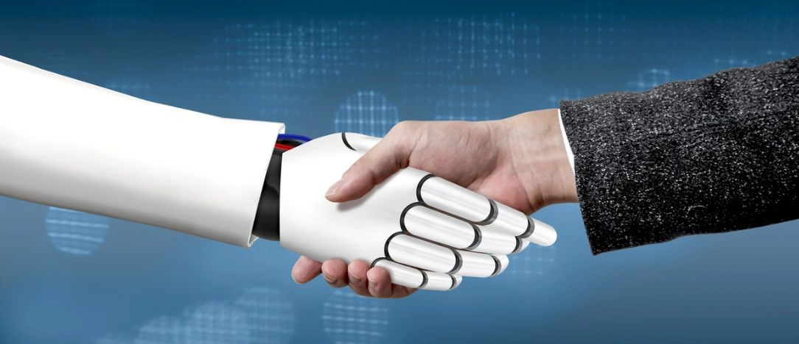
Dear Management: Do you need to provide high-touch or high-tech... to win the day?
High-touch - Referring to the human interaction, the human relationship involved, the well... human side of the business transaction.
High-tech - Referring to the use of the most advanced and relevant technology. It's ALL about the speed and efficiency of the transaction.
Thoughts?
Well my answer would be: BOTH!
High-touch and high-tech are not diametrically opposed... but rather, more dependent than ever.
Buying a home is an emotional rollercoaster for most borrowers. From saving, finding, qualifying, losing, finding another, etc.
Borrowers expect empathy, emotional intelligence, and experience to guide them... WHEN they need it.
But borrowers also live in today's world, and demand as close to instant gratification as they can... in a mortgage transaction.
So what do you end up with?
A hybrid... what I call an "Advanced Tech-Touch"... by leaning into the positives of both.
So, evolve!
Provide the most technologically advanced transaction, in an empathetic and skilled way.
ALL, while balancing the financial impact... so not to destroy the bottom line of your company.
Balance in all things people... balance.
(More blogs/Find my book @ www.mrtenkey.com)

