(Mr. Tenkey #541)
April 16, 2021
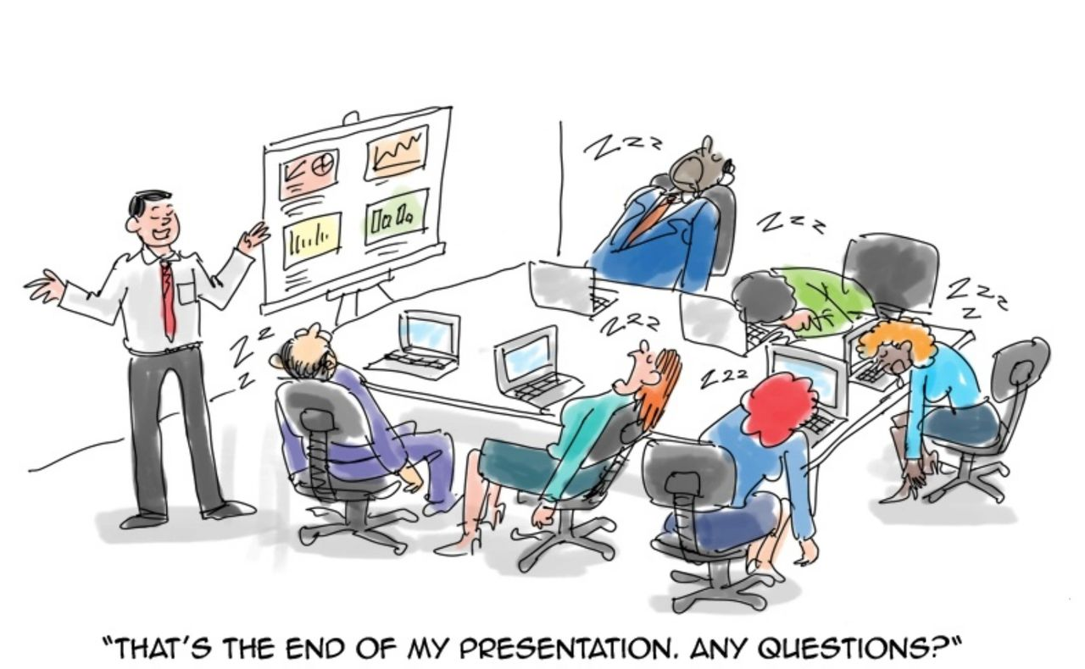
Dear Management: Rules of thumb for a company's analytics and business intelligence reporting...
- Most managers can't be bothered with ALL the details. They simply want cumulative results that tell them a story, of the subject matter they are reviewing.
- Details are for you to provide, when they DON'T LIKE the story the results are telling them.
- Add colored pictures and graphs (as needed) to keep their attention.
Hence,
If you can't have all the stats, prod #'s, pull-thru's, costs, data bits AND pretty pictures...
In a concise, summary result. (A report card, some might say.)...
Then, you're not trying hard enough.
As my take away would be...
It's a report card peeps... NOT report cardssssssss.
My couple pennies.
(More blogs/Find my book @ www.mrtenkey.com)

