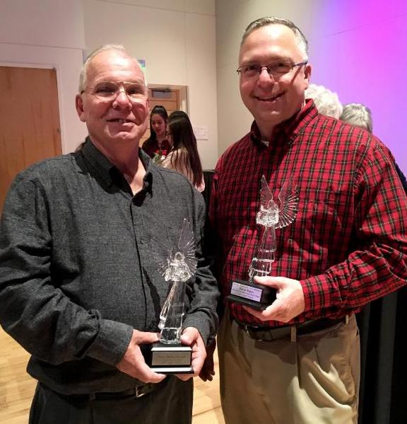
Instructions for Angel Award Chair

Each year, each group in the Greater Lewisville Arts Alliance chooses an “angel”, a member who deserves special recognition. Each Angel receives a trophy.

Member groups of the GLAA take
turns hosting the annual Angel Awards. To see the member groups,
visit lewisvillearts.org.

1. Set date and time.
This is up to the host group, usually happening in November. Angel Awards are held at the MCL Grand, so chair must make arrangements with MCL person in charge of scheduling the venue. Do this well in advance to be able to secure the space.

2. Give all groups a deadline for choosing their angel and getting a bio and photo to you. This should be done early enough to allow for advance publicity.

3. Provide names and group name for each angel to engravers and order the trophies.
We use Carlisle's at 325 E. Main St: They already have the design info. Their phone: 972-436-7219. Allow 3-4 weeks for this and double check spelling before giving to them and after receiving the trophies.

4. Ask all groups to send you a list of people with addresses to invite.
This should include board members, major contributors, people important to their organization. The GLAA members must be invited, as this is their members' annual meeting. You will have to cross check lists for duplicates. (You may wish to limit the number each group may submit.)

5. Create mailing labels.
Remember to include Lewisville city council members, mayor, any other city officials. Typically, 300 invitations are sent. (Approx. 75-80 attend). Email can be used by sending a digital invitation to your contact at each GLAA organization to send to their invitees.

6. Create invitations and program.
VAL’s Graphic Designer will take care of this. Provide the designer with all information needed to be in these documents. If donations are made, remember to thank donors in the program. The designer will take care of printing, we use Minuteman Press in Lewisville. You’ll need to purchase envelopes and stamps.

7. Mail invitations about 3 weeks before event.

8. Plan reception.
This can be quite simple: a wine & cheese or punch & cookies type of menu. It can be held either before or after the event. Plan for approx. 100.

9. Decide on the order of the event.
The awards may be given whenever you feel appropriate for your production. They are usually handed out by the GLAA president, with a committee member assisting. Keep it simple.

10. Follow up with publicity.
Send a brief article and group photo to VAL’s PR, social media and VAL newsletter chairs. You’ll want to arrange for a VAL member to take photographs of the angels as a group, VAL’s Angel and any special guests at the event (i.e. MCL Grand and city officials)

11. Keep track of all expenses.
Stay in touch with the treasurer regarding budget and VAL debit card. Give receipts to the VAL Treasurer. You will be reimbursed for any costs you paid for yourself.

12. Thank you so much for volunteering to handle this for VAL!!

