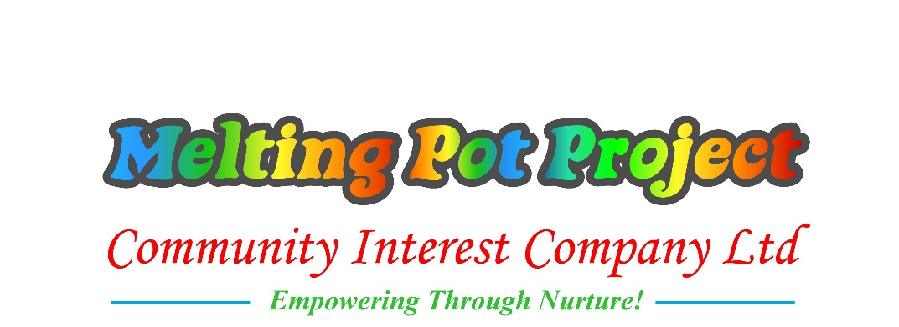

PRIVACY POLICY
STUDENT PRIVACY NOTICE
The categories of student (and prospective student) information that we collect, hold and share include:

- Details about yourself including your name, Unique Learner Number, date of birth and gender;
- Contact details including address, telephone number and email address
- Details of your previous qualifications, employment and educational history
- Information about your nationality and residency, and previous address if applicable
- Information about medical or health conditions, including whether or not you have a learning disability or difficulty
- Ethnicity
- Household information
- Attendance information (such as sessions attended, number of absences and absence reasons)
- Progress information (how well you are doing with your course)
We collect data about criminal convictions in order to protect vital interests of others and in order to carry out our duty to support those with a conviction.
We collect details of carers/ care homes for learners who are not independent travellers or living at home in order to support our duty to support the education and learning as fully as possible.
Why we collect and use this information:
We collect and process personal data relating to the College’s students to effectively manage their learning and to meet statutory obligations as a Further Education Provider. Melting Pot Project is committed to being transparent about information it collects and uses, and to meet its general data protection regulation (GDPR) obligations.
We use student data:
To process applications, including sending relevant marketing materials relating to your application, such as event reminders and joining instructions

- To support learning
- To monitor and report on progress
- To provide appropriate pastoral care
- To assess the quality of our services
- To comply with the law regarding data sharing.
How is this collected?
Most of the information above is collected directly from yourself via an application or enrolment form. However, some information such as previous qualifications, or special needs, may be collected from other organisations such as the Department for Education (DfE), the Local Education Authority, or your previous school.
Where we store data:
Data will be stored in a range of different places, including student information management systems, on paper in stored secure places, or on electronic documents within a secure network.
The lawful basis on which we use this information:
As part of Data Protection Act 2018 (GDPR), Melting Pot Project needs to process data so we can provide you with the highest standards of education and training we are able to give, and to meet its legal obligations from government organisations including the DfE and the Office for Students. Data regarding employment status and benefits is required to assess your eligibility for fee remission or support.
Where the organisation processes other special categories of personal data, such as information about ethnic origin, disability or health, this is done for the purposes of equal opportunities monitoring and monitor our service provision to improve our services to specific groups. We also use the data so we can personalise the provision to each student to provide them with the best possible opportunities to succeed. Any information that has been supplied under the lawful basis of consent, consent can be withdrawn at any time, by contacting the data protection officer.
Contact details will not be used for marketing or survey purposes without your consent, which can be withdrawn at any time. However the college will use the contact information to contact you in order to carry out our duties to you, for example to notify you of a change of course date, and also to obtain data where legally required, such as destination surveys.
The organisation shares your data with third parties where there is a legal or contractual obligation, including the Education and Skills Funding Agency (ESFA), Office for Students (OfS), Learner Records Service (LRS), awarding bodies, validating universities and local authorities.

Who has access to data?
Your information may be shared internally, including with any Melting Pot Project staff who need the data to provide services to students. This will include special categories of data where appropriate.
Where Melting Pot Project engages non-statutory third parties to process personal data on its behalf, we require them to do so on the basis of written instructions, are under a duty of confidentiality and are obliged to implement appropriate technical and organisational measures to ensure the security of data.
The organisation shares your data with third parties where there is a legal obligation, including the Education and Skills Funding Agency (ESFA), OfS, Learner Records Service (LRS) and local authorities.
Further details can be found from gov.uk for Further Education students.
How we use cookies:
A cookie is a small file which asks permission to be placed on your computer’s hard drive. Once you agree, the file is added and the cookie helps analyse web traffic or lets you know when you visit a particular site. Cookies allow web applications to respond to you as an individual. The web application can tailor its operations to your needs, likes and dislikes by gathering and remembering information about your preferences.
We use traffic log cookies to identify which pages are being used. This helps us analyse data about web page traffic and improve our website in order to tailor it to customer needs. We only use this information for statistical analysis purposes and then the data is removed from the system.
Overall, cookies help us provide you with a better website, by enabling us to monitor which pages you find useful and which you do not. A cookie in no way gives us access to your computer or any information about you, other than the data you choose to share with us.
You can choose to accept or decline cookies. Most web browsers automatically accept cookies, but you can usually modify your browser setting to decline cookies if you prefer. This may prevent you from taking full advantage of the website.

