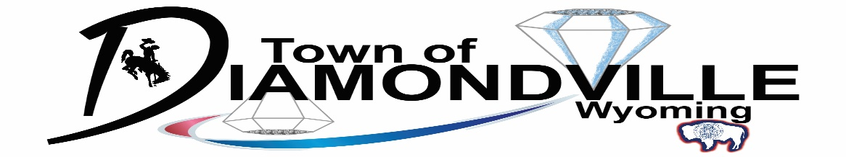
DOMESTIC FOWL PERMIT

Applicant Information
Name of Permit Holder:
Applicant Address:
(Must be the same location where chickens will be kept)
Phone:
Chicken Coop Considerations
Do you have an existing coop?

Yes _______ No ________
Permit Requirements
- $50.00 permit fee is paid
- Only have six (6) chicken hens or six (6) ducks – cannot have six (6) of each
- Domestic fowl shall be confined within a secure outdoor enclosed are.
- The enclosed area shall include a covered, ventilated, and predator-resistance coop.
- The coop shall have a minimum floor area of at least two (2) square feet per fowl.
- If domestic fowl are not allowed to roam within an enclosed area outside the coop, the coop shall have a minimum floor area of six (6) square feet per fowl.
- Coops may only be kept in a rear yard
- Coops must be twenty-five (25) feet from residential dwellings on adjacent lots
- Coops shall fully comply with all setback requirements of Accessory Buildings noted in Ordinance 10.30.070 (B) or Ordinance 10.35.080 (B).
- All coops where domestic fowl are housed shall comply with Ordinance 5.15.010 in regards to cleanliness and/or nuisances
- Tie down and/or anchors are required for stabilization of coops.
- Feed shall be stored and dispensed in rodent-proof and predator-proof containers.
- Coop
- A coop shall be provided and shall be designed to provide safe and healthy living conditions, with sufficient heating and ventilation for the domestic fowl while minimizing adverse impacts to other residents in the neighborhood.
- Domestic fowl runs
- An enclosed run must be provided consisting of sturdy wire fencing. The pen must be covered with wire, aviary netting, or solid roofing.

APPLICATION CERTIFICATION
I hereby certify that the information submitted is true and correct. In submitting the signed application, I acknowledge and agree that the application is subject to all the terms and conditions for a Domestic Fowl Permit found in Section 5.40 of the Town of Diamondville Ordinances. I understand that any false statements or omissions may result in denial or revocation of this permit, along with a fine up to $500.00 and removal of the domestic fowl.
Applicant Signature: Date:

Inspecting Officer
Signature: Date:

