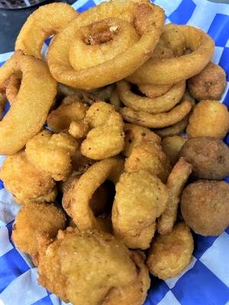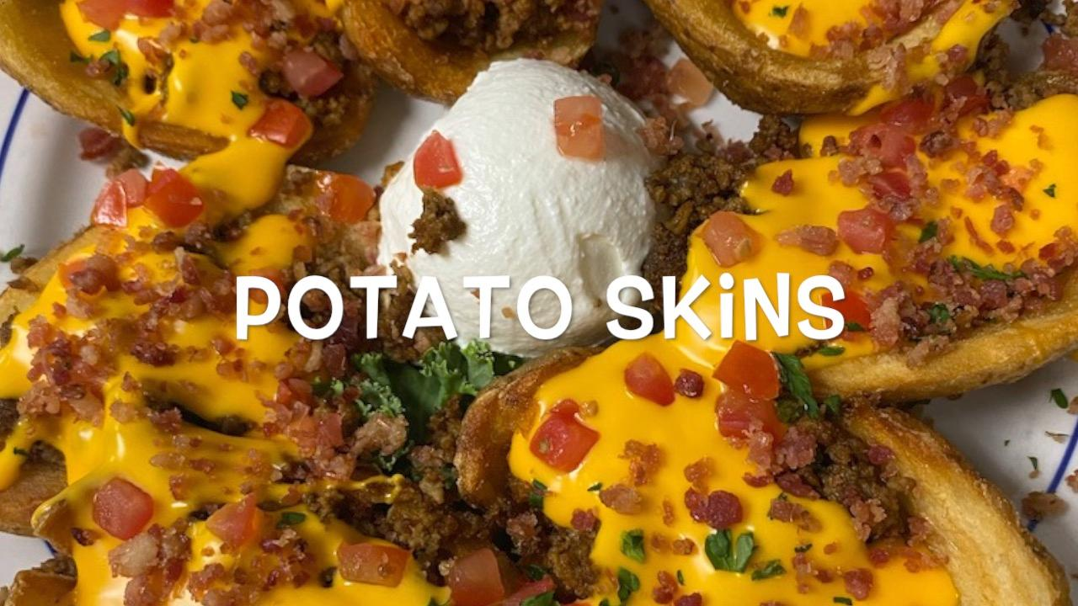

3-22

**

**Homemade Tumbling Onions**

**Buffalo Chicken Strips**

**Potato Skins**

**Gator’s Combo**

Pots