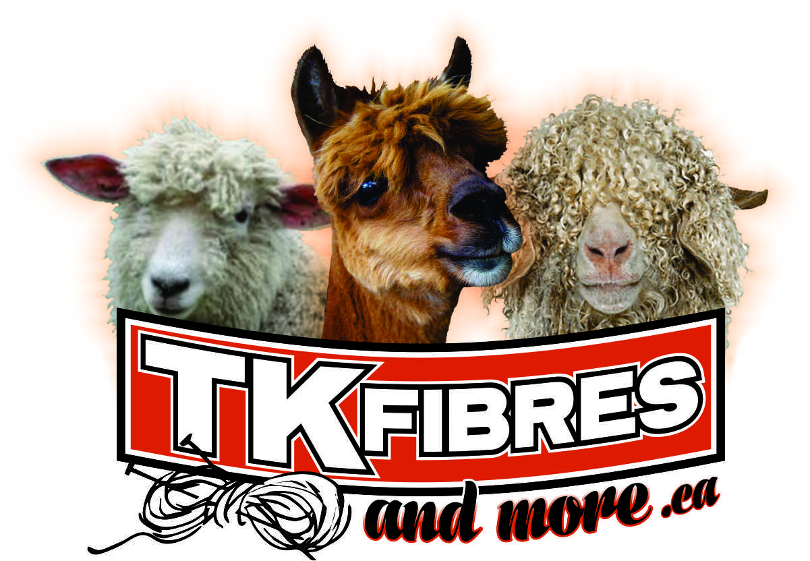
15455 Muirkirk Line, Muirkirk, ON N0L1X0 519-437-1644
Email: t&kfibre@gmail.com

DATE:_____________________

Customer Name:__________________________________________

Address: _______________________________________________

City:________________________ Postal Code:_________________

Telephone: ___________________ email:_____________________

QTY Received: __________ Pounds _________________type of fibre
__________ Pounds _________________type of fibre
__________ Pounds _________________type of fibre

Washing/Scouring (Weight upon acceptance at Mill, dirty weight) $5/pound
Rovings/Batts (Weight after fibre has been tumbled and washed) $15/pound

Shipping fees (if applicable) and HST are additional charges.
50% deposit required upon receiving fibres required.

We reserve the right to decline your fibre if contaminated with bugs, excessive dirt, debris or poor quality of fibres. You need to skirt your fibres and remove excessive dirt and debris.

Prices may change without notice. If there is a balance owing on finished product after 90 days of notification that your order is completed and you have not paid or made arrangements for pick up or shipping, the finished product becomes the property of
T & K Fibres and More.

I agree to the above prices and terms. ______________________________
(customer’s signature)

Estimated cost for custom processing __________________
50% deposit received $___________ by ____ cash ____ cheque ____ debit

Additional notes:
If you have discussed with me that you want your fibres blended please indicate how you want them blended: ie.- 2 pounds alpaca + 1 pound wool

