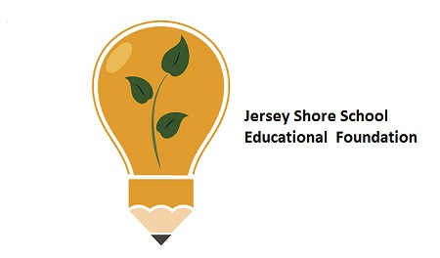
Jersey Shore Schools Education Foundation
End of Year Report 2022

Throughout the school year of 2021 – 2022, the Education Foundation participated in various programs that impacted all of our students in the Jersey Shore School District. The Foundation would like to thank the administration and staff for their assistance in these accomplishments and hope to continue the positive relationship for the benefit of the students at Jersey Shore Schools.
Mission Statement:
Engage and Extend Educational Experiences
Our Mission is to engage partners to enrich and extend learning opportunities beyond the conventional educational experience for students in the Jersey Shore Area Schools.

Vision Statement:
Our Vision is to assist the Jersey Shore Area School District to enrich educational and social opportunities for students.
The Foundation is governed by our Board of Directors that represents the various area communities and towns and fosters the belief that community involvement in public education is essential to providing and sustaining the level of education that is expected in Jersey Shore Schools.

Adaptive Swing at JSE
We started the year with the addition of the adaptive swing at JSE. The community and the Foundation secured the approximately $11,000 to purchase and install the swing.
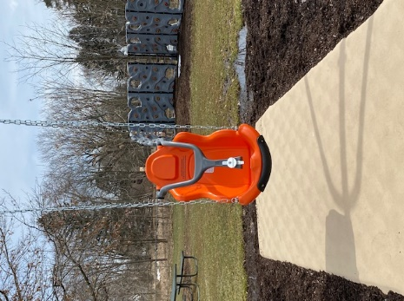
In June of 2021, the Foundation was contacted by the assistant principal of JSE and she informed us about a student with a debilitating disease who attended JSE. He wanted to swing on the swings, but got his wheelchair stuck in the mulch at the playground. JSE needed an adaptive swing so all students would be able to enjoy their recess time. This plea put the wheels in motion to purchase and install said adaptive swing. The total cost was estimated to be $11,000 which was more than the Foundation could support. However, the Foundation committed $5000 towards the purchase and installation. The story of the young student was posted on the Foundation Facebook page and the rest is history. Community members and various community service organizations stepped up in a big way to accept the financial challenge. By September, enough had been raised to set the plan in motion and the walkway for the swing was installed. Supply chain issues prevented the delivery of the swing until March, but it was finally installed.
Teacher Mini-Grant Program Funds Projects for Teachers
The mini-grant program provides district teachers an opportunity to purchase materials to enhance classroom activities. Each year teachers may apply for up to $2000 for special projects that benefit their students and classroom. In the past, these projects have ranged from the arts to academics to STEM activities.
During the 2021-2022 school year, the Foundation funded $20,029.95 for innovative projects and programs proposed by our teachers within the district through our teacher mini-grant program.

Successful grants included:
*Holly Ditmar for picnic tables for an outdoor classroom ($3360)
These items were purchased at the end of the school year. We are looking forward to seeing the new lessons using these outdoor items.
*Nicole Bechdel for stand-up desks for her classroom ($1385.05)
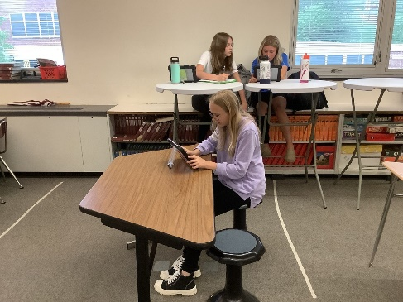
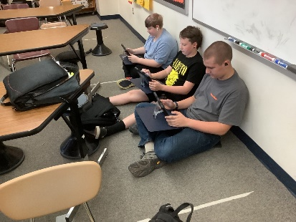
Trading Places was the name of the grant that placed stand-up desks, wiggle stools and surf desks in the classroom at the middle school. There were significantly less discipline referrals. A lot of students were able to choose a seating option which allowed them to work without distraction. It also allowed students to be in their own space away from peers who might bother them.

*Jeff Klugh Rebecca Ball-Schaller for the Boalsburg Museum trip ($1169.96)
These teachers also purchased metal detectors to demonstrate to the students how artifacts are recovered prior to their trip to the museum. Students had to “search” and recover carefully various items that were buried just an archeologist may do.
*Trish Sweitzer for a water wall for the Trout in the Classroom Project ($4383)
Trish Sweitzer and Stephanie Machmer both raise trout in their classrooms and then release them in Little Pine Creek in the Spring. With the funds from this year, they purchased a water wall which is a hydroponic system that will utilize the water from the fish tanks as nutrients to grow plants and then return the “clean” water back to the fish tanks. Funds for this project came primarily from the EITC grant from High, Inc.
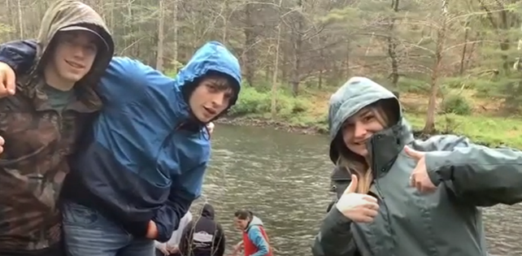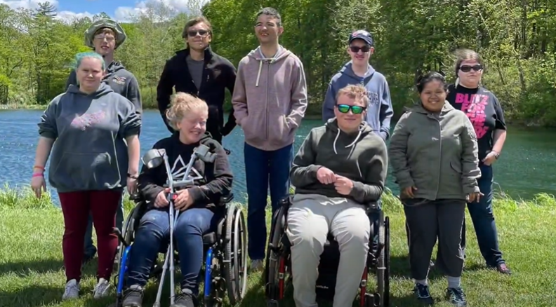
Classes raised trout in the classroom and released them into Little Pine Creek in May.

*Jan Wasson for materials for the Personal Finance Units ($1,637)
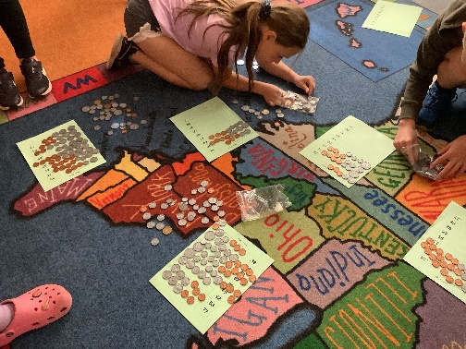
Jan Wasson was able to implement some elementary personal finance standards in her lessons. Learning and counting money is an important skill for young students. The students were able to count money and play interactive real-life situations with the money. The older kids discussed careers and learned the basics about income and expenses. Fifth graders played Monopoly and Life games, without using money and had to complete an account register where they had to record the information from their transactions.

*Katie Wert for author visits for the elementary school and the middle school. (2 @$2000 each- $4000 each)
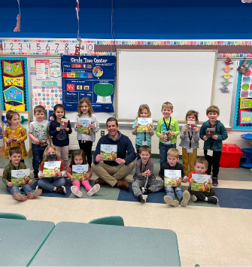
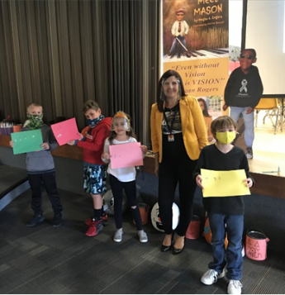
Artist / Author in Residence provided an opportunity for Megan Rogers to speak at the elementary schools concerning her blind son and how he interacts with his environment. The students had opportunities to explore braille for communications and what it is like to be blind. Lesson learned was to keep trying and never give up.
Thomas Speicher visited both the middle school and the Bullpups preschool program. He spoke on the process that he took to write his story and the elements of the story. He then visited the Bullpups program at the high school and read his book to the students.

*Michelle Moore and Angela Haffley for a trip to LHU for a Biology Seminar ($288.80)
Students were treated to a tour of the biology labs at LHU for a preview of what a college science curriculum could be like. A treat for sure to instill a love for STEM careers in the students.
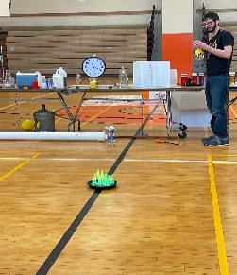
*Tracey Silvis for a chemical demonstration for grades 7 and 8 ($200.00)
There is no better way than hands-on to teach some science. However, allowing students to create fire and small explosions can be a hazard in the classroom. In the hands of a professional chemist, these things are not a problem. The whiz bangs of a great chemical demonstration will do more to spark a student’s interest in the sciences than any other. Just ask Bill Nye the science guy.

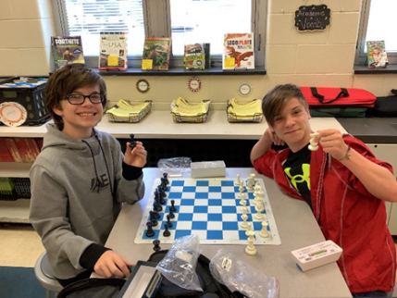
*Karen Fausnacht for a chess activity for middle school students ($2045.26)
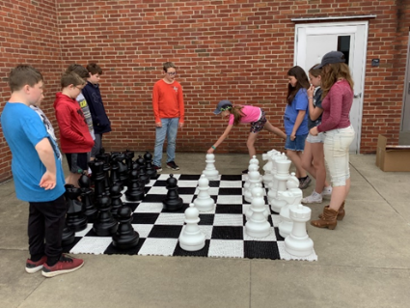
Multiple chess sets were ordered for 6th grade students to use during our Come Alive period at the middle school. Chess assisted my students in developing problem solving and critical thinking skills. Chess served as a tool for mastering the rigorous learning goals associated with various subject areas.
*Diane Mantek for an upgrade in the butterfly garden ($500)
The Butterfly Garden at JSE needs an update and Mrs. Diane Mantek has undertaken a complete make over for plantings in the area. The garden has seen many classes release butterflies in the fall to the delight of all students.

*Mary Aungst for the Community Garden ($1000)
The Community Garden at JSE is now getting ready for its fourth year. Mrs. Mary Aungst has taken custody of the community garden at the elementary school with the help of students. They are planting and weeding and hoping for a plentiful crop during the summer.
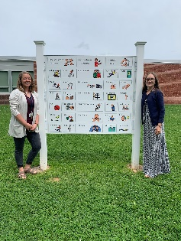
*Jodi Woleslagle and Cindy Ferguson for communication boards for JSE ($1299.77)
Smaller, laminated versions were made for speech teachers, Autistic Support and ES teachers, LSS teachers and the principals to use with students throughout the building. I'm hoping for more utilization next year, especially since we are expecting a number of students coming to JSE with communication needs!

*Stephanie Machmer for Upbeat Outreach ($600.00)
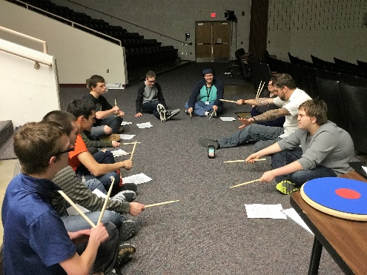
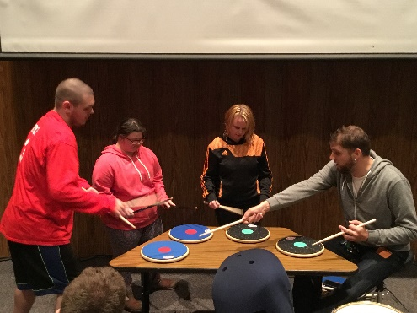
The life-skills students were visited by “Upbeat Outreach”, a drums program allowing students to get involved with drum beats and rhythms. A new twist this year was a trip to a recording studio so the students could participate in a session. Student comments included:
“I love Mike’s positive attitude and want to be like him” – David Neufer.
“Thank you, Mike, for teaching us to always stay positive. “ – Jessica Clark
“I learned that I had to have patience to learn to drum.” – Caleb Leone
“I’m so glad we get to hit the drums with you.” – Heath Neufer You Tube video - Upbeat Outreach Drumming 2022 - YouTube
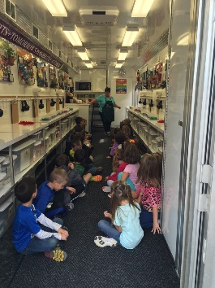
*PA Ag Science Van for all elementary schools ($10,000)
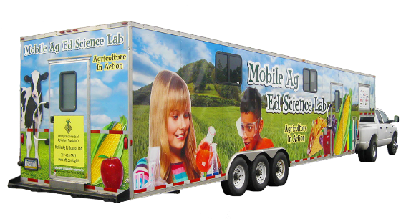
Students love going into the PA Ag Science Van. They participated in hands on lessons concerning PA agriculture and learn how important science is to agricultural careers. The Foundation paid for the ag van to spend a week at all three elementary schools and an extra week at JSE.

Anytime Grants
The Anytime grant program is a success. This grant is designed to provide up to $2000 for unanticipated and/or time-sensitive opportunities that may present themselves over the course of the school year that may not be covered by district funds or teacher mini-grant funds. This year we provided for a chemical demonstration for the 7/8 science classes, a field trip to the Bio labs at LHU for the grade 8 students and an additional $227 for the communications board at JSE.

Scholarships
Scholarships were awarded to 11 students during the June 2022 Senior Awards that amounted to $15,000 to further their education.

American Legion Post 36 CTE Scholarships -5 @ $2K
Each year the local American Legion Post donates funds for scholarships for Consumer and Technical Education (CTE) students and academic students. To date the American Legion has donated $60,000 towards the funding of Jersey Shore students to further their education in any of the trades as well as nursing and other technical fields.
The recipients for 2022 are:
Eddy Danneker – LSU – chem Conner Davis – CPI – Heavy Equipment
Donald (DJ) Steinbacher – HPU – accounting Ambria Confer – LHU - PA Program
Jenna Kramer – Pharmacy

American Legion Auxiliary Unit 36 – 2 @ $500
This is a new scholarship fund this year graciously donated by the Auxiliary Unit of the American Legion. It is specifically for individuals going into the medical professions and children of military veterans.
The recipients for 2022 are:
Liam Goodrich – PCT – Surgical Technician Miranda Paulhamus – CPI – Nursing

Gasperine Family STEM Scholarship – 2 @ 1K
STEM is the integration of scientific principles with technology and the innovative application of engineering and math. The STEM Scholarships are funded by the Gasperine Family to honor their commitment to the promotion of STEM careers. For the past six years, the family has donated $13,000 in scholarships to assist in their educational pursuits.
The recipients for 2021 are:
Karis Huff- Love – Juniata University – Bio/Pre-med Abigail Hall – Keystone College – Wildlife Biology

Jersey Shore Ed Foundation Healthcare – 2 @ $1K
Each year, faculty, staff, and administration of the JS school district donate funds into the scholarship program. There are now enough funds to begin to distribute these monies to JS graduates. The Foundation board and committee decided that more medical professionals are needed to meet the critical shortage of medical professionals as well as recent COVID pandemic.
This year’s recipients are:
Jaylynn Brooks – PCT – pediatric Nursing Jenna Kramer – Pharmacy

Foundation Initiatives
FBLA The JS Ed Foundation has supported FBLA in their various projects in the community. This year, approximately $1400 was donated to assist in the national registration payment for their trip to the National Conference and Competition.
AP Exams
Students taking AP classes and exams can receive college credit for their hard work in academia. The Jersey Shore District offers AP classes in English, European History, American History, Calculus, Spanish, Chemistry, Statistics, Environmental Science, and Calculus BC. During the 2021-2022 school year, over 40 students took at least one AP exam with the majority taking two or more exams. Since the Foundation’s mission is to enhance and enrich academics, the Foundation believes that the cost of the exam should not exclude or discourage students from taking these exams. The JSSEF is contributing a portion of the cost of the exam for students taking two or more exams to ensure all students have an opportunity to receive the appropriate college credit.
EITC Funds
This year the Jersey Shore Education Foundation was the recipient of $47K in EITC funds primarily from Muncy Bank and Trust, Woodlands Bank, PPL Electric, UPMC, FCFP, High Company and Weis Markets. The Pennsylvania Educational Improvement Tax Credit (EITC) Program is administered through the PA Department of Community and Economic Development (DCED) under Act 48. The EITC program allows certain businesses eligibility for tax credits in exchange for donations made to scholarship programs or educational improvement organizations that are based on a list of approved and published organizations by DCED.
The Jersey Shore Schools Education Foundation is listed on the DCED list of approved EITC schools. The following programs have been approved and the Foundation may accept and use funds for the Elementary STEM center, Community Garden, Skills Quest, Field Trip to Boalsburg Museum, Elementary STEAM lab, Health Sciences pathway, Mobile Ag Science Van, Artist/Authors in Residence, Trout in the Classroom, Enviroscape models, and Butterfly Garden upkeep among other programs/projects.
The Skills Quest is a program which promotes job skills in the CTE (Consumer and Technical Education) program. The Caterpillar excavator simulator was purchased last year upon which students may learn how to operate an actual excavator. The simulator “rates” each student during the practice session with a goal to make the operator effective and efficient. The total cost was $42K and included maintenance, software and upgrades for the next five years. This year, the base was purchased for an additional $21K so the experience is rather real with all the bumps and shakes accompanying the work on the excavator.
Additionally, EITC funds purchased environmental watershed models for the middle and high school, funded a sustainability garden at the middle school and materials for the elementary maker space in the library.

Middle School and Elementary STEM classrooms purchased materials through the EITC program. Specifically, the middle school spent over $6000 in materials for VEX robotics and support items. These funds came primarily through an EITC grant from PPL.

Fundraisers
Congratulations to the Senior Class was the theme for this year’s fundraiser. The Foundation purchased Senior Signs to be displayed in the yards of our graduating seniors. The signs were sold for $25 to allow our senior families to purchase one for their graduating senior. Thirty-six signs were sold to date out of fifty with the rest being used during graduation ceremonies.
Become a Donating Member of the JS Ed Foundation
The Foundation invites you to become a donor to be a hero to the students in the district. The generosity of our donors plays an integral role in funding our projects and programs.
Foundation gifts help to promote, enrich and enhance the academics currently in place in the JS District. These special gifts provide opportunities for students who would not normally be able to participate without the additional funds from the Foundation.
Remember that your donations to the Foundation are tax deductible! We welcome any support you or your group may offer.
You Shop. Amazon Gives…to the Jersey Shore Schools Education Foundation
AmazonSmile offers the very same prices, products, and services you are familiar with on Amazon, but has an added bonus. Amazon donates a percentage of your shopping total to supporting charitable organizations. Sign up is a one-time easy and quick process. Then every time you shop, a donation is made to the Foundation.
To date, the JS Ed Foundation has received over $600 in donations from Amazon Smile. Thank you to all who shop with AmazonSmile!
Restricted Funds
There are established restricted fund accounts within the Jersey Shore Education Foundation which individuals may make tax deductible contributions. The current restricted funds accounts are:
- American Legion Post 36 Scholarship – This fund provides 5 - $2000 scholarships for individuals to pursue Technical Education or academics at universities and trade schools.
- American Legion Auxillary Unit 36 Scholarship – this fund provides 2 - $500 scholarships for individuals to pursue a health care education at universities, trade schools, and programs.
- Jersey Shore Schools Education Foundation Health Care Scholarships - This fund provides 2 - $1000 scholarships for students enrolled in a health care profession at any level of post-secondary education.
- Gasperine STEM Scholarship – This fund provides 2 - $1000 scholarships for individuals pursuing a Science, Technical, Engineering and Math career.
- FBLA – (Future Business Leaders of America) – A national organization that provides opportunities for high school students to practice and hone business skills such as public speaking, Roberts Rules of Order and leadership as well as accounting and network design. The FBLA sends students to national competitions on a yearly basis.
- General Scholarship Fund – A fund that is still growing and developing. This fund is designed to allow students to apply for funding to assist in further career pursuits in post-secondary education.
- Music/Drama – These funds are specifically used for production of plays and musicals within the music and English department. This past year, funds were not used since there were no productions due to COVID.

Capital Funds Projects
Jersey Shore Education Foundation is partnering with the District to help raise funds for various school related capital projects. This fund and program is currently under development and will be included in our future plans to assist in new projects within the district.
Next Year
We are looking forward to next year to see what new projects and items which the Foundation may be able to contribute. Already, we have been approached for possibly providing funding for new mannikins for the state graduation requirement of CPR for all students. I am sure there will be more ideas. If anyone on the board has any questions, concerns or ideas or would like to see any of our projects in action, please contact the Foundation through Dr. Ulmer or Mary Thomas (your JSASD board representative on the JSSEF board). Thank you for all your cooperation and assistance through the years.
Financial Statements
The Jersey Shore Schools Education Foundation (JSSEF) is staffed by all volunteers, any expenses are kept to a bare minimum. All contributions are placed into appropriate funds as they are received. The board’s funds are subjected to an independent audit annually.
Unrestricted funds are used to fund teacher mini-grants and to subsidize a myriad of projects such as the communication boards at JSE and the special swing at JSE. Administrative expenses such as tax preparation and insurances are also taken from the unrestricted funds.
EITC funding covers projects approved through Harrisburg that go above and beyond the scope of the regular curriculum. Examples of this funding are the AP Exam fees for any student taking more than two tests, the PA Ag Van for the elementary schools and the Boalsburg trip at the middle school among other projects.
The Jersey Shore Schools Education Foundation 990 Form is posted on the Foundation’s website at https://jsedFoundation.org/.
The JSSEF wishes to extend a thank you to all who help to make our students’ educational experiences the very best that can be.

