A Parent's Guide to Handling Pandemic-Related Changes
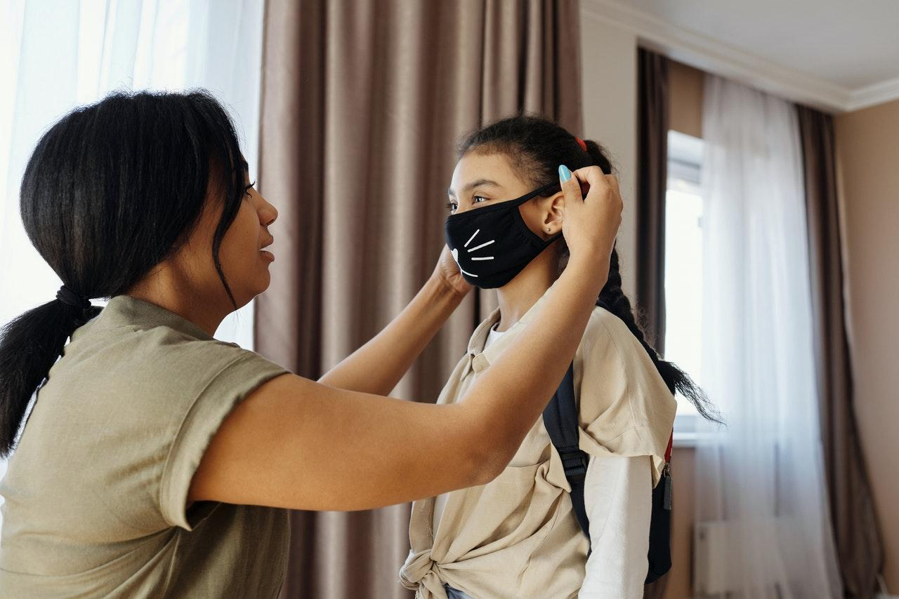
Photo Credit: Pexels.com

The impact of COVID-19 has been inescapable for most Americans. According to one PEW Research Center survey, 51% of people expect their lives to be permanently changed after the pandemic ends. While vaccines have been rolled out, the world is still adjusting to the new normal. If you're a parent, this transitional period can be especially challenging. You have your own fears and adaptations to deal with — as well as those of your children. With some effort, you can find ways to take COVID-related changes and use them for the better. Here are some inspiring tips on how you can take negative changes and turn them into positives.

Your family is more stressed than ever.

COVID-related anxiety can be especially problematic for parents who want to keep up a strong front for their little ones while grappling with their own worries. Frontiers in Psychology reports that parents' reactions to stress directly impacts children's problems. If you're struggling with the unique challenges of parenting during a pandemic, it may be a good idea to discuss these issues with a mental health professional.

You and/or your partner have lost work.

If you or your partner lost a job in the past two years, you aren't alone. COVID-19 created a global economic crisis. While job loss can be unnerving, it can also be the chance you or your loved one needs to make a positive career change and switch professional tracks. Northeastern University provides a list of signs that it's time to change jobs, such as feeling apathetic or dreading going to work. If this is how you or your partner were feeling pre-pandemic, take this opportunity to switch paths.

During the pandemic, many people have chosen to start their own businesses or begin a career in freelancing. These options allow you to work remotely from home so you can still care for your children. If you’re starting your own business, there are benefits to forming an LLC, including shielding your personal assets from litigation, tax advantages, and limited paperwork. The easiest way to set up an LLC is to hire an online formation company with the business know how to help you efficiently file the necessary paperwork.

Your current home no longer suits your family's needs.

With the trend towards remote working for adults and distance learning for kids, you may have found that your current home simply can't comfortably accommodate your entire family anymore. Don't delay moving. Like doctor's appointments and tax filings, this is the kind of change that shouldn't wait. As you research houses, keep current home design trends in mind and how much value they add to a property.

The kids are struggling with school.

Distance learning has proven to be a challenge for many kids. An education via Zoom simply isn't equivalent to in-person teaching, especially for younger children with shorter attention spans. Brain MD offers tips to help your child if they still have to learn remotely. For example, it's best to establish a daily schedule and limit screen time beyond school hours. Further, don't hesitate to ask for help. If your child has struggled to keep up with remote learning, a professional tutor may be able to help.

You're struggling to maintain a healthy lifestyle.

The COVID-19 pandemic has caused many people to lead a more sedentary lifestyle. As Johns Hopkins Medicine explains, too much sitting can be harmful to your health and is linked to a greater risk of cardiovascular disease, cancer, and type 2 diabetes. Take this moment to commit to a healthier lifestyle for you and your family as a whole. You can also commit to healthier eating — and have fun in the process — by cooking as a family.

Your family will probably experience permanent changes due to COVID-19. It's up to you to take those changes and ensure they result in positive outcomes. While this is a challenging time — especially for parents — there are many resources available to help.

Tri-County Family Care Center is committed to educating and empowering families and individuals and connecting them with various community services and resources.

