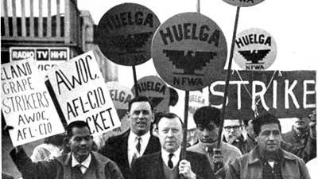

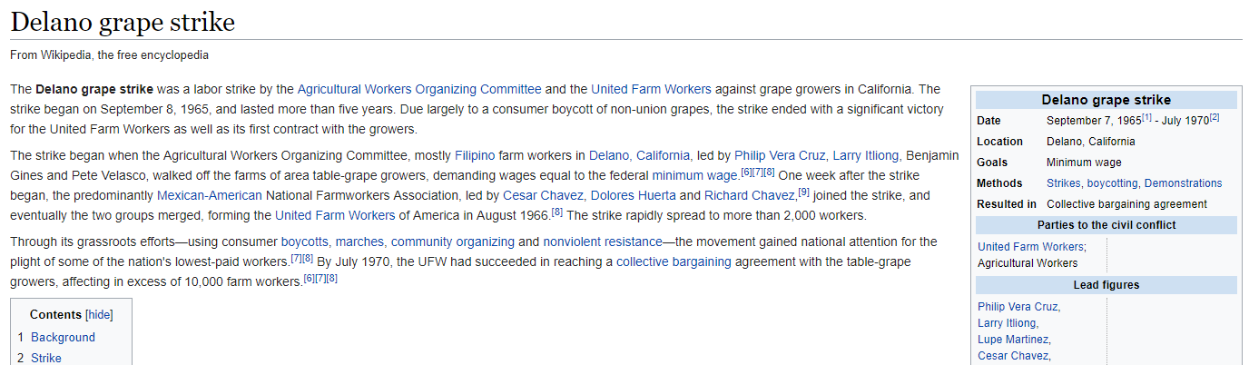
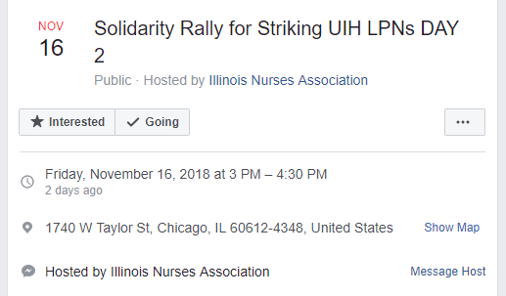
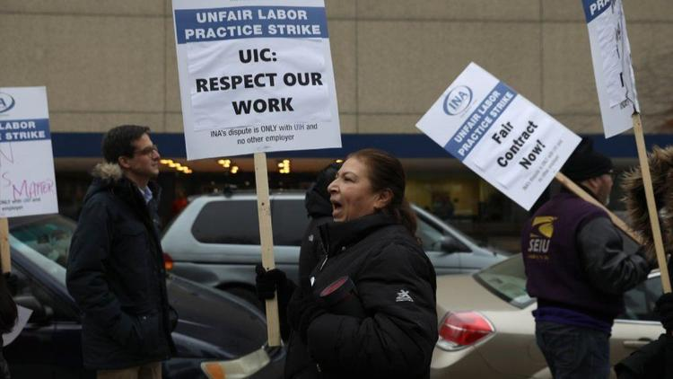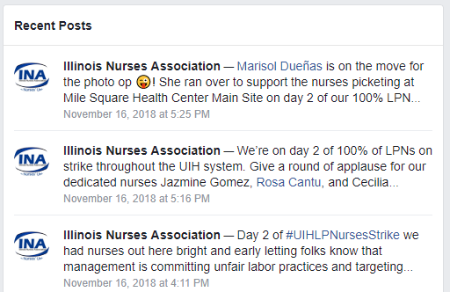
Yesterday, the Licensed Practical Nurses (LPNs) at the UI Hospital, who are part of the Illinois Nurses Association, went out on strike. The LPNs are mostly Black and Latina women, there are only 35 of them, they're paid far below the average starting wage of other LPNs in Chicago, and the University is trying to force them into accepting a second-class contract. They're still on strike today and will be holding a rally in front of the UI Hospital (1740 W Taylor) this afternoon at 3pm, which GEO members are encouraged to attend to show solidarity.

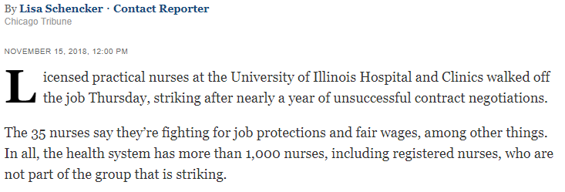

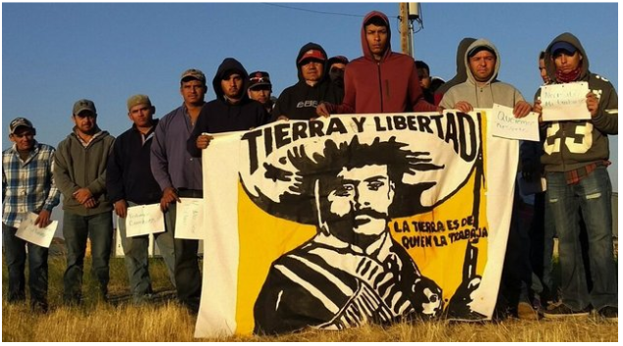

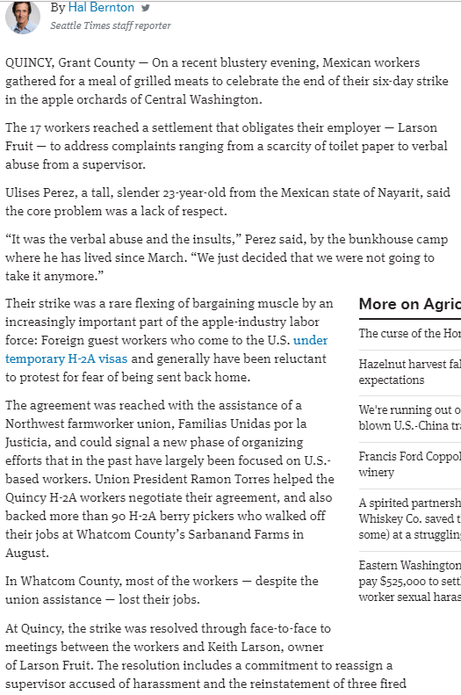
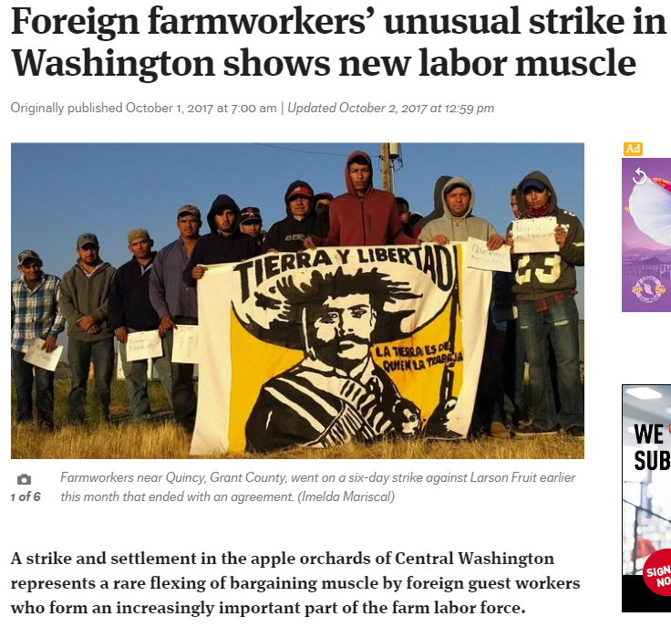

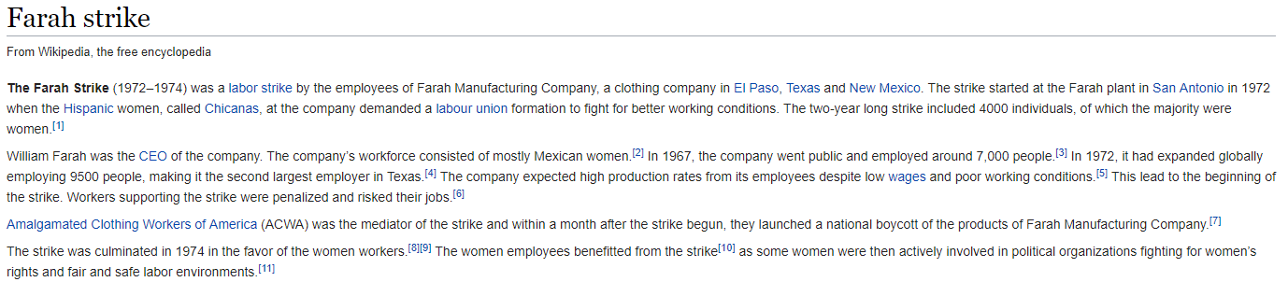

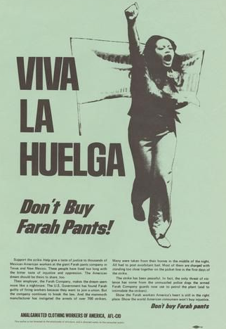

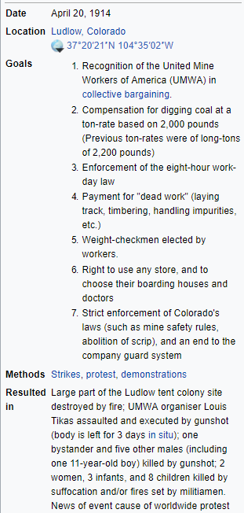
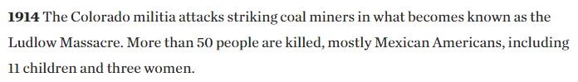
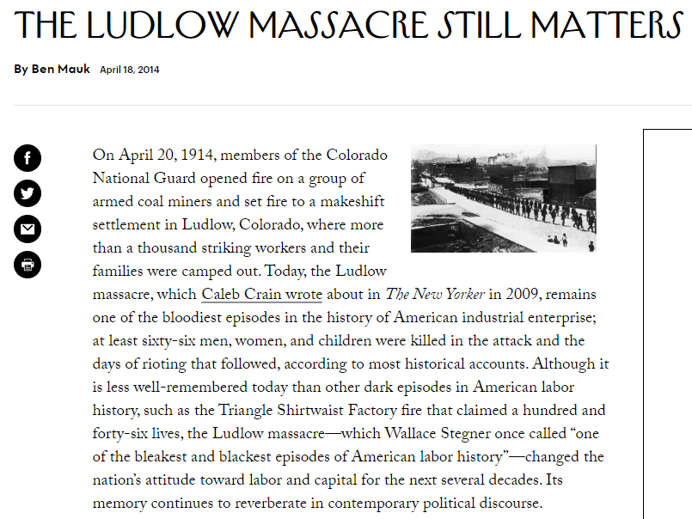
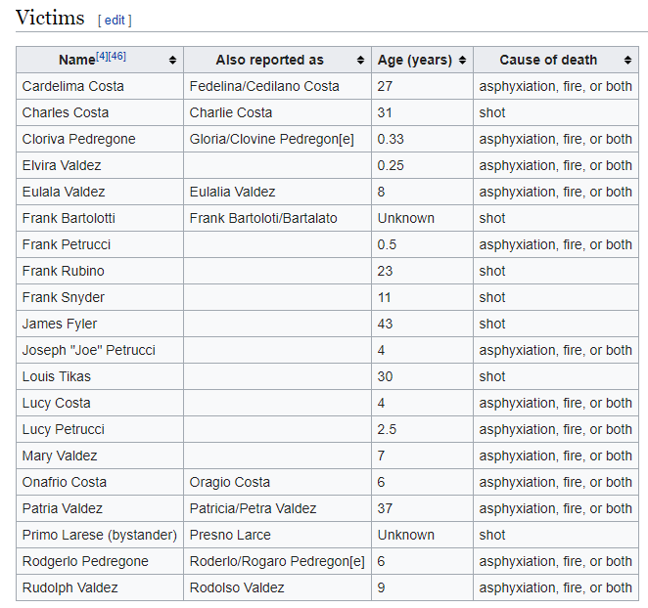

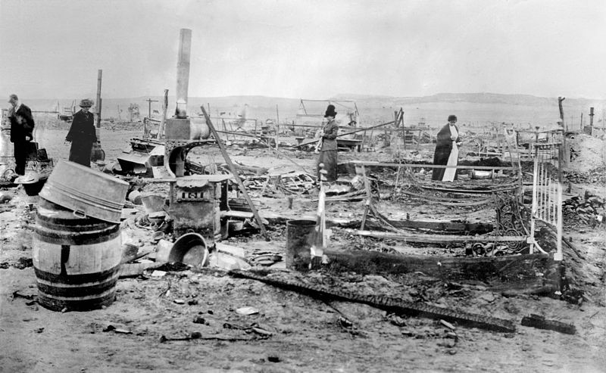
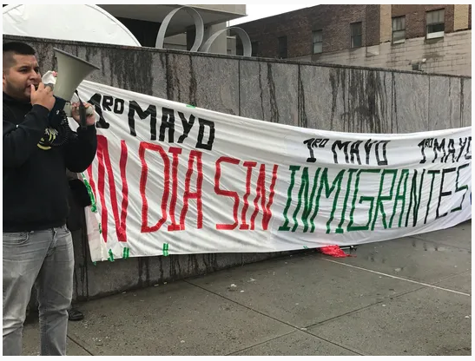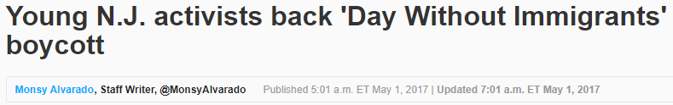
Catalina Adorno has spent weeks on the road living out of a small suitcase and sleeping on an inflatable mattress as she traversed the Northeast talking to farm workers in Maine and restaurant employees in Maryland about a boycott on Monday aimed at bringing attention to the economic and labor contributions of immigrants.
Adorno arrived last week in North Jersey, near where she was raised in Union City, but said she wasn’t sure where she and other organizers of Movimiento Cosecha would sleep that night, saying they needed to stick together and strategize as the day of the “huelga,” the strike, approached.
“We have an inflatable bed, so as long as there is space we have a place to put our mattress,’’ she said. “These last couple of weeks we have been staying in the houses of allies of the movement who want to support us.”
Adorno, 26, who will receive a master’s degree in science education from Columbia University later this month, is among 24 full-time unpaid community organizers who have joined Movimiento Cosecha, which translates into the Harvest Movement. The national immigration rights coalition is supporting undocumented immigrants as they coordinate strikes and protests in at least 80 cities across the country. Of those 24 full-time organizers, six have ties to New Jersey. A part-time organizer and Adorno's brother, Li, also resides in the Garden State.
The members of the New Jersey contingent all have personal connections to the cause of undocumented immigrants, whether it's themselves now or in the past or a family member or friend living in the country without legal status. All are college graduates and knew one another from previous immigrant advocacy work they had done for organizations in New Jersey. Most left full-time jobs to join the movement within the last year or two.
"Regardless of the respective organization that we all have worked for, we have all maintained a deep friendship, and that has always kept us connected,'' said Juan Orjuela, who grew up in Lodi and works in Minneapolis as a member of the group's mobile team. "We kind of shared the same distaste with what was happening in the immigrant rights movement, and we all stumbled upon Cosecha with each other."
The organizers are preparing for “Un Dia Sin Inmigrantes,” or “A Day Without Immigrants,” on Monday, International Workers' Day, when immigrants and their allies will not go to work or school and will abstain from shopping as a way to show the public the country cannot function without the immigrant workforce, organizers said. They say Monday’s strikes will be part of a series of actions, protests and boycotts that will be planned in the future — all leading

