Building a Stub End Terminal – Part 2 Jeff Lee. MMR

Laying track, wiring, and signals

The mock up for the structures is progressing and some of the structures are being scratch built, but first we need to complete the track and wiring.

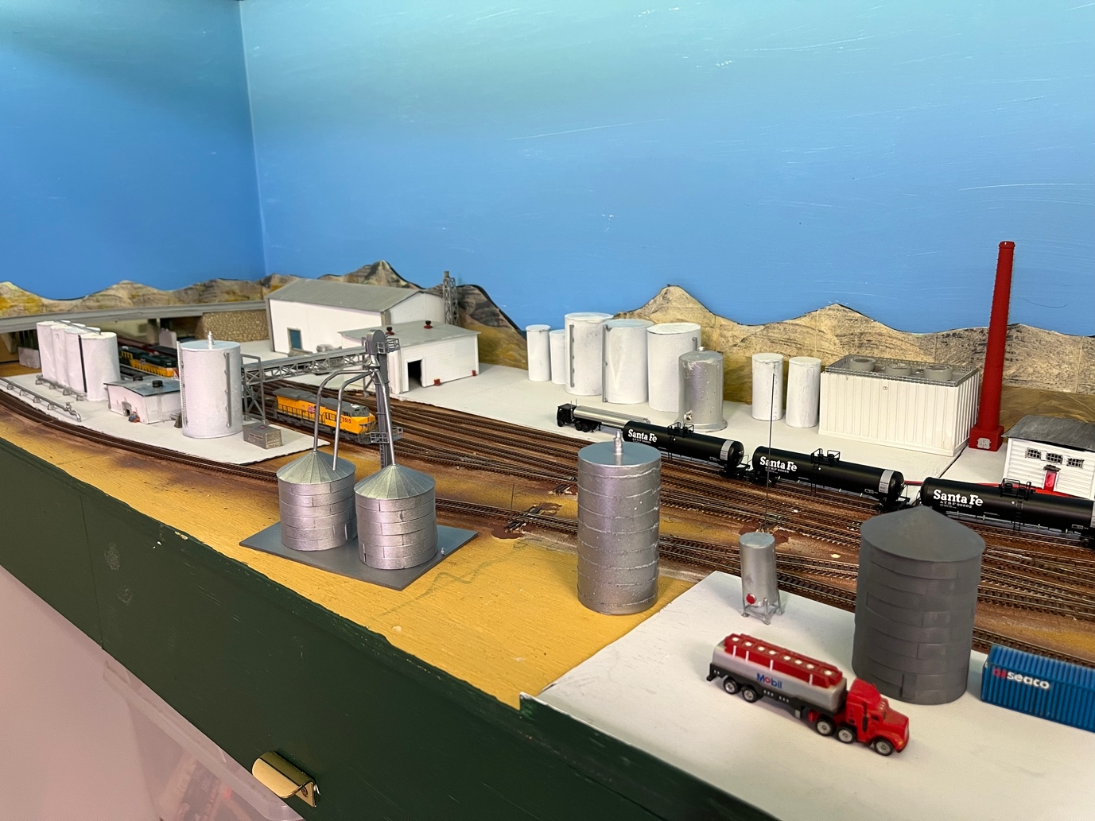

In the first part I shared the planning considerations, for my ethanol plant and some of the challenges I still had to face. I will describe these approaches below.
I am building a stub-end ethanol terminal on a 1800x500mm removable plywood base. Because it is removable, wiring and placement of the circuit boards like frog juicers, change significantly from a permanent layout. Most controls on a portable layout are attached to the underside of the base board. On a permanent layout you can attach controls anywhere – within reason. I want to have the minimum connectors between the removeable base and the permanent layout. However, there are basics such as the bus wires that need to connect to the main layout. Follow on and I will describe my journey and some of the challenges and lessons learnt.
On my permanent layout, I have most of the wiring and electronics at the front of the layout behind pull down fascia panels. This works well, but it is not what will work with a portable layout. With a portable module most of the wiring and electronics (like frogjuicers) will be attached to the underside of the baseboard.
After successfully laying the cork roadbed, I am now going to lay track. As well as laying track I also need to consider where the bus wire will be best placed, how to power the frogs of the switches, and wiring for signalling. Logically the bus wire goes under the main lines. However that is also where the servos to control the switches will be positioned.
As you now know I planned to make this as portable / modular, as possible, so we don’t want a large number of wiring plugs. The more controls I can attach to the underside of the shelf, provided they do not impinge on the frame, the better.
I also wanted to extend the 12V DC, 16V AC, and 5V DC bus wires to the module. To do this I used a 6 pin terminal connector and ran the six wires at the rear of the module base. The bus wires are stapled to the base board and terminated by screwing into a terminal strip at the end of the module.
Track Wiring and Feeders:
One of the lessons most of us have learnt is to wire every section of track to the DCC bus. I prefer to attach the wires under the rails of the track. The benefit is they are not visible when the track is laid. Some considerations are that you need to drill the holes for the feeders at the right location, but that can be fixed easily – see on. Another consideration is that in order to solder the wires you have to remove a couple of sleepers. The removed sleepers can be sanded down, so they slide in under the soldered wires when laying the track. Soldering the feeders involves using flux on the rail bottom and the feeder wire to connect to the rail bottom. Then both the wire and the rail is “tinned” with a little solder. If the soldering iron is hot then the solder should flow in a second or two and not harm the plastic ties. Once both parts are tinned bend the wire, place on to the rail and touch both with the soldering iron. It should not be necessary to add additional solder. If you do need more solder keep the amount of solder small. Here is a section of track with feeders soldered.

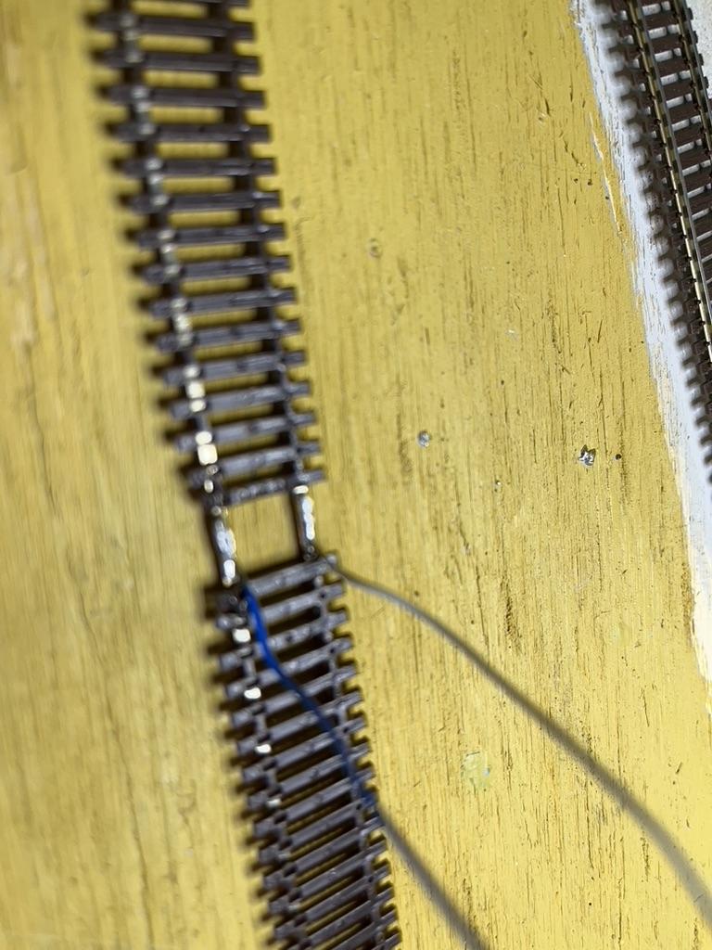
As well as wiring the track each switch / turnout should ideally be wired. Relying on the track connectors to power the rails is not a good long-term solution as many of us have discovered. I follow a basic wiring standard. Blue wire is the back rail, white is the front and green is the frog lead. Below you can see the switch soldered with track feeders and the frog lead also soldered. Attaching the stock rails to the point rails ensures power is available to all rails of the switch and you are not dependent on the rail contact for power, even though Atlas switches have a connector already wired in., and this is still a good solution. Atlas switches also have the frog lead ready for attaching a wire.
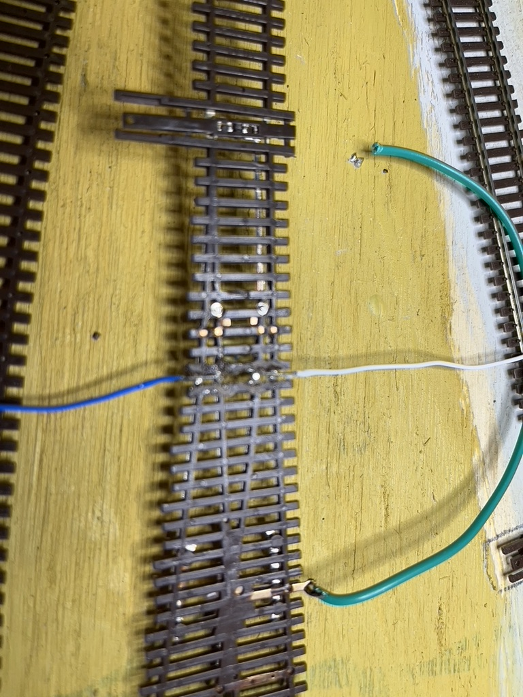

- Laying the track:
Once the track and switch feeders are soldered, I connected up the tracks. Metal rail joiners are the most common, but insulated joiners are needed where switches face each other. There are variations on wiring depending on the brand of track so follow these guidelines as to where to put insulated rail joiners. Joining the tracks allowed me to see that all sections of track were aligned and also, where the feeders would go through the baseboard. At this stage I marked all the holes for the feeder leads with a “Sharpie” black pen. Then we drill those holes for the feeders. The next stage is to insert all the feeder wires and assemble the track prior to gluing down.
As I will be using servo motors to power the switches, I needed to drill a hole under the throw bar for the wire connection to the servo. At this stage I drilled a 10mm hole under the throw bar position. This is more than needed but once the servo is installed and working the hole can be minimised with thin styrene, cut to protect the throw of the servo wire.
At the connection between this portable section and the mainline I needed to secure the tracks robustly. It is key that the tracks at the connecting points are securely attached, so once the base board is in position the tracks are also aligned and will not move. To do this I used several circuit board sleepers soldered to the rails at both sides of the joint. Near the junction between the permanent layout and this module I removed some of the plastic sleepers on both sides and replaced with circuit board sleepers. These circuit board sleepers will hold the rails in gauge. I soldered the circuit board sleepers to the rails. Of course, you need to ensure the circuit board sleepers are isolated so there is no short. A quick file across both sides of the sleeper to remove the copper, will ensure there is no short. The Bondcrete will attach the sleepers firmly to the roadbed. Once secured I will cut the rails at the gap with a fine razor saw., so we can remove the module

I start the gluing of the track at one end. Instead of PVA white glue I used Bondcrete which is a thicker similar product that is also waterproof when dry. I had drilled all the feeder holes and fed the wire feeders through the holes. For each section I raised the tracks above the cork roadbed and if they did not support themselves on the feeder wires, I added some “chocks” to keep the tracks raised above the cork roadbed. Then I squeezed a film of Bondcrete over the cork roadbed. Using a paint brush, I spread the glue evenly and then pressed the tracks down. Once the track was aligned using a straight edge and eyesight, I used a combination of weights and pins to hold it down. Bondcrete dries within an hour but reaches maximum strength in 24 hours, so I left it for 24 hours before progressing.
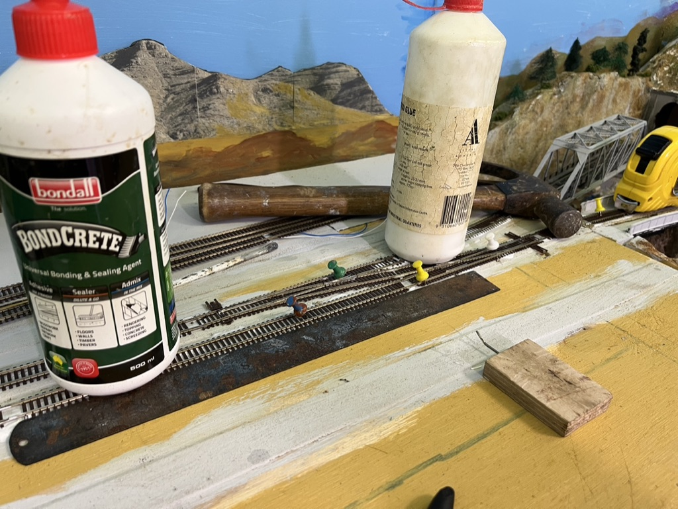

The next sections were similarly glued down, and left for 24 hours.
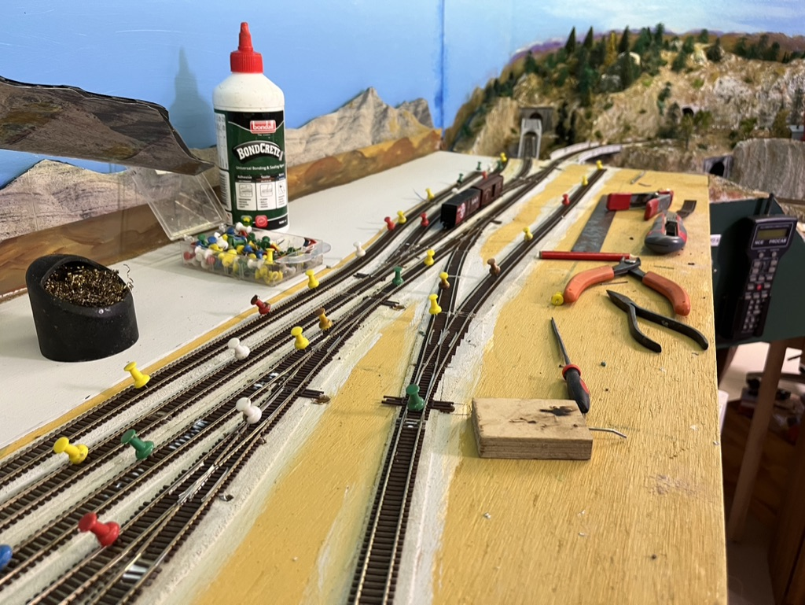

Once all the track was glued down I cut the two tracks leading into the terminal with a fine razor saw, and removed the module to wire the feeders.
One advantage of a portable layout is you can remove it and flip it over to solder the wires.
Here is the underside of the ethanol module. I attached the bus wires (Blue for back feeder and white for the front feeder) to the baseboard using a staple gun. It is easy to solder the track feeder wires to the bus whilst sitting on a stool. It certainly beats getting under the layout to solder or connect wires with Suitcase or T-Tap connectors.

I used a “workmate” to hold the module, and this made wiring much easier.
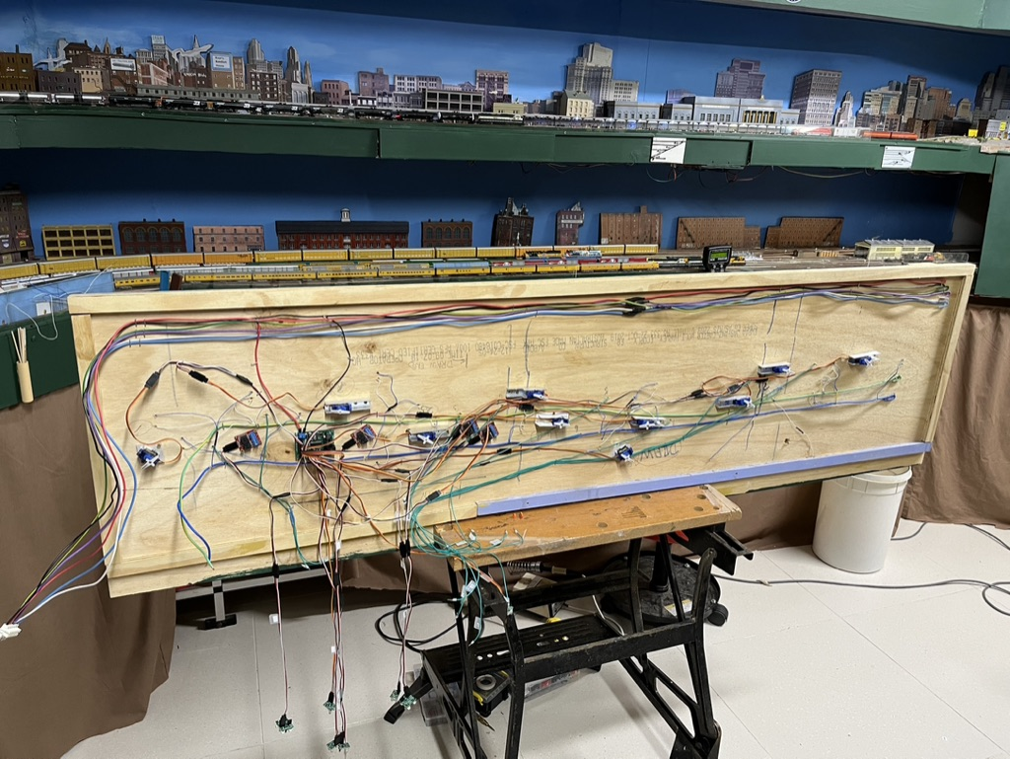

One lesson is to always label wires and controls. Each of the servos are numbered. Servo wires to the control panel are also labelled / numbered. It doesn’t take a lot of time now but will save hours later.
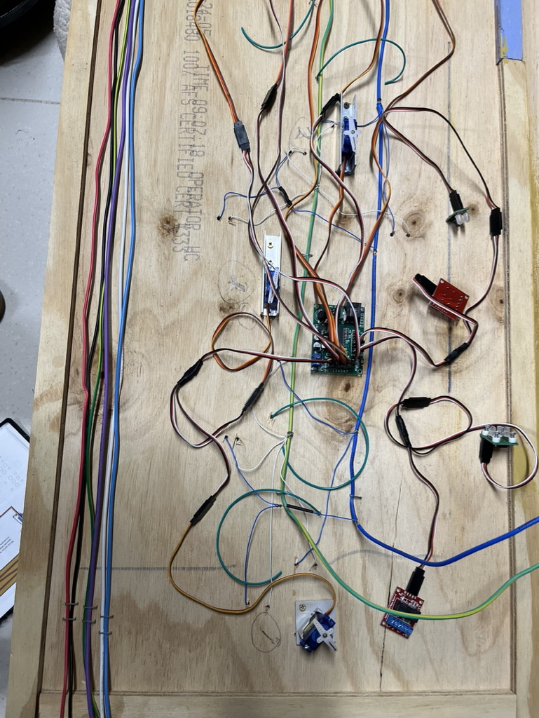

The next step was to return the section and test. The bus wires connect to the Power District circuit breaker and Tam Valley reversing switch (Dual Frogjuicer) via lever wire clip connectors purchased in bulk from Amazon.

Connecting up the bus wires and turning on the power district we had our first test. Bingo, it worked! I have an on-off switch for every power district. This on-off switch is labelled and simple to isolate that section of track. This is a key feature which I strongly endorse. When a short occurs on the layout, and they sometimes do when a train runs a switch the wrong way etc, turning off every power district and turning them on one by one will identify where the short is.
However, even though we appeared OK, I discovered a couple of areas to fix.
- Solder had spread from one of the connections to the track and flowed up the rail causing cars to jump. A quick fix was done with some filing. Once fixed the area was vacuumed to remove any possible metal filings that may find their way into motors.
- In 3 locations the rail gap was more than ideal. I used 0.6x0.8mm Evergreen strip styrene. This was super glued into the gap and allowed to dry. Once dry using a sharp new blade the strip styrene was trimmed.
After that and some more track cleaning the new track worked well. This is a critical time. It is tempting to move forward but ensuring all the track is smooth at this stage is important as I have learnt many times. Fixing uneven track once scenery is completed is much harder than at this stage.
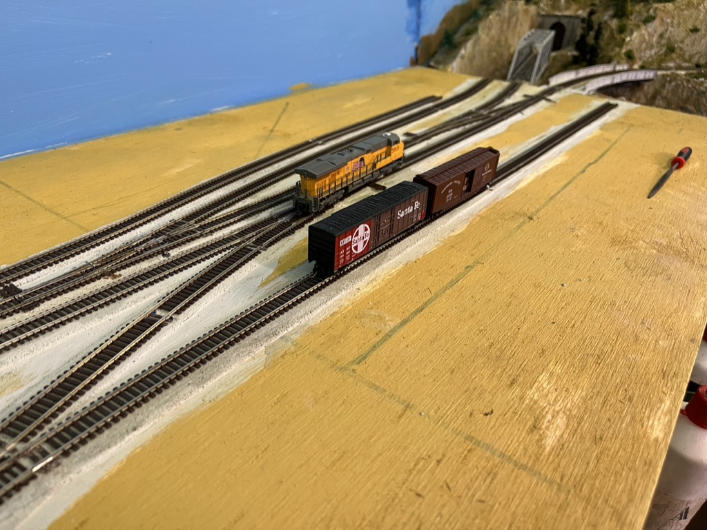

2: Track Painting:

Now the track seemed to be stable, it was time to paint the rails. The first stage was to use masking tape over the switch throw bars. This is key to ensure the contact between the throw bar and stock rail remains free of paint to ensure electrical connectivity.

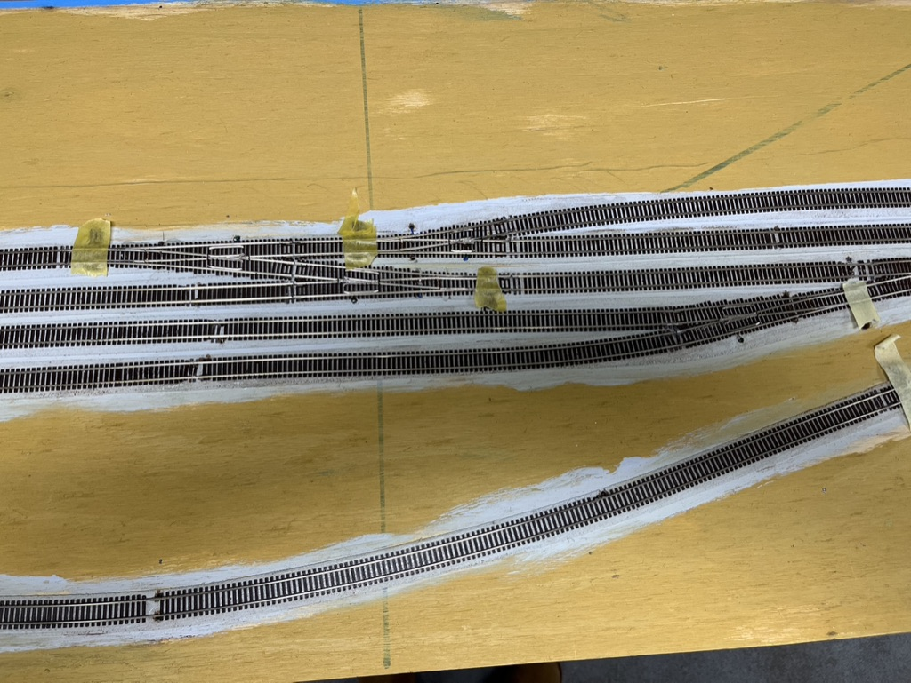

I used Rustoleum Terrain spray paint in a “rattle can” to paint the tracks. The paint can dry quickly so I did the layout in 3 sections. Once the first bit had been sprayed it was time to clean the tops of the rails.
I used an old rag, and where it became difficult to remove the paint, I added a little mineral turps to the rag.
Then we slowly progressed with more spraying and cleaning.
Below is me cleaning the tops of the rails:
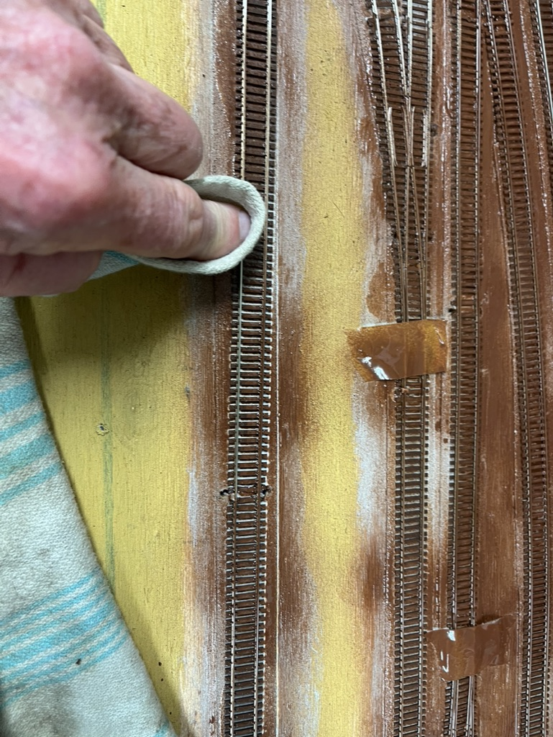

Here is the painted track.
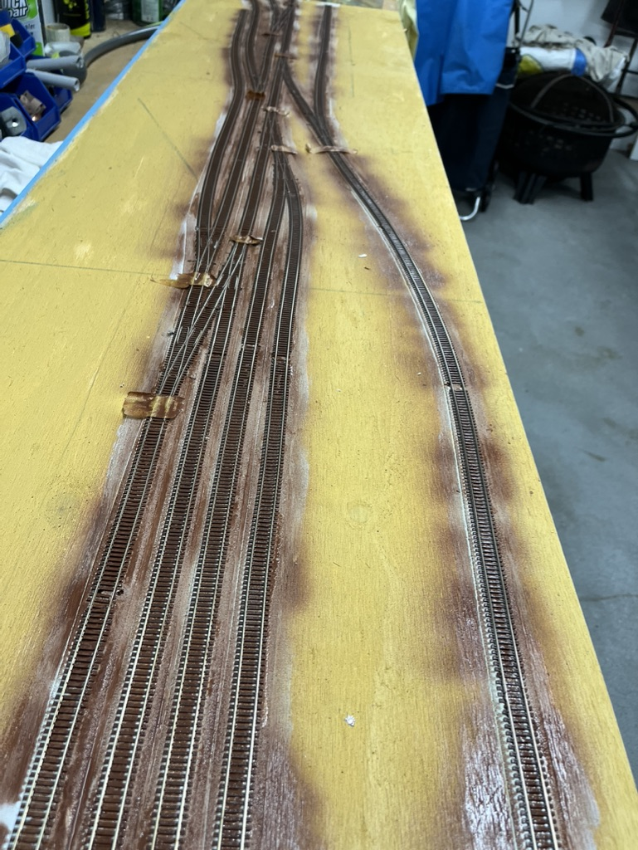

Once the rails were cleaned again it was worth checking the tracks worked well again. Yes they did with a few small sections to clean.

3: Installing Servos:
The next stage is to install the servos to control the switches, set up a push button panel on the fascia, install the “Frogjuicers”, and test.
I worked out which switches I needed to signal. I decided to use relays attached to the servos to set up the signals. Signalling would be simple. If the switch was closed to a line, the signal would be red. If the switch was open it would be green.
Another method of controlling the switches and signals is to use Double Pole Double Throw (DPDT) slide switches. This is cheaper than servos (or Tortoise switch machines). However, I decided to have all switches (10) controlled by servos with a push button panel on a track diagram.
If I was recommending track and controls, I would prioritise using Peco Code 55 and manual control. Peco switches have a spring that holds the switch when thrown. This would be cheaper than my method with Atlas Code 55 rail, and servos and controllers. On a “narrow” terminal like this all the switches are accessible for manual operation.
I used Tam Valley servo controllers. My servos are purchased via eBay. There are many ways to mount the servos. Several members have made 3D printed mounts. I used 16mm aluminium channel, as below, There is a small 2mm hole for the servo wire and two holes at the other end for screwing to the baseboard.

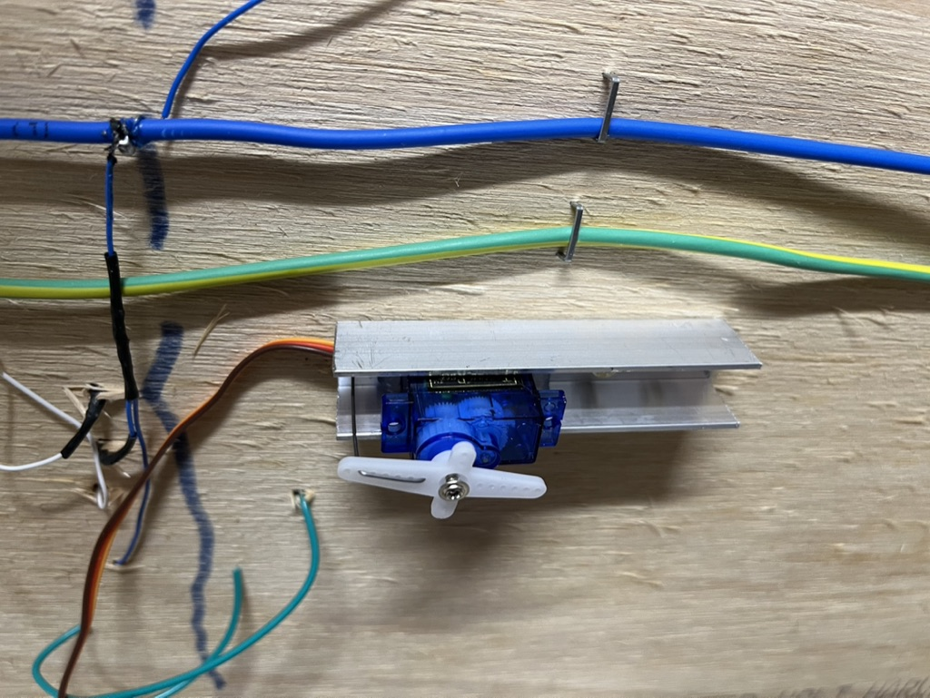

I ensure the servo is secure in the channel with silicone adhesive.
The servo will come with the lever centered, however it is preferably to double check this. Tam Valley offer a tool to do this, or you can use the servo controls on the board.
To attach the servo and channel I use double sided tape on the bottom of the channel. The throw rod is inserted into the throw bar of the switch through the hole previously drilled. Once centered, the servo is screwed to the base through the drill holes in the channel.
On the switches I decided to signal, I attached relays to the servos. My LED signals can take 12 volts but I found 5 volts gave sufficient light.
Adjusting servos can be time consuming but once set up they work fine with minimal maintenance.

4: Fascia Panel:
I used Tam Valley push buttons for the servos and switches. Each of the servo leads were labelled and numbered. Hey, do this, you will regret it later if you don’t. My simple method is to print out the numbers and once cut out attach them to the wires with clear scotch tape. There are commercial labelling products as well but this works and is cheap.
The fascia panel is 2mm thick styrene. This was spry painted black. I drew the track diagram and used 2mm masking tape to lay out the track plan. Then the panel was spray painted white. Once dry the masking tape was removed. Using a template for the push button controllers I drilled the holes for the push buttons.
Here is the panel with the push buttons installed. Note that all the switches are numbered. This is power district “4”. So, the switches go from 401 to 410, and the leads are similarly labelled. The numbers on the panel are printed on a laser printer and glued on with white glue.
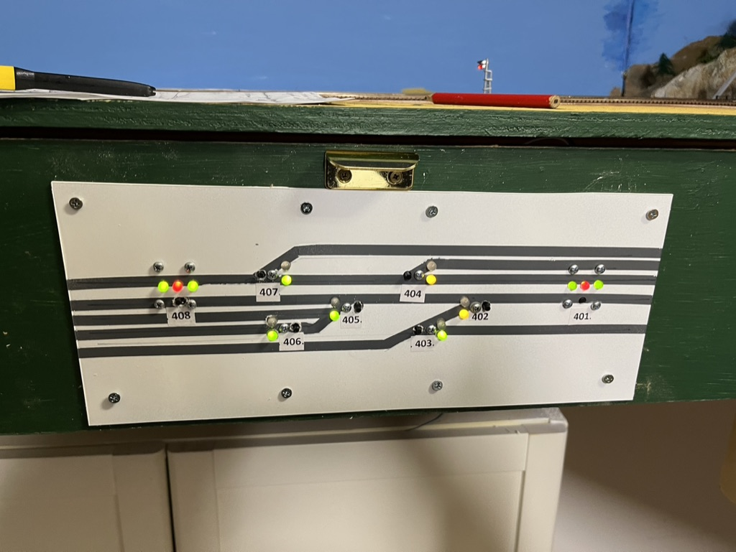

Here is the back side of the panel showing the frog juicers and the reversing circuit.
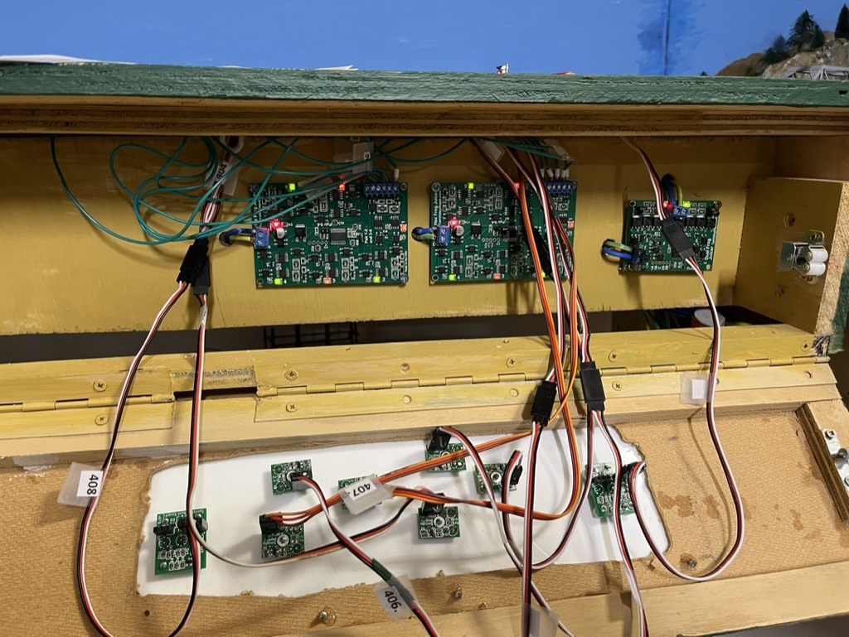
A key lesson I would suggest is patience. Check the wiring and controls consistently. You will probably be OK but running a loco and checking every switch will ensure future reliability.

In the next episode I will describe what I find more enjoyable – building structures and scenery – but only if you get the track and controls working 100%.

