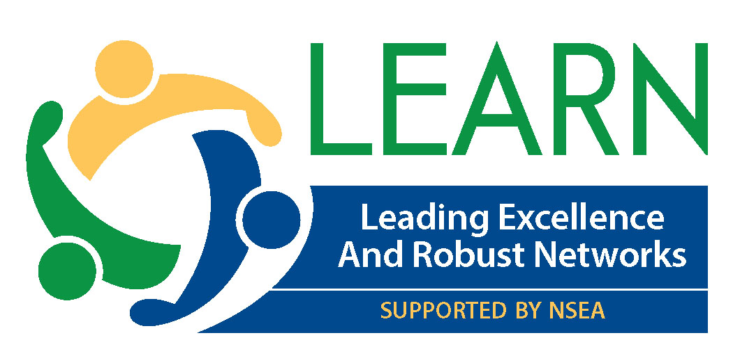

New Non-Profit to Benefit Nebraska
Educators, Students and Schools

Lincoln, Sept. 26, 2017 – A new non-profit has been formed to provide professional development for Nebraska teachers. The Leading Excellence and Robust Networks (LEARN) program, which is funded by the private sector, will bring cadres of teachers together to talk about trauma informed classrooms, teacher leadership, classroom management, community outreach, innovation and other topics that will increase student success.

“The goal of LEARN is to empower education professionals across the state to provide an excellent education for every student,” said Jenni Benson, president of the Nebraska State Education Association (NSEA). Benson said LEARN is supported by the NSEA because “it is important that teachers lead professional development efforts.”

“We have a profound obligation to be the quality control guardians of our profession,” said Benson. “It is the best way we can make sure that teachers have the tools they need to help every student reach his or her potential.”

LEARN programs will be delivered in a “blended learning” format. Activities will be offered both in person and through web-based networking programs such as Zoom, said Maddie Fennell, NSEA executive director.

TEACHER LEADERSHIP SUMMIT
The first LEARN event is a one-day summit focused on teachers leading innovation from the classroom out. Any teacher in Nebraska with an innovative idea for education is encouraged to apply.

“Innovative ideas pop up on a regular basis, but often die for lack of follow through, adequate planning, funding, administrative support or a myriad of other reasons,” said Fennell. “Now, through the LEARN 501(c)3 program, Nebraska educators from all corners and locales can propose such ideas and get the guidance and assistance needed to get the idea off the ground – and begin to transform education in the classroom.”

The key assistance will come at a one-day Powered by Teach to Lead Teacher Leadership Conference in Kearney on Saturday, Dec. 2. All educators with an idea that might strengthen or improve a classroom, school building, school district – or even public education on a statewide basis – can submit that idea no later than Sunday, Oct. 22, at this website: http://bit.ly/NE-LEARN

There is no registration fee, meals will be provided and most travel costs will be covered. Any Nebraska educator who wants to work with a team to make their idea reality is encouraged to apply. When invited to attend, they will determine the composition of their team which could include administrators, parents, students, other educators – any five stakeholders necessary to move from idea to action. The only requirement is that there must be at least one practicing teacher on the team.

The team will leave the Kearney conference with a fully-formed logic plan and action steps to enact back in their classrooms and schools.

APPLY TO ATTEND SUMMIT
Here’s how the LEARN Summit will work: A Nebraska educator has a great idea that they believe will strengthen education at the classroom, school, district or state level.
- Talk about your idea with others for their feedback and support.
- Apply to attend the Summit by Sunday, Oct. 22, at http://bit.ly/NE-LEARN
- A team of practicing educators reviews all ideas and selects those they believe will have the greatest impact or potential for success.
- If chosen, you will be given about two weeks to put a team of five stakeholders together. Team members can be other educators, administrators, school board members, parents, legislators or students. The applicant gets to select the key team members.
- The team is paired with an expert in strategic planning.
- The team learns more in a pre-conference webinar.
- The team meets in Kearney on Dec. 2 to develop a strategic plan utilizing the expertise of a national trainer.

LEARN is an IRS approved 501c3. All gifts are tax deductible. Find out more at https://learnnebraska.org/

More about Teach to Lead
Over the past three years, Teach to Lead has helped drive a national conversation on teacher leadership and helped teachers turn their leadership ideas into action. The National Board for Professional Teaching Standards, ASCD and the U.S. Department of Education have been joined by more than 100 supporting organizations in this critical work. It is Teach to Lead’s mission to expand opportunities for teacher leadership by providing resources, facilitating stakeholder consultation, and encouraging professional collaborations to develop and amplify the work of teacher leaders. http://teachtolead.org/

Teach to Lead Vision
Teach to Lead envisions a world in which teachers are valued as the foremost experts in instruction, and as such, are leaders of informing, developing, and implementing education policy and practice to steer systematic improvements to benefit student learning.
Teach to Lead Mission
Teach to Lead expands opportunities for teacher leadership by providing resources, facilitating stakeholder consultation, and encouraging professional collaborations to develop and amplify the work of teacher leaders.

For more information, email info@nsea.org or call 402-475-7611 or 800-742-0047.

