You get what you pay for
LAST UPDATED ON MONDAY, 8 OCTOBER 2012 08:37
WRITTEN BY STONE51
MONDAY, 25 JUNE 2012 11:13

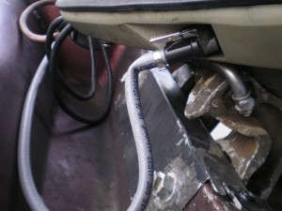
Grey hose is a no no …. At this point there is no substitute for fuel lines (inculding bulb’s) other than OEM marine grade fuel hoses. In short, do not use the grey hose made by Tempo or Attwood, found at Academy or Wal-Mart. They kink & crack and we have found they are not compatible with today’s ethanol fuels. The result is hurting your motor by either putting containments in your carburetors or starving your motor of fuel.
TAGS: ATTWOOD, BAD GAS, FUEL LINE, GREY HOSE, MOTOR DIES, MOTOR STALLS, TEMPO

