Low water pick-ups – there are some disadvantages!
LAST UPDATED ON MONDAY, 4 FEBRUARY 2013 11:31
WRITTEN BY STONE51
WEDNESDAY, 12 DECEMBER 2012 03:15

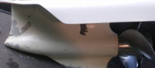
Low water pick-ups – there are some disadvantages!
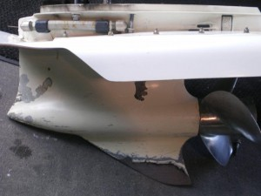
Low water pick-ups on the lower unit have their place in shallow water applications.
Low drag and better hole shot allow the boater to get on plan faster, in shallow water.
But there are some disadvantages to having one, and most don’t find this out until their boat is in the shop.
It’s nice having bragging rights as to just how shallow you can go. But most do not have the patience to simply putt out a little deep before punching it. Your motor is not designed to run on mud & sand! It’s supposed to run in water, with enough depth for your lower unit to pick up water.
Keep in mind the modified intakes (on low water pick-ups) on outboard motors are large enough to allow grains of sand & shell into your water pump and like sand paper this is grinding your internal water pump wear-plates. As a result, you are losing water pump pressure.
This is the case not only with low water pick up type gear cases but any outboard that you run or plane on the bay bottom.
E-Tec has OEM high intake screens you can install, but you allow more trash in, with the added changes.
It is recommended that you change your water pump EVERY YEAR if you find yourself mainly fishing in shallow waters, with these modifications.
Normal maintenance: Would be to change your water pump every 2 years needed or not. (with minor use)
NOTE: never just replace your Impeller, as you will only be doing half of the job.
The below picture a great example of the pit falls of a low water pick-up on a bay boat.
This is the water pump wear plate is off of a 2008 115 E-Tec Evinrude with only one season on it.
Most of the water pump pressure was lost due to the groves that developed in the cup and plate of the water pump.
Another TIP if you are not sure how much time you spend in the shallows: Take a look at your skeg, how much paint is missing and how much smaller is it than when it was new?
This is a good indicator as to just how much abuse you are giving your water pump.
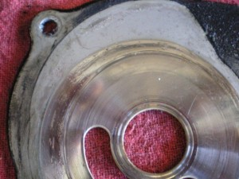
TAGS: BOB'S LOW WATER PICK UP, BOB'S MACHINE SHOP, BOBS LOW WATER, INTAKE SCREENS, LOW WATER INTAKE, LOW WATER PICK UP, TRP YAMAHA, WATER PUMP, WATER PUMP MAINTENANCE

