Easy prop maintenance
LAST UPDATED ON TUESDAY, 2 APRIL 2013 08:50
WRITTEN BY STONE51
TUESDAY, 2 APRIL 2013 08:48

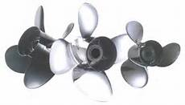
It’s easy to forget the simple things.
Removing your outboard propeller to check the shaft for line is one of the easy things you can do to help protect your motor.
Below, this customer ran over a jug line.
He thought he was doing the right thing by cutting off the line, but he failed to remove the prop to inspect the prop shaft. This photo shows the result of not the properly doing the right maintenance. The rope melted into the prop shaft seal and removed the seal from the seal carrier letting water into the gear case. The result was a larger repair, and big hit to the wallet.
Don’t forget to remove your prop often to inspect for “God knows what” might be wrapped around your prop shaft.
More often we see fishing line doing the damage. Fishing line is everywhere we take our boats, and it causes damages to hundreds if not thousands of boats every year.
TAKE THE TIME TO REMOVE YOUR PROP FOR AN INSPECTION AND WHILE YOUR AT IT CHECK YOUR LOWER UNITS OIL CONDITION.
We want you on the water and not in the shop.
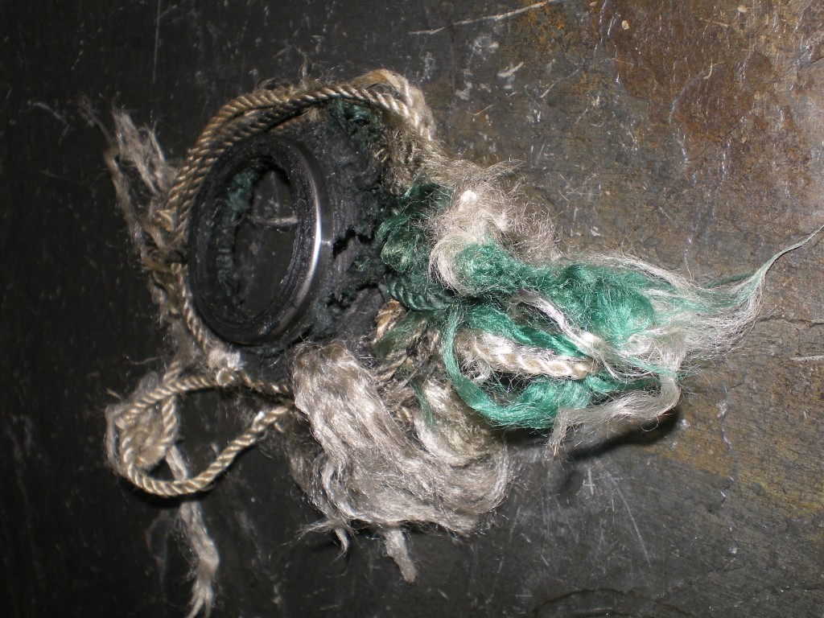
TAGS: EASY OUTOBARD MAINTENANCE, LOWER UNIT DAMAGE, LOWER UNIT MAINTENANCE, LOWER UNIT SEALS, OUTOBARD MAINTENANCE, PROP MAINTENANCE, PROP SHAFT, PROP SHAFT ISSUES, WHAT TO DO ON AN OUTOBARD

