Fuel Filter
LAST UPDATED ON WEDNESDAY, 30 MAY 2012 04:01
WRITTEN BY STONE51
WEDNESDAY, 30 MAY 2012 03:59

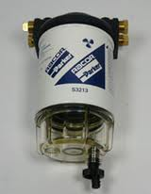 Being on the water is fun, having water in your fuel is not. Boat engines require clean, dry fuel, a challenge with today’s ethanol fuels/ gas.
Is your fuel system compatible with ethanol blends? Could your deteriorating fuel lines be causing further damage to your motor?
At Stone and Sons Marine, our mechanics are certified and factory trained to look for problems like this. If you catch it early you could SAVE tons of time & money on future repairs.
TAGS: BAD GAS, ETHANOL, ETHONAL, FILTER, FUEL FILTER, FUEL LINES

