Water in your fuel can cause all kinds of issues
LAST UPDATED ON FRIDAY, 19 APRIL 2013 11:37
WRITTEN BY STONE51
FRIDAY, 19 APRIL 2013 11:35

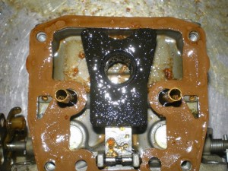
Not a pretty site
This customer complained about low power with his outboard.
He told us he just rebuilt his carbs, installed new plugs and replaced all fuel lines.
Still his motor did not have full power and had poor idling quality.
In this case he would have done himself justice to take a fuel sample as part of his due dalliance.
Our advice is to install a glass or clear in-line filter to keep check on water in the fuel system.
This makes for cheap insurance.
At Stone and Sons we cater to do-it yourselfers and will help you the best we can with any technical support you might need to perform your own repairs.

TAGS: FUEL FILTER, OUTBOARD IDLING, POOR IDLING, WATER IN BOAT FUEL, WATER IN CARBS, WATER IN GAS

