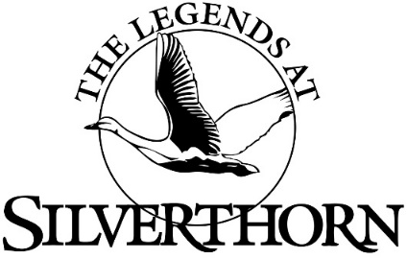
Sunday 9:00 am -5:00 pm
For take-out orders please call 352-799-4653 ext 106
Breakfast 9am -1pm
Your Way Omelet Three Eggs with choice of toppings: Ham, Sausage, Bacon, Onions, Peppers, Tomatoes, Veggies, Cheddar, Swiss, American, Mozzarella served with Home Fries or Hash Browns…………………………………………….12.48

The Legends Club Breakfast Two Eggs any style, served with Home Fries or Hash Browns, Bacon or Sausage..10.40
Fried Eggs, Ham & Cheese Sandwich (sub Bacon add $2)……………………….…………………………………………….……….6.24
Breakfast Burrito Eggs, Cheese, Ham or Sausage (sub Bacon add $2)………………….…………………..…………………….6.24
The Legends Breakfast Bowl Scrambled eggs loaded with choice of toppings: Ham, Sausage, Bacon, Onions, Peppers, Tomatoes, Veggies, Cheddar, Swiss, American, Mozzarella, choice of Toast……..…………………..…………..8.52
The Legends French Toast or Pancakes…………………………………….…………..……………………………………..…..………..8.52

Belgian Waffles With Maple Pecan Syrup, choice of topping: Strawberries, Banana…….………………….……..…..…..8.52
Thoughtful Chef Frittata Baked Fresh Egg Whites Omelet, Topped with Spinach, Julienne Veggies, Salsa and Low Fat-Cheese……………………………………………………………………….……………………………………………………..……..….… 10.40
Eggs Benedict consisting of two halves of an English muffin, each topped with Canadian Bacon, 2 Poached Eggs, and Hollandaise sauce. served with Home Fries or Hash Browns……………………….………………..…………..….….12.48
APPETIZERS 9am -1pm
Legends Chili or Soup of the Day………………………….………………………………………….…………………………………...….5

Bangkok Firecracker Shrimp (7) Lightly Fried Shrimp, tossed in a Bang Bang Sauce…………………………...12

Shrimp Cocktail (7) Large Shrimp on Ice served with Cocktail Sauce ………….………..….…………………………....….12

Five Pepper Crusted Ahi Hard Seared Rare (rare) with Ginger, Wasabi &Thai Sauce……………………………..…. 13

Fried Far East Pot Stickers Golden Fried and Tossed in House Made Thai Sauce Paired with Wasabi Horseradish Dipping Sauce…………………………………………………………………………………………….………………….……..9
Fried Calamari Fingers Flash-fried with Pepperoncini and Sweet-Spicy Asian Sauce…………………………..…….…..13
Sea Salt Edamame Steamed Young Soybeans with on the Shell……………………………………………………….…………..6
Legends Wings BBQ Dry-Rubbed / Honey BBQ / Buffalo Style / House Hot Sauce (8 wings) 12 (12 wings) 17
Quesadilla (Chicken or Pulled Pork) Choice of Meat, Cheese, Onions Paired with Sour Cream & Salsa……..….12

SALADS 9am -1pm
Side House Salad or Caesar Salad…………………………………..………………..………………………………………………….5.20

Entrée The Legend A Blend of Romaine & Iceberg with Cherry Tomatoes, Red Onion, Cucumbers, Cheddar Cheese & Croutons ……………………………………….……………………........................................................................ 9.36
Entrée Caesar Romaine, Parmesan Cheese, Croutons & Caesar Dressing………………………………..……….……..…9.36
Grilled Chicken Add…..5.20……..Grilled Salmon or Grilled Shrimp add 8.32
Baby Iceberg Wedge Salad Candied Pecan, Blue Cheese…….……………………………..……………………………………7.28
Southern Fried Chicken Cobb Salad Salad Mix topped with crisp fried Chicken, Cheese, Ham, Eggs, Onions, Tomatoes, Guacamole, Bacon and Blue Cheese…………………………………………………………..………………………..14.56
Far East Wok Stir-Fried Chicken Lettuce Wrap Stir-Fried Chicken Pieces with Wasabi Peas, Thai Sauce Served with Iceberg Lettuce Wrapped …………………………………………………………………………………………………………..14.56
Hawaiian Grilled Chicken & Shrimp Salad topped with Grilled & Shrimp, Pineapple-Mango Salsa………….. 15.60
Beef Taco Salad Salad Mix Crisp Tortilla bowl with Topping seasoned Taco Meat, Cheese, Onions, Tomatoes Black Olives and Jalapeno……………………………………………………………………………………………………………………14.56
Greek Salad Tossed Salad Mix with Potato Salad, Feta diced Cucumbers, Tomatoes, Beets, Onions, Olives Medley, Pita Bread 9.36 Grilled Chicken add 5.20 or Grilled Salmon add 8.32
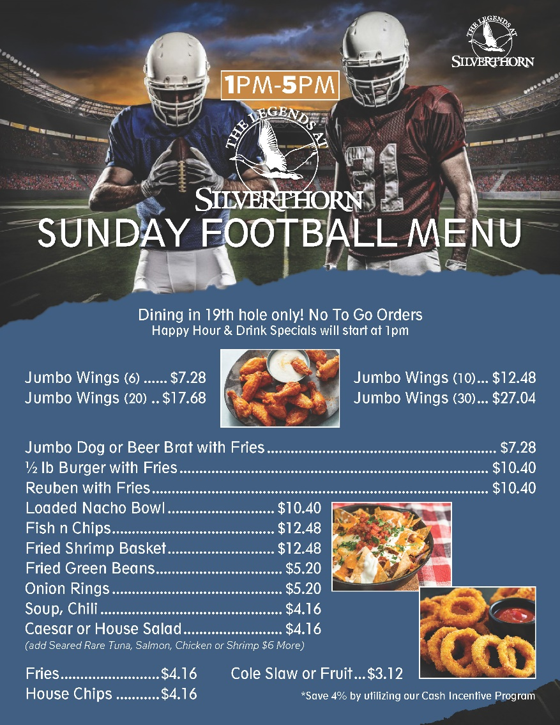
Save 4% by utilizing our cash incentive program

