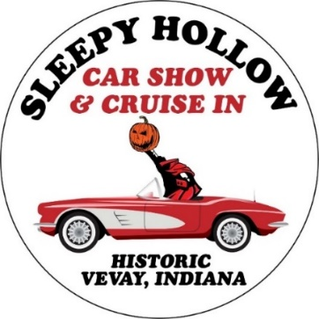

Sleepy Hollow Car Show Registration Form
Check all that apply: Cruise In on October 13th, 2023 @ 6 pm / Car Show on October 14th, 2023 @ 10am
*Deadline to apply for meal and to register for the car show is September 30th*
Cruise In -$20 (One Meal included)
Number of additional meals: ___ (Each Additional Meal -$15)
Car Show -$25
Contact Information
Name:_____________________________________________________________________
Address:___________________________________________________________________
City:___________________ State:______________ Zip Code:________________________
E-mail:_____________________________________________________________________
Phone number: (_____) ______ - __________
Vehicle Information
Year:_________________________ Color:________________________________________
Make/Model: ______________________________ Name of car: _____________________
Plate Number: ________________________
Signature: __________________________________________________________________
How did you hear about the Sleepy Hollow Car Show and Cruise In?
____________________________________________________________________________
To register or for more information, contact Switzerland County Tourism at (812) 427-3237 or (800) 435-5688, email infospecialist@switzcotourism.com
Please make checks payable to: Switzerland County Tourism
https://www.facebook.com/switzcotourism @switzerlandcountytourism

