KS2 Football Club
Dear Parents/Guardians,
We at Grassroots Sports Bristol are happy to tell you that we are going to be running an Afterschool Football Club for KS2 at Waycroft Academy on Thursdays!
DAY OF CLUB | SPORT CLUB | CLUB OPEN TO | TIME | DATE | COST PER CHILD
Thursdays | Football | KS2 | 3:20-4:30 | Term 5 & 6  Thurs 18th April – Thurs 18th July | Total = £58.50  (13 weeks, £4.50 per session)

Please bring Appropriate clothing/footwear.
Please contact Jeff Dickens - 07877287072, to book your place in the club and for any enquiries.
When booking please inform us of any information that we will need to know. Otherwise please complete this form and ensure we receive it on the first club of term.
To secure a place in our club, payment will need to be complete before start date.
Our Bank Acc details are, Account No: 52293982, Sort Code: 09-01-29. Please use my name Jeff Dickens as your ref.
If for any reason, Waycroft Academy must close. No refunds will be permitted.
FYI: Club can only run if sufficient numbers sign up. We will inform you, if the club doesn’t go ahead!
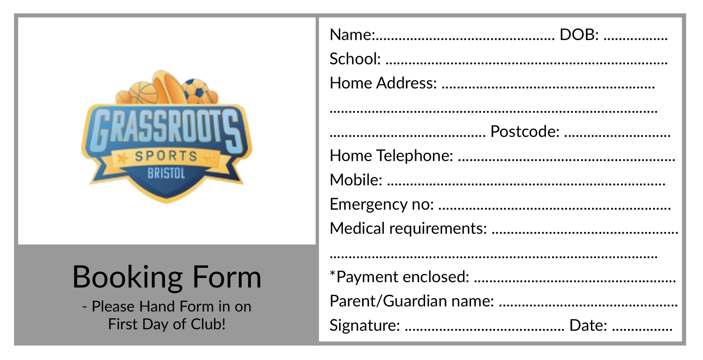
Many Thanks, Hope to see you soon!

