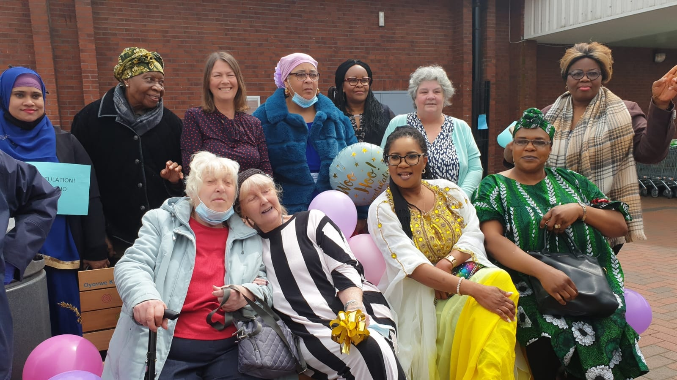
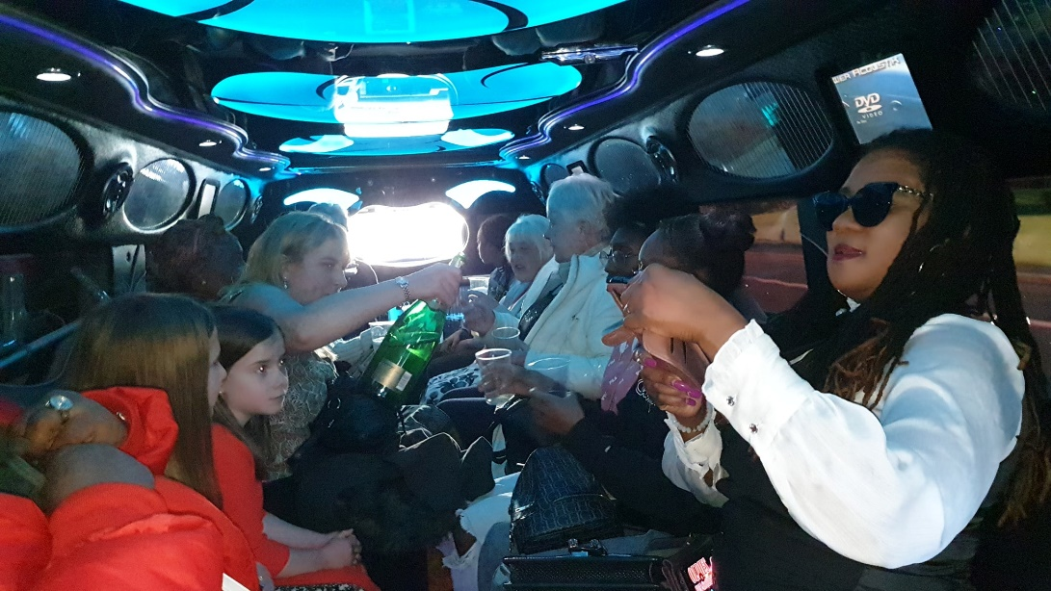

www.widowsempowerment.com
Registered Charity 1171317
ANNUAL REPORT
2020 – 2021
Contents
Objectives and activities 3
OUR STRATEGY 3
OUR VISION: 3
OUR MISSION: 3
OUR AIM: 3
OUR VALUES: 4
OBJECTIVES: 4
COVID-19: 5
THANK YOU NOTE FROM TRUSTEE BOARD MEMBER STEPHANIE ROBERTS 5
THANK YOU NOTE FROM FOUNDER/CEO OYOVWE KIGHO 6
Awards October 2020 – September 2021 7
PROVIDING A SUPPORTIVE ENVIRONMENT 8
PUBLIC BENEFIT 9
BEFRIENDING SERVICES 9
MEALS OUT 11
DONTATIONS TO MANCHESTER ROYAL CHILDREN’S HOSPITAL 11
CHRISTMAS GIFTS 12
EASTER EVENT 12
MOTHER’S DAY ONLINE EVENT 13
INTERNATIONAL WOMENS DAY 14
COMMUNITY SHOPPING 15
ARTS & CRAFTS 16
VIRTUAL BINGO 17
COOKING AND BAKING 18
VIRTUAL WORK BASED LEARNING 18
WORK EXPERIENCE 19
VOLUNTEERS 20
CAMPAIGN AND AWARNESS (MEDIA & PR) 21
OUR FUTURE PLANS 21
RISK REVIEW 22
FINANCIAL REVIEW 22
STRUCTURE, GOVERNANCE AND MANAGEMENT 23
Responsibilities and basis of report 24
Independent examiner's statement 24

Annual Report End of October 2020 - September 2021

The Widows Empowerment Trust Report of the Trustees for the Year Ended 30 September 2021

The trustees present their report with the financial statements of the charity for the year ended 30 September 2021. The trustees have adopted the provisions of Accounting and Reporting by Charities: Statement of Recommended Practice applicable to charities preparing their accounts in accordance with the Financial Reporting Standard applicable in the UK and Republic of Ireland (FRS 102) (effective 1 January 2015).

Objectives and activities

The Widows Empowerment Trust Vision
The Widows Empowerment Trust was born out of compassion and empathy for widows. it was officially adopted as a Registered Charity on the 25th of October 2017. Trust was founded by Mrs Oyovwe Agatha Kigho and three board members of the trustees and Chief Executive Office.

OUR STRATEGY
Linking our vision to our plan

OUR VISION:

Helping widows to restore hope in their lives.

OUR MISSION:

To bringing back smiles, happiness, warmth and intrinsic value in widows.

OUR AIM:

- To support and to provide relief for women and others in need due to bereavement- Reduce the level of social Isolation facing widows.
- To work with other organisations to meet the needs of widows.
- To continue to develop the skills of our volunteers and stronger community.
- To reduce loneliness and Isolation facing widows.
- To reduce the level of mental health facing widows.
- To improve health and well- being.
- To challenge the stigma facing widows.
- To bring back lost hope.

OUR VALUES:

Empathy, compassion, value, integrity, equality, empowerment:
Empathy: we put ourselves in widow's shoe! We support empathy in widows
Compassion: we support our clients to restore hope and we empathise with our clients feeling in their journey of grieving.
Value: We champion the interest of our clients to be able to socialise, we appreciate their participation and value diversity.
Integrity: We provide our clients with high quality practical and emotional support and treat our volunteers, clients with respect
Equality: our clients are treated the same regardless of culture, race, disability, nationality, colour, faith, ethnicity, and belief.
Empowerment: We work tirelessly to empower widows to recover their dreams and we take pride in our professionalism and aim to provide the best support to promote social inclusion in the lives of widows.

OBJECTIVES:

- To offer a supportive environment where widows can talk freely in the company of others in the same position such as Education and Training.
- To provide a social environment which includes wide variety of events/party to suit all taste such as valentine's day, Mother’s Day, and Christmas party.
- We offer befriending/ home visit.
- Meal out/ day out trip
- Pampering session (Spa)
- Delivery practical workshop such as Art and Craft
- Sign posting to the relevant Agencies
- Food parcels
- Engaging Volunteers

COVID-19:
Due to covid-19 we have had to move many of our services online to continue accommodating our widows and widowers. Our online services include:
- Over the phone befriending.
- Online Events around Holidays including Christmas, Easter, Mother’s day, and International Women’s Day.
- Online Arts and Crafts sessions.
- Virtual Bingo.
- Cooking and Baking.
- Virtual work-based learning.

We have also employed paid temporary staff to provide our services throughout covid-19 due to increased demand for the service.

THANK YOU NOTE FROM TRUSTEE BOARD MEMBER STEPHANIE ROBERTS

I would like to say a huge thank you for all the effort and support provided by our volunteers. They have shown true dedication, compassion and have given all that they can in order fundraise, provide befriending services and help with Admin/Finance duties for The Widows Empowerment Trust. With the help of our volunteers, we have been able to reach 179 service users this year.
Exceptionally proud of the work carried out by The Widows Empowerment Trust.

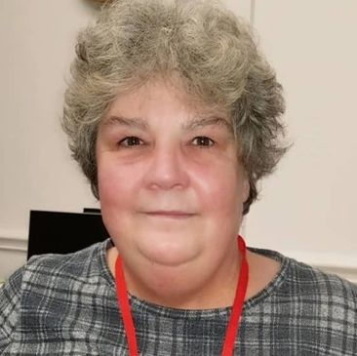

THANK YOU NOTE FROM FOUNDER/CEO OYOVWE KIGHO

We have helped tackle loneliness and become socially inclusive for 179 service users last year. When our service users reach out to The Widows Empowerment Trust, they are looking for support and are in a situation where they need to be around others who have suffered the loss of a partner.
Our service users feel alienated from society, and they cannot relate to others who are still carrying on with their lives, they often socially isolate themselves because they feel there is no one out there that can relate to their sadness. The mental health services in the UK are overstretched and there are often long waiting lists. The Widows Empowerment Trust was set-up to bridge that gap, to let the service users know that they are not alone in their grief, and we provided a safe environment for them to relate to others who have suffered the same sense of loss. This has only been possible with the great dedication of our staff and volunteers. Lastly, my gratitude to our funders, donors and supporters, none of this would have been possible without you.

Awards October 2020 – September 2021

CEO Oyovwe Kigho received the British Citizen Awards honours in health for outstanding work in the community, in reducing isolation and loneliness has been recognised on a national level.
We were also chosen among three organisations to attend a meeting with the Head of Loneliness, Baroness Baron MBE, to discuss how to address loneliness in light of the covid-19 pandemic.
The dedication of Oyovwe Kigho, who spends most of her free time volunteering for The Widows Empowerment Trust, has been recognised by the following awards:
ITV one million minutes special recognition award – reducing loneliness across the country.
National Lottery dedicated bench for service to the community located at ASDA Harphurhey.
Recognition in local TV news for support of widows and widowers in the community.
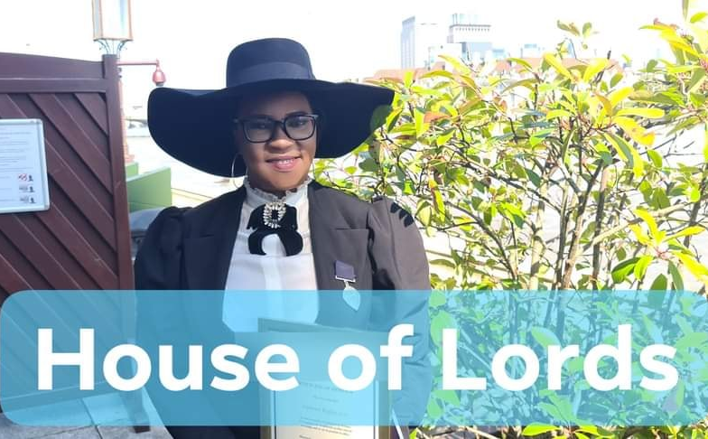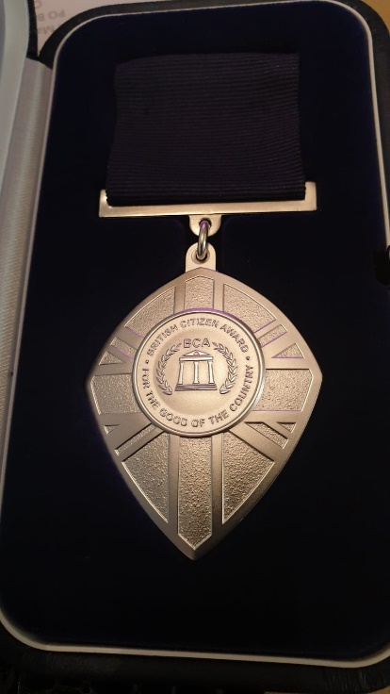

PROVIDING A SUPPORTIVE ENVIRONMENT

The Widows Empowerment Trust understands the deep pain that one suffers as a result of becoming a widow or widower, their sense of loss is so immense that they stop being social and end up isolating themselves for long periods of time, which have long-term negative impact on their mental wellbeing. Our service users are mostly referred to us from external agencies or they reach out to us to find out how we can support them through their grieving journey. Sometimes our service users are not even able to their own basic needs.
The staff and volunteers at The Widows Empowerment Trust are extremely dedicated to providing support for the service users so that our service users do not have to go through the journey of grief alone.
The Widows Empowerment Trust has reached out to 160 service users this year. Our staff and dedicated volunteers have set-up online weekly workshops which were adapted during the first lockdown. Our service users have been able to come together and meet others online who are all in a similar situation, they socially interact and learn new skills such as sewing, knitting etc. allowing our beneficiaries to be socially inclusive and not have the feeling of being alone that comes as a result of becoming a widow/widower.

PUBLIC BENEFIT
Who has benefitted from our services:
- Our objective and funding address women & men that are bereaved regardless of age, cultures, religion, ethnicity, race, colour sexuality, belief, faith and disability etc.
- Gender access to our service has improved with more widowers now benefitting from one-to-one home visits.
However, the impact of our work goes far beyond those we helped directly and include volunteers both young and elderly in our community, students from the Universities such as Manchester, MMU and Salford University students getting involved.
It is estimated that 29% widows are lonely and isolated which could lead to poor health and mental issue. Widows living in the UK, sometimes struggle to have their voice heard by the mainstream government system. The result is that widows can become some of the most marginalised group in society yet are often those in the greatest need. Whether in terms of financial help, physical or mental health, or emotional or practical adjustments in their lives (Women National Commission).
Assessment of the activities that were carried out was measured by carrying out a baseline assessment before and after each project, using our questionnaire and interview process. Being able to review and evaluate our activities time to time enabled us to track our progress and achievement at the end of each project. Also, we encouraged our service users with their feedback after every activity. Below is a list of the services that we provided last year:

BEFRIENDING SERVICES

- Our volunteers visited 179 in their homes to offer a befriending service.
- Our volunteers provided support by listening to our service users with empathy.
- Our volunteers played chess, let the service users play music, go for walks or have a cup of tea.
- By offering our befriending service we give our service users time to engage socially, especially for those who have become socially isolated.
- Our befriending visits are something that they look forward to and very much enjoy as it prevents them from being alone and isolated.
- Apart from home visits, The Widows Empowerment Trust in the last year, called 84 service users and regularly set-up weekly check-in befriending calls.
- These calls are designed so that our service users can talk about their grief and how they have done that week.
- Sometimes just allowing our service users to talk about their grief helps them to alleviate the burden of sadness and just allows them to then go on and focus with positivity for the rest of the week.
- They need space to be able to speak about their grief and are often let down by the mental health services as they are already quite stretched. Our organisation gives them that chance to talk which promotes their own mental wellbeing.
To ensure that The Widows Empowerment Trust is accessible to those who are in need, we have become community partners working in collaboration with other great organisations:
- Cruse Bereavement Manchester,
- NHS Navigator and housing association,
- other professional agencies and other community organisations
- community explorer
- Macc
- GMCVO
- NCVO
- Universities such as MMU, Manchester University, Salford University
- Key businesses such as Asda, Tesco, Morrison, Sainsbury
- Manchester Royal Children Hospital
- Manchester BME
- CAHN
We reach out to bereavement support groups on social media and to ensure we are diverse we also send literature to BME community groups throughout the UK.
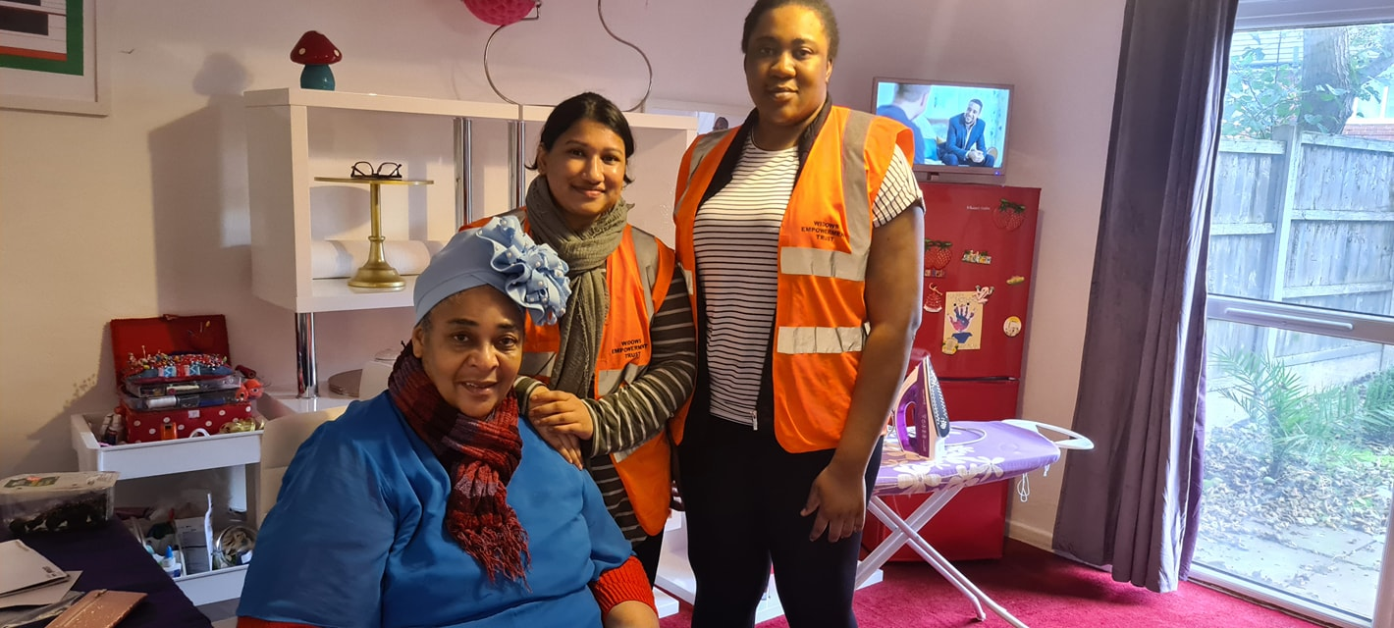

MEALS OUT

When someone loses a life partner, they also lose their social circle, they often withdraw from social activities. We recognise their loss and the fact that they feel alone in what they are going through.
- In the last year we have provided 7 meals out for our service users with other widows/widowers.
- We provide these days out to promote their mental wellbeing and bring about a sense of positivity about their lives.
- In doing so our service users feel uplifted and are given renewed strength in navigating their grieving journey.
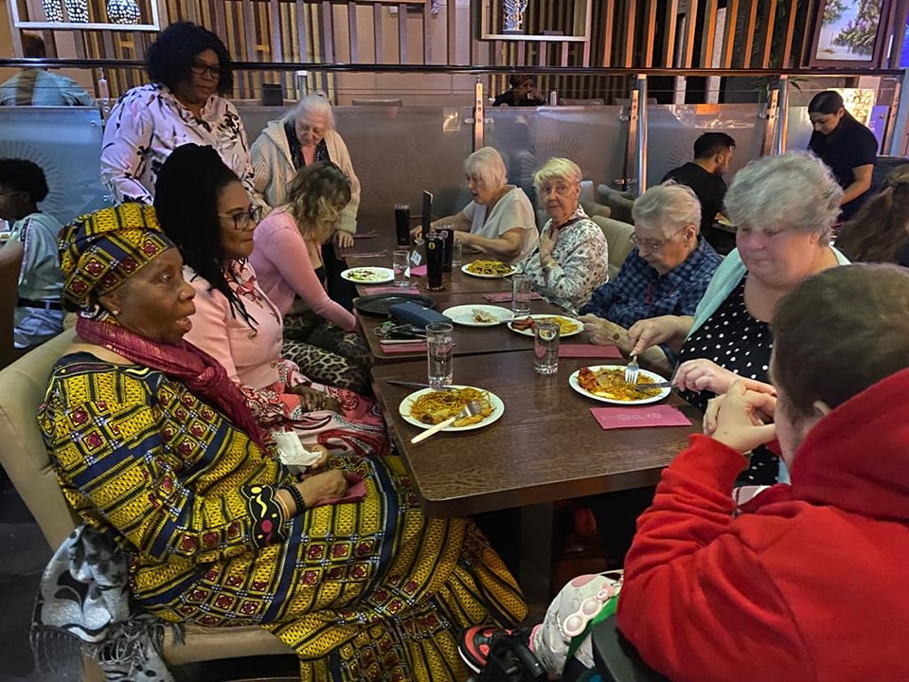

DONTATIONS TO MANCHESTER ROYAL CHILDREN’S HOSPITAL

It is important for us to remember that we should support a wide array of charitable efforts in our community. Connecting our widows and widowers into other charitable efforts promotes their mental wellbeing and builds a sense of community for them.
- We organised with 5 of our service users to deliver gifts to unwell children at the Manchester Royal Children’s Hospital.
- This gives our service users the chance to connect with others and gain the sense that they are contributing to the wellbeing of themselves and others.
- This also builds our network and allows us to reach out to more organisations in the future.
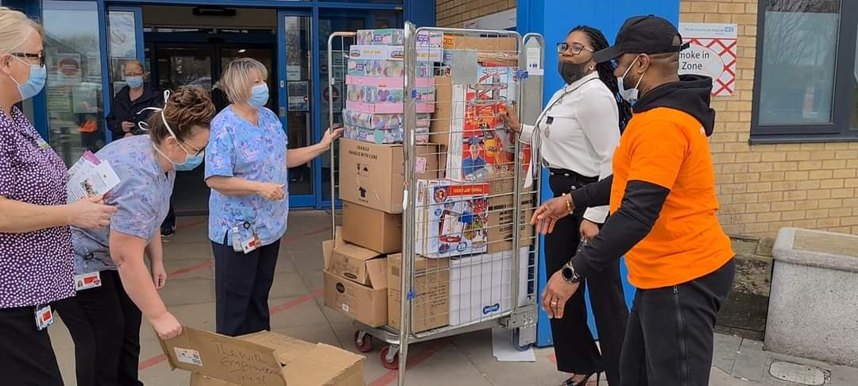

CHRISTMAS GIFTS

Our Widows and Widowers often struggle around Christmas time, being isolated at what would usually be a family time can be very detrimental to the health of our Widows and Widowers. We have strived this year to provide a gift to our service users through the Christmas period.
- We delivered 50 gifts to service users in our community.
- Service users who receive a gift from us feel looked after and less alone throughout the Christmas period and this can support the mental wellbeing of our widows and widowers.
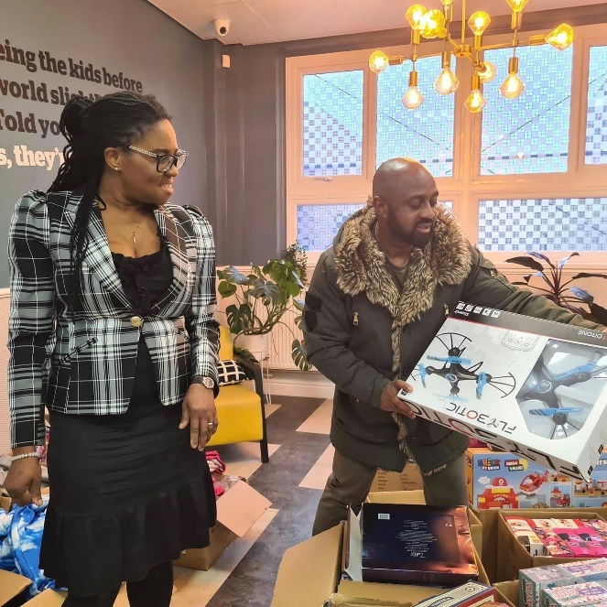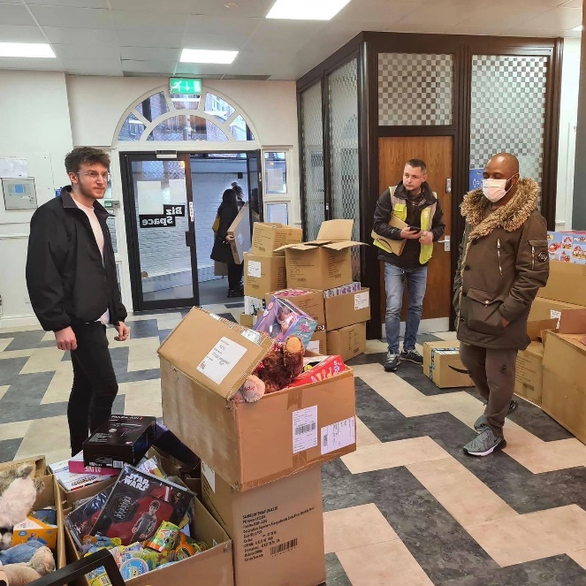

EASTER EVENT

We have focused on providing social events and celebrations around holidays that are usually devoted to family for our widows and widowers, after losing a loved one it can be difficult to face such events, especially after being isolated by loss.
- During Easter 2021 we set up and ran an online session for 25 of our widows and widowers to connect and share a sense of family and joy.
- We also organised our volunteers to deliver 22 Easter gift bags to members of our community to engage in arts and crafts activities.
- This boosts mental wellbeing and promotes creativity in our widows and widowers which is invaluable for bolstering their sense of joy and happiness.
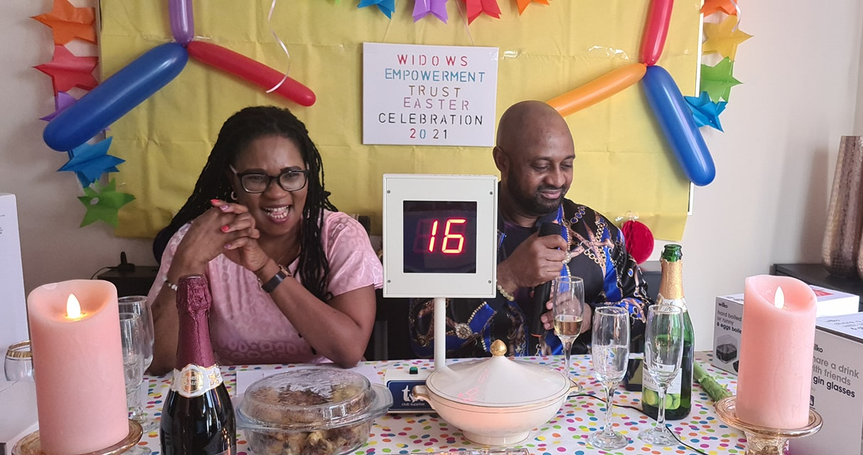

MOTHER’S DAY ONLINE EVENT

For our widows, we understand that Mother’s Day can be a difficult time. During this time, we provide an online event including a raffle, prizes and social connection as we believe this to be the best way to combat isolation and loneliness.
- We set up an online event for 73 of our widows to meet, socialise and have a chance at winning wonderful prizes.
- Provided prizes to 25 of our widows to boost their positivity and joy.
- We believe that social connection is important to breaking isolation and ending loneliness, so this event was highly focused on providing a social opportunity to our widows.

INTERNATIONAL WOMENS DAY

We wanted to celebrate our widows during International Women’s Day this year, so we organised an online event to celebrate with our widows. This boosted their confidence and gave them a sense of joy and community with us and was a big boost to those who would otherwise be alone.
- We organised an online event for 73 of our widows to join, celebrate and socialise.
- Celebrating bringing women from different backgrounds together in celebration of International Women’s Day.
- We included Poem readings, Arts and crafts, Bingo and prizes in the event to boost creativity and support mental wellbeing of our widows.

COMMUNITY SHOPPING

Our volunteers have continued to work tirelessly throughout the year to provide for our widows and widowers. This year we have been trying to help our community by delivering shopping to our widows and widowers which has been an increasingly challenging problem in the face of covid-19.
- We delivered shopping to 70 of our service users throughout the year.
- Many of our widows and widowers are too unwell to collect their own shopping, by offering this service we are filling a necessary role in the community.
- By providing for our widows and widowers we are relieving the need for other organisations and charities to provide this service, many are stretched thin as is, hence why providing this support is crucial.
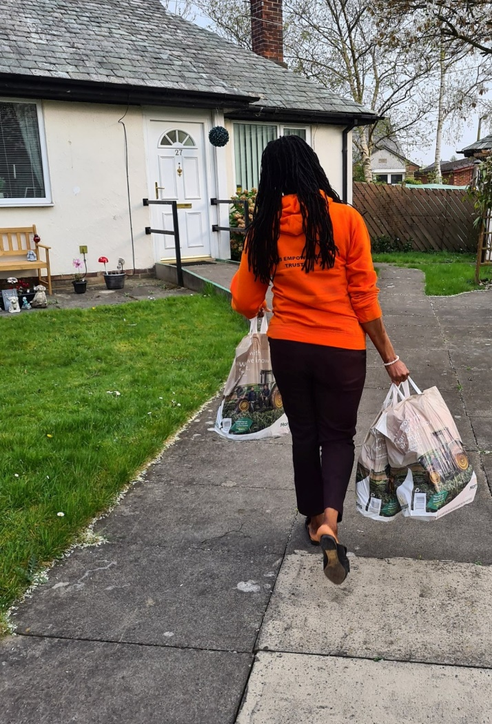

ARTS & CRAFTS

We have been providing weekly arts and craft sessions online for our clients every Wednesday throughout the year. This not only provides a creative opportunity for our widows and widowers to be able to have a manual task to complete which boosts mental wellbeing, but it is yet another chance for them to communicate with each other.
- We provided 50 Arts and crafts sessions throughout the year, as well as providing 100 of our clients with the supplies needed to engage in arts and crafts.
- This promotes mental wellbeing by providing a consistent activity for our community and boosting their interest in new hobbies.
- Completing arts and crafts projects also reinforce our widows and widowers with a sense of accomplishment and brings a sense of positivity in their life and bereavement journey.
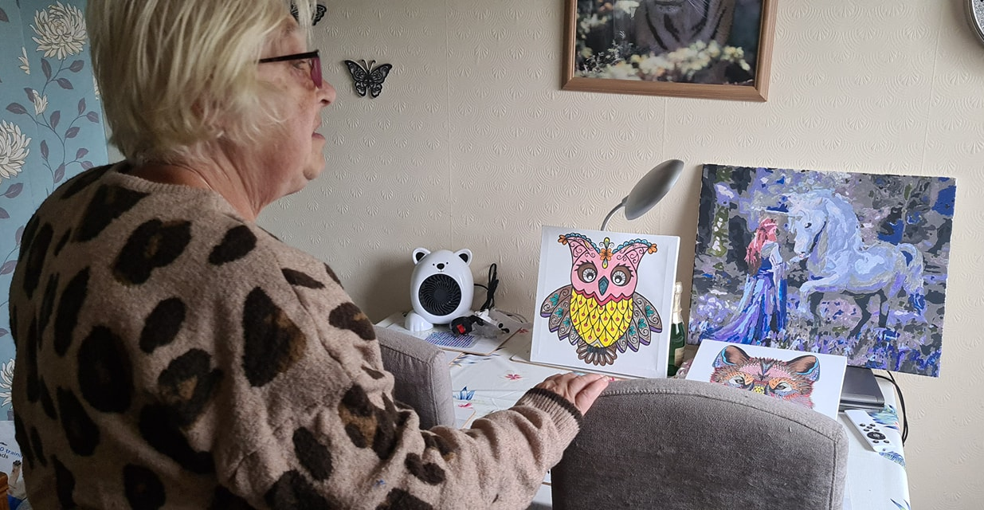

VIRTUAL BINGO

Combatting isolation has been increasingly difficult this year due to covid-19 however, we have managed to consistently provide virtual entertainment to our community by introducing virtual bingo to our clients.
- We have delivered 48 sessions of bingo online consistently throughout the year and this has given our widows and widowers a chance to socialise digitally and has been a great way to maintain our goal of reducing loneliness and isolation.
- By providing a social opportunity to our widows and widowers we have alleviated pressure on the mental health services that would otherwise be needed for our community.
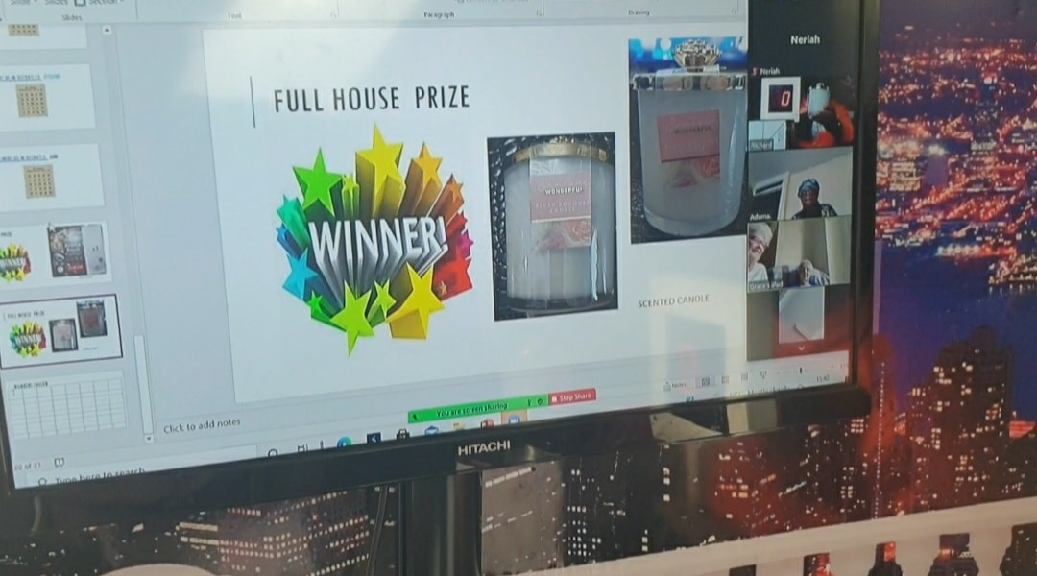

COOKING AND BAKING

Many of the bereaved are lacking in key skills after the loss of a loved one and need help in providing for themselves, others feel too isolated to ask for help and just need a community there for them, supporting them in all kinds of activity. We have been providing cooking and baking classes every month to try to teach new skills to our widows and widowers as well as continuing to provide key social connection. This year due to covid-19 these classes have had to move online but we have continued to provide this service.
- We held 8 cooking and baking sessions across the year.
- Providing this service gives our users the chance to learn new skills and recipes to try at home, this can boost their positivity which is key in their bereavement journey.
- Socialising during these sessions also helps promote good mental wellbeing in our clients.
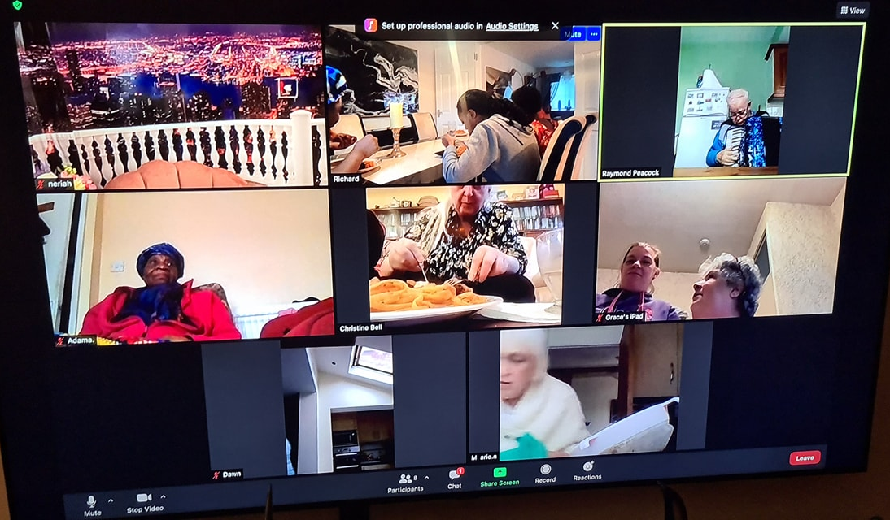

VIRTUAL WORK BASED LEARNING

We have recognised the need to establish the skills and empathy needed in the caring profession in the students of today, by building a sense of community and care in all people we can create an environment where those that suffer loss can be cared for.
- We worked with Manchester Metropolitan University to provide virtual work-based learning in the psychology department and the health and social care department to 60 students.
- This has effectively built their skills for approaching the caregiving roles and the mental health services. Both areas are in need of additional support and by providing training we can bolster the workforce of these services.
- Students will find this provision invaluable and have learned the skills necessary to develop themselves into wonderful graduates.

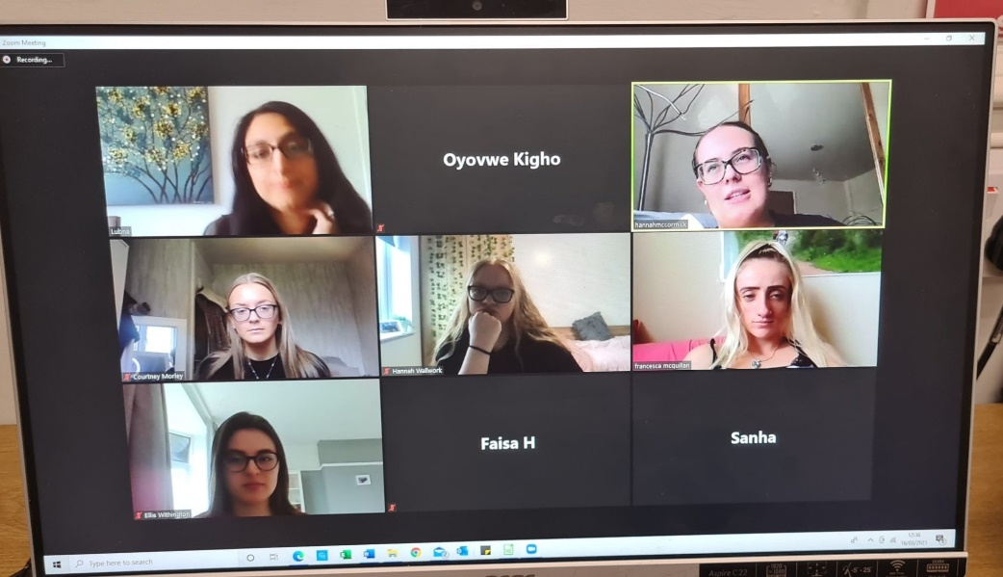

WORK EXPERIENCE

As part of our efforts to provide important skills and training to the community we have been working with several organizations to get in contact with those most needing of work experience.
- We have joined with the DWP kickstart scheme to recruit members of the community who are at risk of long-term unemployment so that they can receive training and skills not only to fill out their CVs but to boost their confidence in approaching the job market.
- We also connected with the Global Business School to provide 150 hours of work experience to 3 students in the field of caregiving and support, these students can use this experience to sooner reach a career and it shares valuable skills for the workplace with those who will build the workforce of the future.

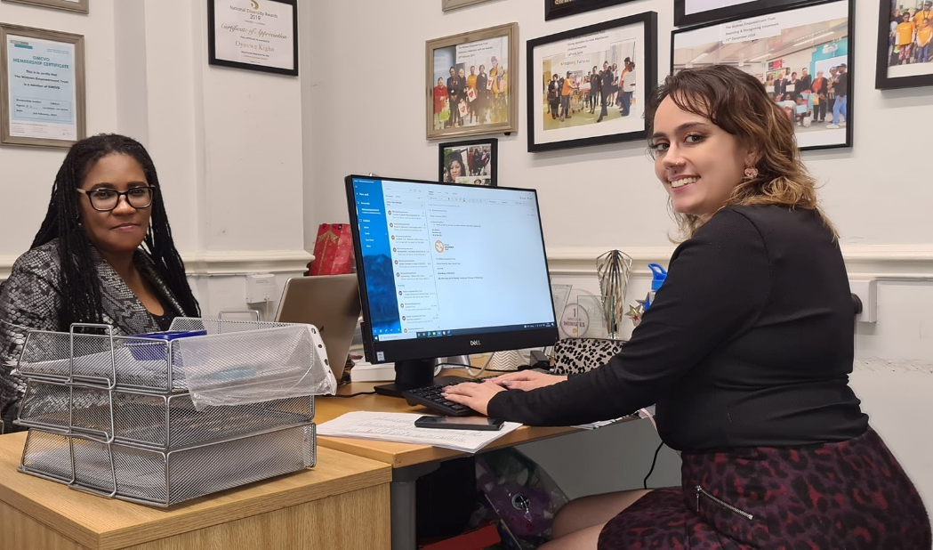

VOLUNTEERS

Our volunteers are the backbone of The Widows Empowerment Trust, without them giving up their own personal free time we will not be able to support our service users as effectively as we do right now.
- We have a bank of 156 volunteers
- The Widows Empowerment Trust endeavours to reward our volunteers by ensuring that they are learning new working skills that will help them to develop themselves further in future careers.
We provide the option of learning:
- admin
- accounting
- fund writing
- community care skills.
- We have a partnership with University of Manchester for student placements.
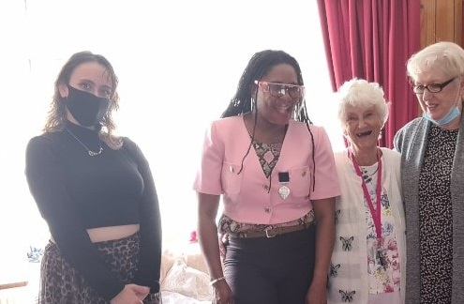

CAMPAIGN AND AWARNESS (MEDIA & PR)

• Featured on Local New (Manchester TV NEWS) 6 TIMES
• Feature on BBC One news on International Women’s Day
• Feature on Wythenshawe FM Radio Station in February 2021
• Featured on ITV Good Morning Britain and other ITV TV stations

OUR FUTURE PLANS

- Able to reach out to more widows/widowers across the country.
- Expand our volunteers to provide a more of a national befriending service via home visits.
- Expand our offering of providing work experience to volunteers to help further their careers
- Expand our virtual based activities
- Develop the technological skills of our beneficiaries
- Developing and providing more virtual support accessible by our beneficiaries throughout the UK
- We will endeavour to have in place a therapeutic facility centre for the bereaved to be able to access our services as well as wellbeing activities such as Spa.
- Expand our creativity classes and meet up sessions throughout the UK to help support the bereaved spouse.
- We endeavour for the primary care services of the NHS to recognise our services for the bereaved and to be able to recommend using our services along with counselling support.
- We endeavour to create more opportunities for the community with our facilities centre. We would be able to create more job opportunities as well as volunteer opportunities.

We will continue to provide an all-inclusive social, safe space for our widows/widowers under the local authorities’ guidelines that are covid-19 safe. We will continue to partner with local universities to be able to provide their students with office work experience as well as community care work experience. We will increase working partnership with the local jobcentre to be able provide work experience for their job seekers. We are committed to the continuance of training our volunteer befrienders, to be able to provide the best support that our beneficiaries require.

RISK REVIEW

The Trustee have the responsibility to monitor and control the risk of the charity. With every activity we do, we consider the risk involve.
Identifying existing controls and any mitigating actions such as the liability insurance and procedures which help to reduce the risk whilst managing how to monitor and maintain an efficient use of resources. The fundamental risk factor is the imbalance between the resources available to The Widows Empowerment and the unmet need of the widows. The most difficult part is the pressure on key personal who have limited support and scope to delegate with Succession risk. Our resources are therefore planned effectively to mitigate any risk.

FINANCIAL REVIEW

The Trustees have examined the requirements for free reserves, and they consider that, given the nature of the Charity's work, free reserves should be equivalent to approximately 2 months routine expenditure at £5,000. The Trustees are of the opinion that this provides sufficient flexibility to cover temporary shortfalls in incoming resources. The expenditure mainly consists of restricted costs.

STRUCTURE, GOVERNANCE AND MANAGEMENT

Governing document
The charity is controlled by its governing document, a deed of trust and constitutes an unincorporated charity.

REFERENCE AND ADMINISTRATIVE DETAILS
Registered Charity number
1171317

Principal address
Wilsons House
Biz Space Business Park Monsall Road Manchester
M0 8WN

Report of the Trustees
for the Year Ended 30 September 2020

Trustees
V Keke
S Roberts
L Slack

Independent Examiner
Raise
Chartered Accountants 10th Floor
3 Hardman Street Spinningfields Manchester
M3 3HF

Approved by order of the board of trustees on 02/11/2021 and signed on its behalf by:
S. Roberts

Independent examiner's report to the trustees of The Widows Empowerment Trust
I report to the charity trustees on my examination of the accounts of The Widows Empowerment Trust (the Trust) for the year ended 30 September 2021.

Responsibilities and basis of report
As the charity trustees of the Trust you are responsible for the preparation of the accounts in accordance with the requirements of the Charities Act 2011 ('the Act').

I report in respect of my examination of the Trust's accounts carried out under section 145 of the Act and in carrying out my examination I have followed all applicable Directions given by the Charity Commission under section 145(5)(b) of the Act.

Independent examiner's statement
I have completed my examination. I confirm that no material matters have come to my attention in connection with the examination giving me cause to believe that in any material respect:

- accounting records were not kept in respect of the Trust as required by section 130 of the Act; or
- the accounts do not accord with those records; or
- the accounts do not comply with the applicable requirements concerning the form and content of accounts set out in the Charities (Accounts and Reports) Regulations 2008 other than any requirement that the accounts give a true and fair view which is not a matter considered as part of an independent examination.

I have no concerns and have come across no other matters in connection with the examination to which attention should be drawn in this report in order to enable a proper understanding of the accounts to be reached.

