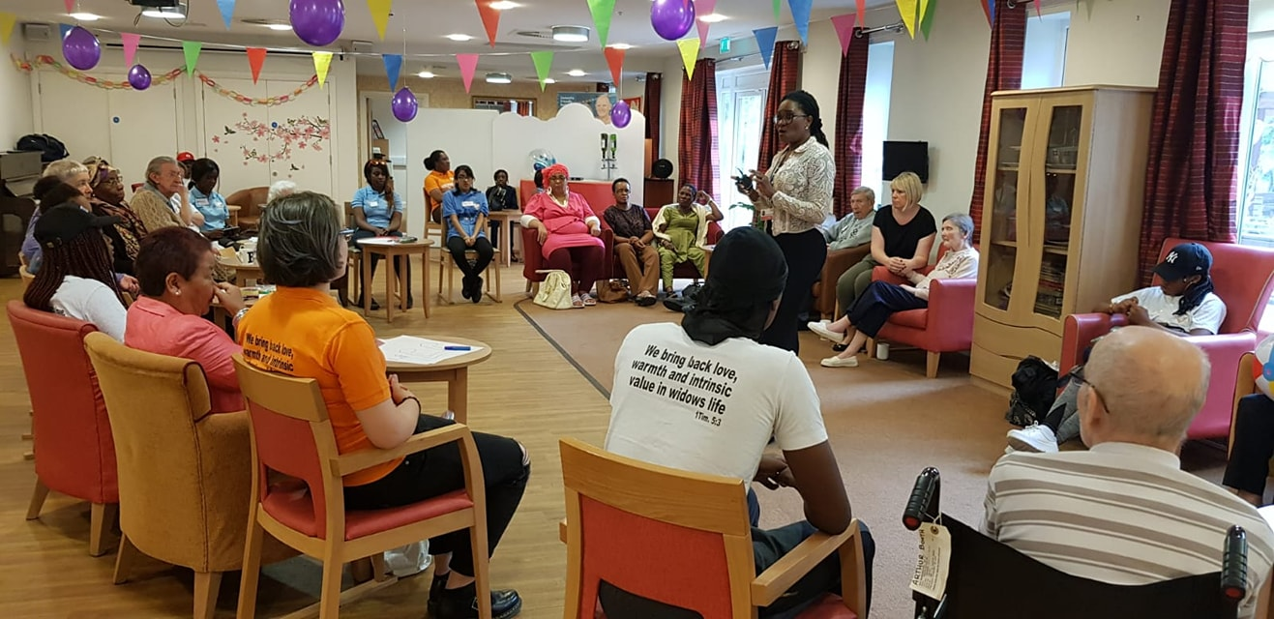
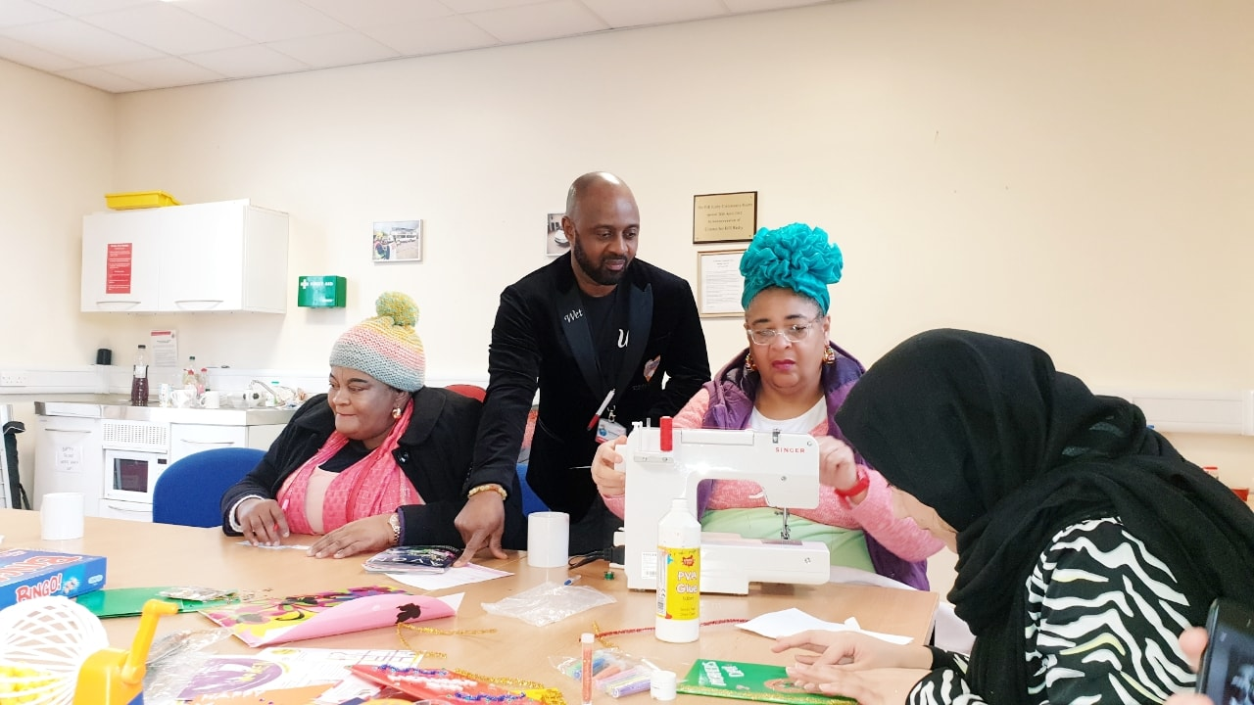
www.widowsempowerment.com Registered Charity 1171317
ANNUAL REPORT 2019 - 2020
Contents
Annual Report End of October 2019 - September 2020 3
Objectives and activities 3
OUR STRATEGY 3
OUR VISION: 3
OUR MISSION: 3
OUR AIM 3
OUR VALUES 4
OBJECTIVES: 4
DAWN CHEETHAM’S STORY 5
THANK YOU NOTE FROM TRUSTEE BOARD MEMBER 6
THANK YOU NOTE FROM FOUNDER/CEO 7
AWARDS October 2019 – September 2020 7
PROVIDING A SUPPORTIVE ENVIRONMENT 8
DEMENTIA SERVICE 9
SOCIAL OUTINGS 10
OCCASIONS 10
BEFRIENDING SERVICES 12
Covid-19 13
VOLUNTEERS 16
VOLUNTEER - CASE STUDY 18
CAMPAIGN AND AWARNESS (MEDIA & PR) 18
OUR FUTURE PLANS 19
RISK REVIEW 19
FINANCIAL REVIEW 19
STRUCTURE, GOVERNANCE AND MANAGEMENT 20
The Widows Empowerment Trust Independent Accounts 21
Notes to the Financial Statements 25

Annual Report End of October 2019 - September 2020

The Widows Empowerment Trust Report of the Trustees for the Year Ended 30 September 2020

The trustees present their report with the financial statements of the charity for the year ended 30 September 2020. The trustees have adopted the provisions of Accounting and Reporting by Charities: Statement of Recommended Practice applicable to charities preparing their accounts in accordance with the Financial Reporting Standard applicable in the UK and Republic of Ireland (FRS 102) (effective 1 January 2015).

Objectives and activities
The Widows Empowerment Trust Vision
The Widows Empowerment Trust was born out of compassion and empathy for widows. it was officially adopted as a Registered Charity on the 25th October 2017. Trust was founded by Mrs Oyovwe Agatha Kigho and three board members of the trustees and Chief Executive Office.

OUR STRATEGY

Linking our vision to our plan

OUR VISION:

Helping widows to restore hope in their lives.

OUR MISSION:

To bringing back smiles, happiness, warmth and intrinsic value in widows.

OUR AIM

- To support and to provide relief for women and others in need due to bereavement- Reduce the level of social Isolation facing widows.

- To work with other organisations to meet the needs of widows.

- To continue to develop the skills of our volunteers and stronger community.

- To reduce loneliness and Isolation facing widows.

- To reduce the level of mental health facing widows.

- To improve health and well- being.

- To challenge the stigma facing widows.

- To bring back lost hope

OUR VALUES

Empathy, compassion, value, integrity, equality, empowerment:

Empathy: we put ourselves in widow's shoe! We support empathy in widows

Compassion: we support our clients to restore hope and we empathise with our clients feeling in their journey of grieving.

Value: We champion the interest of our clients to be able to socialise, we appreciate their participation and value diversity.

Integrity: We provide our clients with high quality practical and emotional support and treat our volunteers, clients with respect

Equality: our clients are treated the same regardless of culture, race, disability, nationality, colour, faith, ethnicity, and belief.

Empowerment: We work tirelessly to empower widows to recover their dreams and we take pride in our professionalism and aim to provide the best support to promote social inclusion in the lives of widows.

OBJECTIVES:

- To offer a supportive environment where widows can talk freely in the company of others in the same position such as Education and Training.

- To provide a social environment which includes wide variety of events/party to suit all taste such as valentine's day, Mother’s Day, and Christmas party.

- We offer befriending/ home visit.

- Meal out/ day out trip

- Pampering session (Spa)

- Delivery practical workshop such as Art and Craft

- Sign posting to the relevant Agencies

- Food parcels

- Engaging Volunteers 2019

DAWN CHEETHAM’S STORY

Dawn became a widow 18 months ago after her husband was diagnosed with Pancreatic Cancer. He passed away at the age of 47 and took him 7 weeks to pass away after diagnoses. Seeing the cruelty of the way that Dawn’s husband died still remains with her after 18 months. Dawn is now left as a single mother to her very young daughters who were at the time below ten years old. Dawn felt there was no support from anyone after her husband passed away, not only did she have to endure the loss of a partner she also had to deal with what she felt were misgivings from the hospital and care of her husband. Dawn tried counselling but had to wait a long time on the NHS to be seen. Dawn was absolutely desperate to reach out to other widows like herself who were left alone to raise children, but every door she knocked, she found that they were either oversubscribed or she felt that they lacked the empathy she needed. Eventually Dawn found us and since beginning of March 2020 as been an active service user to whom we provide befriending services to and we provide a social engaging environment for Dawn to get involved.
Testimonial from Dawn Cheetham
“I enjoy bingo every sat as well as the arts & crafts with the others who have suffered from the same grief as we have such a laugh and again it gives me something to look forward to for myself and not just be there for others.”

THANK YOU NOTE FROM TRUSTEE BOARD MEMBER
STEPHANIE ROBERTS
I would like to say a huge thank you for all the effort and support provided by our volunteers. They have shown true dedication, compassion and have given all that they can in order fundraise, provide befriending services and help with Admin/Finance duties for The Widows Empowerment Trust. With the help of our volunteers we have been able to reach 142 service users this year.
Exceptionally proud of the work carried out by The Widows Empowerment Trust.

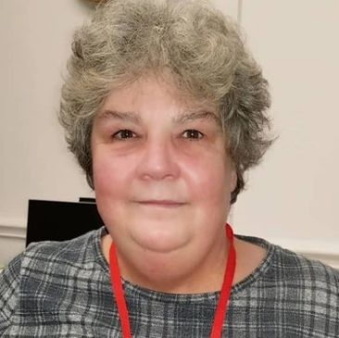

THANK YOU NOTE FROM FOUNDER/CEO
OYOVWE KIGHO
We have helped tackle loneliness and become socially inclusive for 142 service users last year. When our service users reach out to The Widows Empowerment Trust, they are looking for support and are in a situation where they need to be around others who have suffered the loss of a partner.
Our service users feel alienated from society and they cannot relate to others who are still carrying on with their lives, they often socially isolate themselves because they feel there is no one out there that can relate to their sadness. The mental health services in the UK are overstretched and there are often long waiting lists. The Widows Empowerment Trust was set-up to bridge that gap, to let the service users know that they are not alone in their grief and we provided a safe environment for them to relate to others who have suffered the same sense of loss. This has only been possible with the great dedication of our staff and volunteers. Lastly, my gratitude to our funders, donors and supporters, none of this would have been possible without you.

AWARDS October 2019 – September 2020

The Widows Empowerment Trust has been recognised as an organisation committed to tackling loneliness caused by bereavement. The CEO, Oyovwe Kigho has been invited to a meeting with the Head of Loneliness UK Baroness Barran MBE, under the parliamentary state to discuss the issue of loneliness in relation to grief.
Oyovwe Kigho has been panellist at the National Conference – CAMPAIGN TO END LONELINESS.
The dedication of Oyovwe Kigho, who spends most of her free time volunteering for The Widows Empowerment Trust, has been recognised by the following awards:
LIFE TIME ACHIEVER FINALIST – NATIONAL DIVERSITY AWARDS 2019
ITV GOOD MORNING BRITAIN – ONE MILLION MINUTES AWARD 2019 - SPECIAL RECOGNITION FOR LONELINESS ACROSS THE COUNTRY
TURNING AROUND AWARD FINALIST FOR OUTSTANDING SOCIAL BEHAVIOUR

PROVIDING A SUPPORTIVE ENVIRONMENT

The Widows Empowerment Trust understands the deep pain that one suffers as a result of becoming a widow or widower, their sense of loss is so immense that they stop being social and end up isolating themselves for long periods of time, which have long-term negative impact on their mental wellbeing. Our service users are mostly referred to us from external agencies or they reach out to us to find out how we can support them through their grieving journey. Some times our service users are not even able to their own basic needs.
The staff and volunteers at The Widows Empowerment Trust are extremely dedicated to providing support for the service users so that our service users do not have to go through the journey of grief alone.
The Widows Empowerment Trust has reached out to 142 service users this year. Our staff and dedicated volunteers have set-up workshops weekly where our service users have been able to come together and meet others in a similar situation and learn new skills such as sewing, knitting etc. allowing our beneficiaries to be socially inclusive and not have the feeling of being alone that comes as a result of becoming a widow/widower.

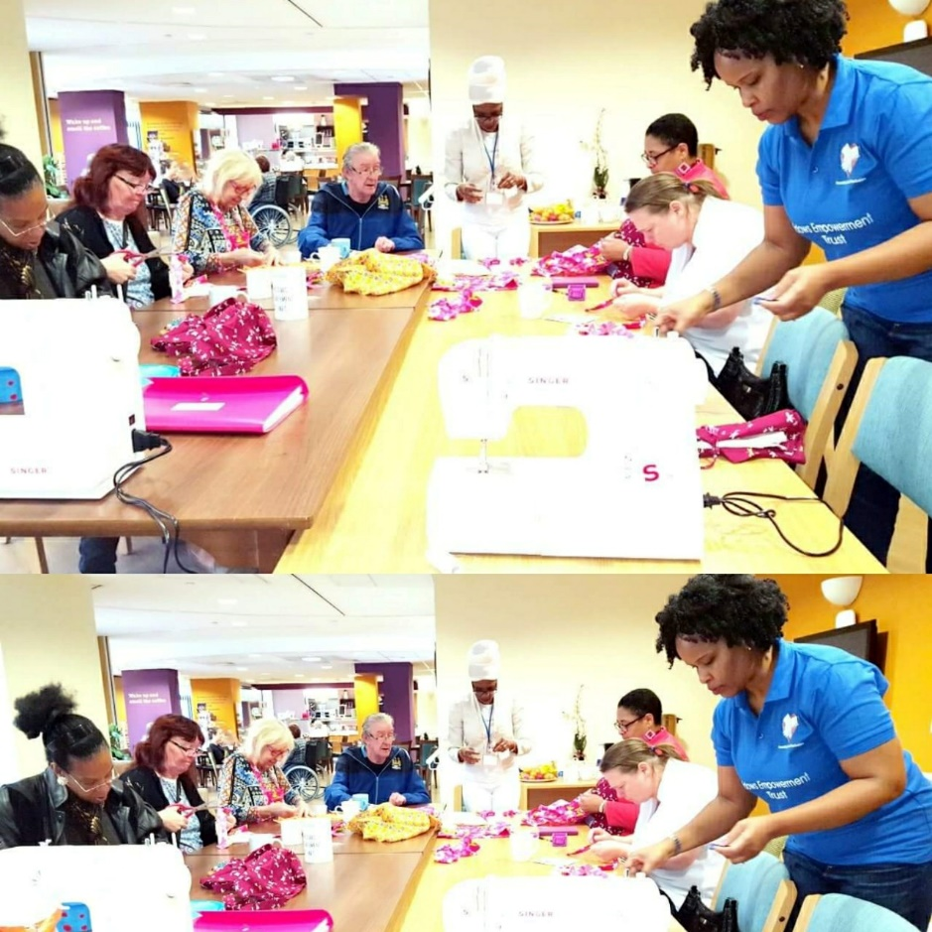

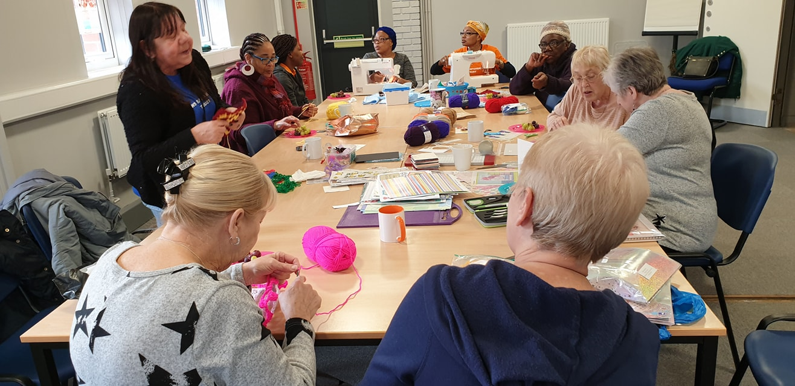

DEMENTIA SERVICE

Widows Empowerment Trust has provided arts & crafts classes to our service users who suffer from dementia weekly every Thursday at Each Step. The classes offer our service users art therapy that is known to help with the mental wellbeing of the service user. The classes provide a safe space for the service users to be socially inclusive without any kind of judgement and allows them to feel part of an integrated society as well as be amongst those who are also suffering from the bereavement of losing a life partner and dementia.
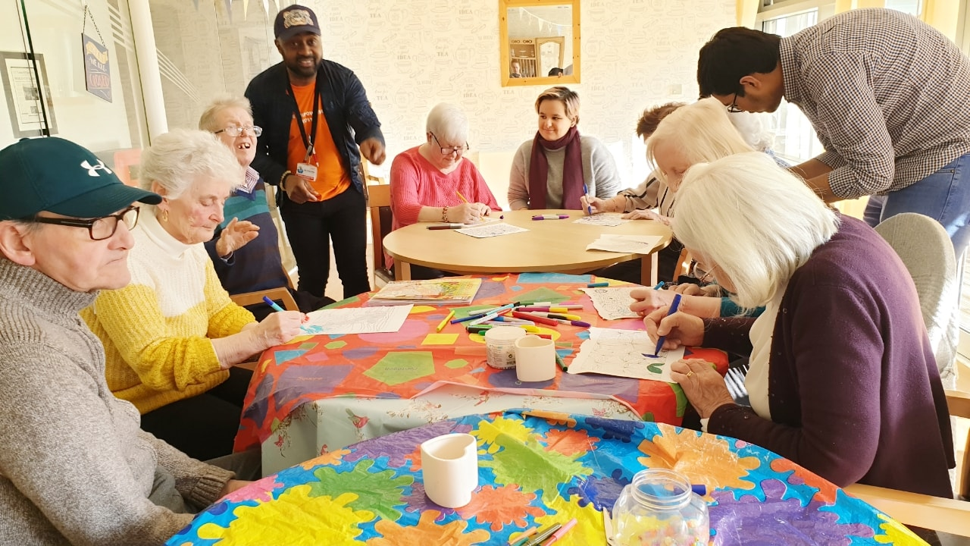

SOCIAL OUTINGS

When someone loses a life partner, they also lose their social circle, they often withdraw from social activities as they feel they are not able to relate to their peers anymore or they feel that their peers do not understand their situation. We recognise their loss and the fact that they feel alone in what they are going through. In the last year we have set-up 28 meal days out and also days out to the spa to with other widows/widowers who are able to relate to struggles that they each face. We provided these days out to promote their mental wellbeing and bring about a sense of positivity to their lives, In doing so our service users feel uplifted and are given a renewed strength to be able to navigate through their grieving journey.

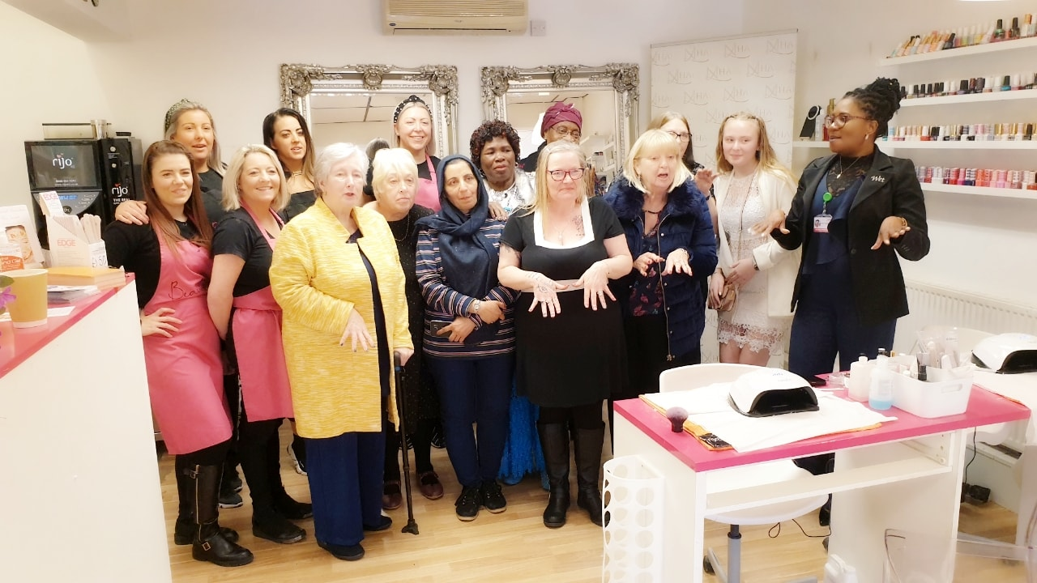

OCCASIONS

Special occasion no longer holds the same meaning after the loss of a life partner, or these occasions can just be overlooked in the day to day struggle of getting used to the new life that they have. The widows Empowerment Trust, celebrates such occasions to focus on the service users to show them that they haven’t been forgotten about and that they are not alone in their struggle. The biggest factor facing widows/widowers is social isolation and we try to do everything possible to help widows/widowers stay connected.

VALENTINE’S DAY
We donated gifts this year to the unwell children at The Royal Manchester Children’s Hospital. Apart from visiting our beneficiaries like we usually do on this day; we asked our beneficiaries to become involved in presenting of gifts to the hospital to be able to actively engage our beneficiaries into the community. Our beneficiaries felt a positive sense of attitude and an increase in their mental wellbeing by being able to give back to the community and be part of our community cohesion.
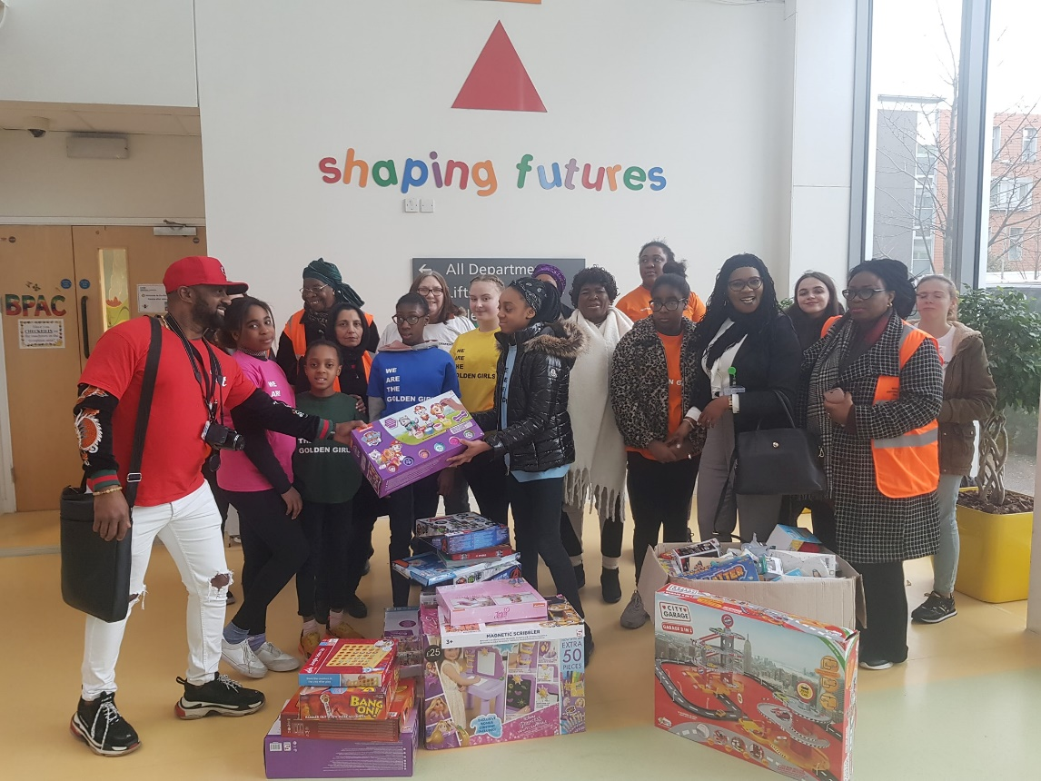

Christmas times can bring home the grief that was originally felt having lost a life partner. Last year we organised a Xmas get together for our service users and for their families to attend, again being amongst others that are going through the same things allows are services users to relate and feel in a safe space for them to celebrate with their families.

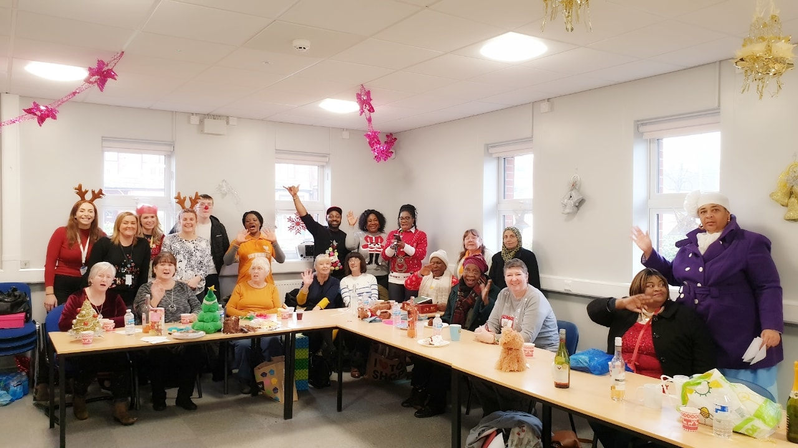

BEFRIENDING SERVICES

Last year our volunteers visited 84 in their homes to offer a befriending service. Our volunteers provided support by listening to our service users with empathy. Our volunteers played chess, let the service users play music, go for walks or have a cup of tea. By offering our befriending service we give our service users time to engage socially, especially for those who have become socially isolated. Our befriending visits are something that they look forward to and very much enjoy as it prevents them from being alone and isolated.
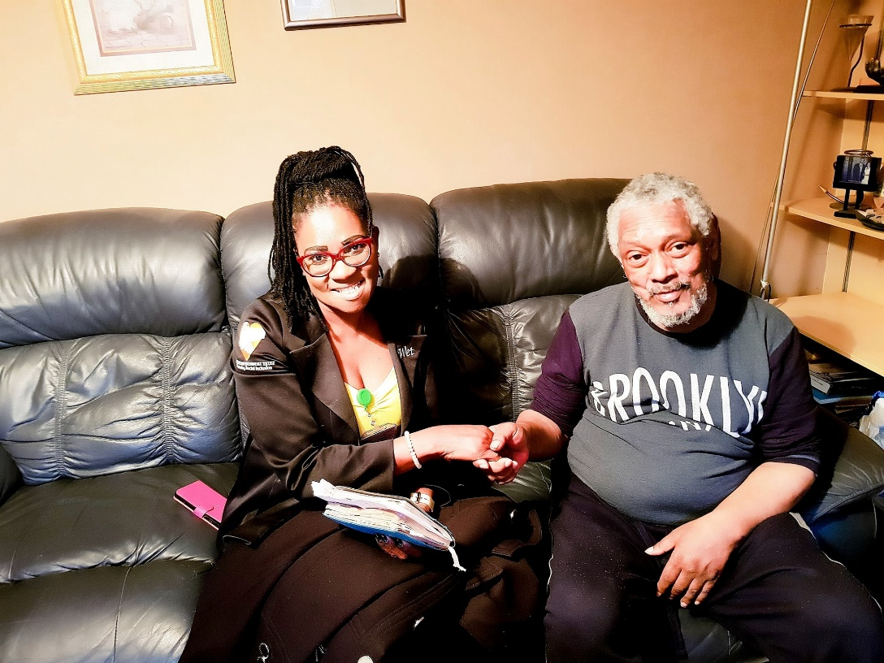
Apart from home visits, The Widows Empowerment Trust in the last year, called 198 service users and regularly set-up weekly check-in befriending calls. These calls are designed so that our service users are able to talk about their grief and how they have done that particular week. Sometimes just allowing our service users to talk about their grief helps them to alleviate the burden of sadness and just allows them to then go on and focus with positivity for the rest of the week. They need space to be able to speak about their grief and are often let down by the mental health services as they are already quite stretched and the likes of our organisation gives them that chance to talk to promote their own mental wellbeing.
To ensure that The Widows Empowerment Trust is accessible to those who are in need, we have become community partners working in collaboration with other great organisations:
• Cruse Bereavement Manchester,
• NHS Navigator and housing association,
• other professional agencies and other community organisations
• community explorer
• Macc
• GMCVO
• NCVO
• Universities such as MMU, Manchester University, Salford University
• Key businesses such as Asda, Tesco, Morrison, Sainsbury
• Manchester Royal Children Hospital
• Manchester BME
We reach out to bereavement support groups on social media and to ensure we are diverse we also send literature to BME community groups throughout the UK.

Covid-19

Since the start of the pandemic, we have helped to delivered food shopping to 82 service users on high risk across Greater Manchester. These are our vulnerable service users who were asked to shield during the first lockdown. We immediately sprang into action when lockdown first occurred. We knew that some of our services users did not have any family or friends near them and we knew that they would have struggled with getting out to do their own shopping. We rounded up our volunteers and went grocery shopping for our most vulnerable service users.

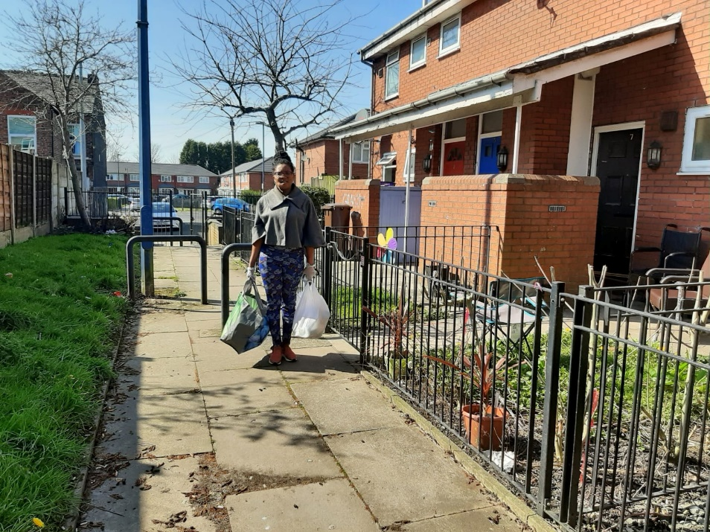

During the Covid-19 pandemic, The Widows Empowerment Trust has to adapt its services. Instead of physical workshops, the trust introduced via zoom arts & craft classes every Wednesdays. Considering that some of our users were unfamiliar with zoom. The Widows Empowerment Trust volunteers dedicated their time to be able to safely go in to the homes of our service users and teach them how to use zoom so that they can partake in these sessions. This is to ensure that our service users are still able to socially engage with others who have suffered from a similar loss and to ease the burden of being in lock-down and provide a sense of comradery. We have between 18 – 25 service users take part every week. Every week we deliver all of the materials that are required for the arts & crafts zoom session to our service users.
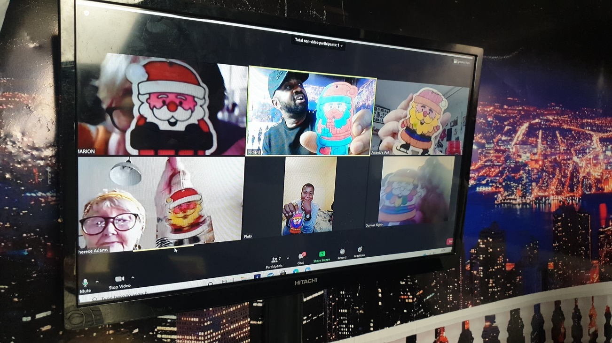

The Widows Empowerment Trust have had to adapt the home visits by introducing one to one community visits. Our volunteers go out to the community to check-in with 67 service users on Tuesday, Wednesday & Thursday. Our one to one visit has been welcomed by our service users since the start of covid-19 as it shows them that they haven’t been forgotten and that there is still a human face to our services. It provides them an opportunity to see and interact with another person, in some cases our volunteers are the only human contact that they have weekly. It is essential that this part of our service continues as it helps promote mental wellbeing. As part of our community visit, we do try to encourage our service users to use this opportunity to get some fresh air by suggesting going for walks together.

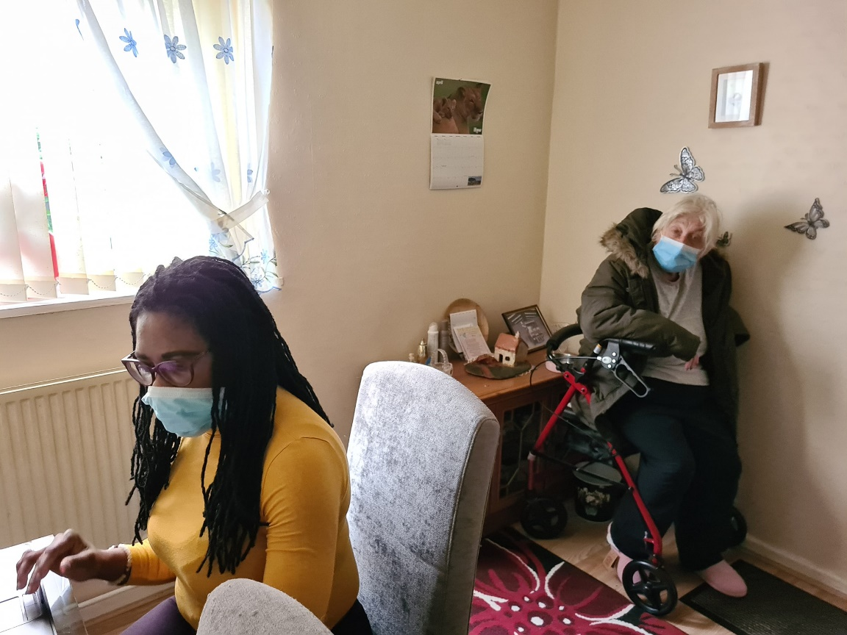

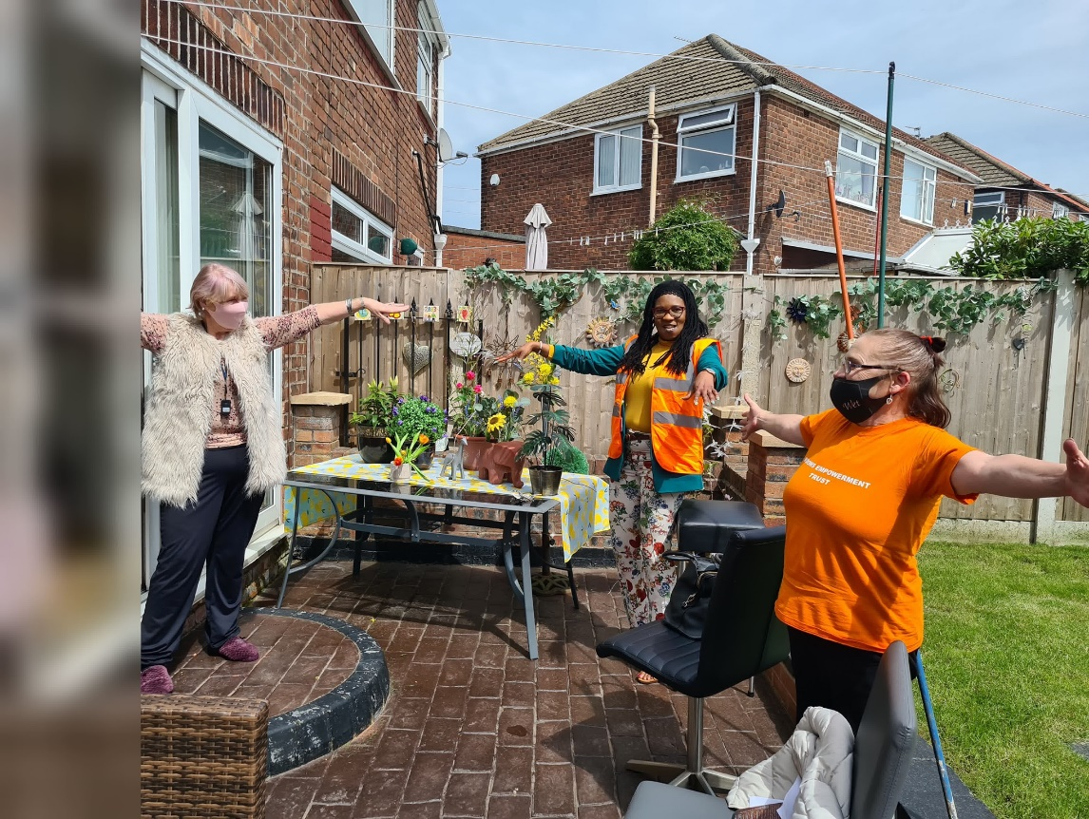

The Widows Empowerment Trust also introduced Bingo & Quiz night via zoom every Saturday. Our bingo & quiz nights offer a safe space for our widowed community to come on-line and socialise in a jovial environment. We have 18-28 join us every week for this session.
Our service users look forward to Saturday Bingo & quiz night as it allows them to be socially inclusive and not left feeling alone.
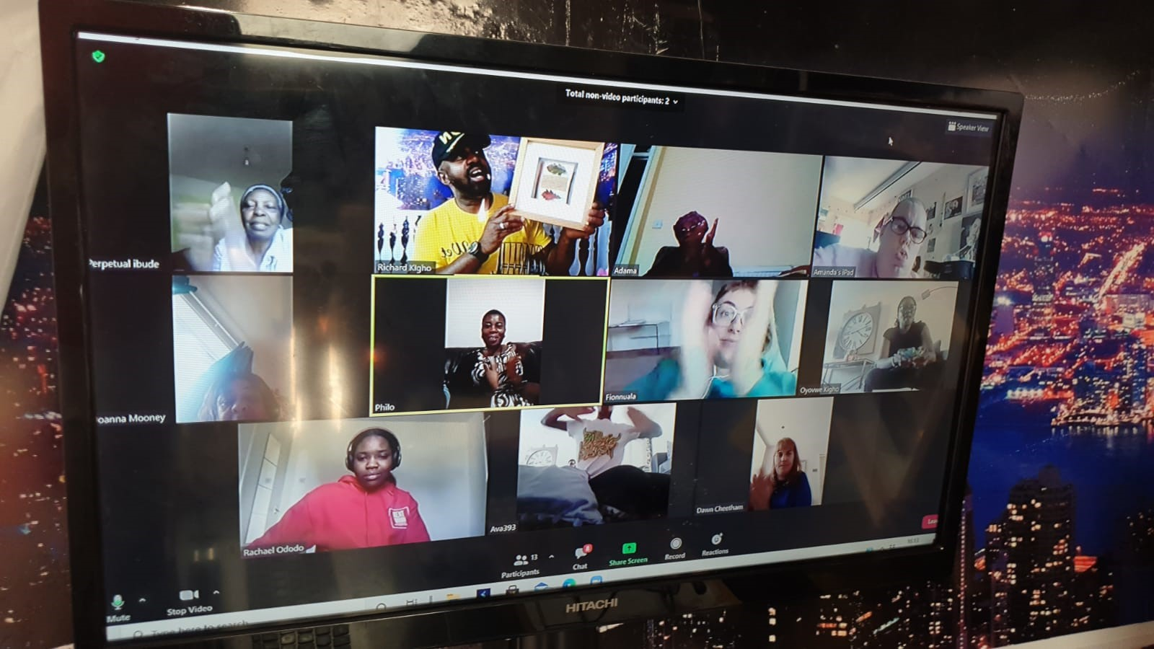

VOLUNTEERS

Our volunteers are the backbone of The Widows Empowerment Trust, without them giving up their own personal free time we will not be able to support our service users as effectively as we do right now. We have a bank of 156 volunteers
The Widows Empowerment Trust endeavours to reward our volunteers by ensuring that they are learning new working skills that will help them to develop themselves further in future careers. We provide the option of learning admin, accounting, funding, writing and community care skills. We have a partnership with University of Manchester for student placements.
Last year with the help of our volunteers we were able to carry out 18 fundraising activities before the March 2020 lockdown and we had 1120 volunteers help with the fundraising. Our volunteers have learned the skills of communicating with the public and gaining confidence in their ability to converse with others, which in turn builds their confidence in a work like environment. Last year we provided 15 student placements, who also worked as volunteers gaining office administration skills as well as finance skills. By providing these placements we are establishing ourselves as Trust that gives back to society by arming the volunteer students with employability skills to help them gain future employment.
As an organisation we are committed to providing training to our volunteers who want to excel within the community services sector. Last year we provided befriending training to 95 volunteers, who carried out befriending home visits as well as telephone befriending services. Our volunteers will use the skills learned in their future employment with the community sector.

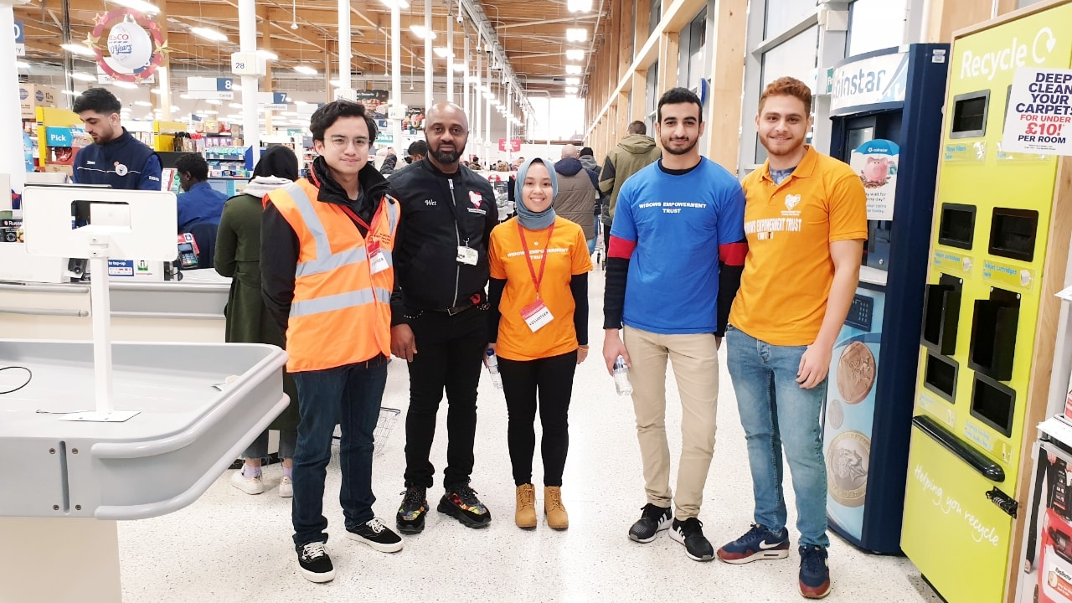
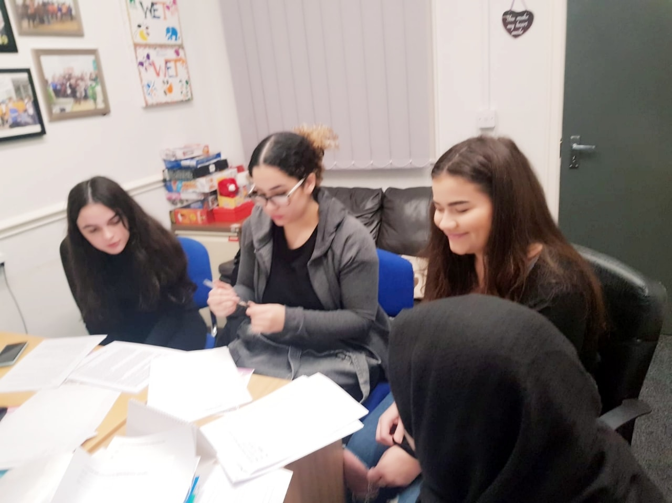

VOLUNTEER - CASE STUDY

The Widows Empowerment Trust provides employable skills for our volunteers. We would like to highlight Ola’s story. He was referred to us by the job centre as he was continuously unsuccessful in gaining employment as an admin/data entry role in the UK. We offered Ola, admin/data entry opportunity as a volunteer to gain the valuable work place skills that are needed to fill the gap in his CV. Whilst volunteering with The Widows Empowerment Trust, Ola was able to gain confidence in the experience he had from Africa in Data Entry role, he picked up skills very quickly which gave him the confidence to talk about his skills in interviews which after 8 weeks of volunteering with us, Ola secured a job role as an admin/data entry clerk. Ola is no longer on benefits and feels his self-worth is restored as he is able to contribute to society and the community by earning.
The more we are able to invest in our volunteers as an organisation the better the impact it will have on our society by providing employable skills, which will produce positive mental wellbeing of our society and therefore less strain on our NHS Mental health services.

CAMPAIGN AND AWARNESS (MEDIA & PR)

• Featured on Local New (Manchester TV NEWS) 6 TIMES
• Feature on BBC One news on International Women’s Day
• Featured on ITV Good Morning Britain and other ITV TV stations

OUR FUTURE PLANS

- Able to reach out to more widows/widowers across the country.
- Expand our volunteers to provide a more of a national befriending service via home visits and telephone.
- Expand our offering of providing work experience to volunteers to help further their careers
- Expand our virtual based activities
- Develop the technological skills of our beneficiaries
- Developing and providing more virtual support accessible by our beneficiaries throughout the UK
- We will endeavour to have in place a therapeutic facility centre for the bereaved to be able to access our services as well as wellbeing activities such as Spa.
- Expand our creativity classes and meet up sessions throughout the UK to help support the bereaved spouse.
- We endeavour for the primary care services of the NHS to recognise our services for the bereaved and to be able to recommend using our services along with counselling support.
- We endeavour to create more opportunities for the community with our facilities centre. We would be able to create more job opportunities as well as volunteer opportunities.

We will continue to provide an all-inclusive social, safe space for our widows/widowers under the local authorities’ guidelines that are covid-19 safe. We will continue to partner with local university’s to be able to provide their students with office work experience as well as community care work experience. We will increase working partnership with the local jobcentre to be able provide work experience for their job seekers. We are committed to the continuance of training our volunteer befrienders, to be able to provide the best support that our beneficiaries require.

RISK REVIEW

The Trustee have the responsibility to monitor and control the risk of the charity. With every activity we do, we consider the risk involve.
Identifying existing controls and any mitigating actions such as the
liability insurance and procedures which help to reduce the risk whilst managing how to monitor and maintain an efficient use of resources. The fundamental risk factor is the imbalance between the resource available to The Widows Empowerment and the unmet need of the widows. The most difficult part is the pressure on key personal who have limited support and scope to delegate with Succession risk. Our resources are therefore planned effectively to mitigate any risk.

FINANCIAL REVIEW

The Trustees have examined the requirements for free reserves and they consider that, given the nature of the Charity's work, free reserves should be equivalent to approximately 2 months routine expenditure at £5,000. The Trustees are of the opinion that this provides sufficient flexibility to cover temporary shortfalls in incoming resources. The expenditure mainly consists of restricted costs.

STRUCTURE, GOVERNANCE AND MANAGEMENT
Governing document
The charity is controlled by its governing document, a deed of trust and constitutes an unincorporated charity.

REFERENCE AND ADMINISTRATIVE DETAILS
Registered Charity number
1171317

Principal address
Wilsons House
Biz Space Business Park Monsall Road Manchester
M0 8WN

Report of the Trustees
for the Year Ended 30 September 2020

Trustees
V Keke
S Roberts L Slack

Independent Examiner
Raise
Chartered Accountants 10th Floor
3 Hardman Street Spinningfields Manchester
M3 3HF

Approved by order of the board of trustees on 17 /12/2020 and signed on its behalf by:

S. Roberts
S Roberts - Trustee

The Widows Empowerment Trust Independent Accounts

Independent examiner's report to the trustees of The Widows Empowerment Trust
I report to the charity trustees on my examination of the accounts of The Widows Empowerment Trust (the Trust) for the year ended 30 September 2020.

Responsibilities and basis of report
As the charity trustees of the Trust, you are responsible for the preparation of the accounts in accordance with the requirements of the Charities Act 2011 ('the Act').

I report in respect of my examination of the Trust's accounts carried out under section 145 of the Act and in carrying out my examination I have followed all applicable Directions given by the Charity Commission under section 145(5)(b) of the Act.

Independent examiner's statement
I have completed my examination. I confirm that no material matters have come to my attention in connection with the examination giving me cause to believe that in any material respect:

1. accounting records were not kept in respect of the Trust as required by section 130 of the Act; or
2. the accounts do not accord with those records; or
3. the accounts do not comply with the applicable requirements concerning the form and content of accounts set out in the Charities (Accounts and Reports) Regulations 2008 other than any requirement that the accounts give a true and fair view which is not a matter considered as part of an independent examination.

I have no concerns and have come across no other matters in connection with the examination to which attention should be drawn in this report in order to enable a proper understanding of the accounts to be reached.

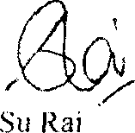

BA Hons, FCA, DChA
Raise
Chartered Accountants 10th Floor
3 Hardman Street Spinningfields Manchester
M3 3HF

Statement of Financial Activities
for the Year Ended 30 September 2020
 |  | Unrestricted | Restricted | 30.9.20  Total | 30.9.19  Total
 | Notes | fund  £ | fund  £ | funds  £ | funds  £
INCOME AND ENDOWMENTS FROM  Donations and legacies |  | 5,457 | 72,415 | 77,872 | 38,236
Other trading activities | 2 | 3,506 | - | 3,506 | -
Total |  | 8,963 | 72,415 | 81,378 | 38,236
EXPENDITURE ON
Charitable activities
Travel and subsistence
Volunteer expenses |  | - | 2,632 | 2,632 | 8,925
Gifts to widows |  | - | 3,622 | 3,622 | 2,803
Purchases |  | - | 3,017 | 3,017 | 2,168
 |  | 270 | 5,448 | 5,718 | 3,223
Advertising Fundraising and events |  | - | 1,949 | 1,949 | 2,400
Office expenses |  | - | 6,923 | 6,923 | 5,555
 |  | 881 | - | 881 | 775
Rent of hall |  | - | 3,416 | 3,416 | 3,338
Support costs Insurance |  | - | 7,500 | 7,500 | -
 |  | 154 | 34 | 188 | 385
Telephone  Legal and professional fees |  | - | 709 | 709 | 730
 |  | 426 | - | 426 | 364
Memberships |  | - | - | - | 101
Training IT |  | - | 1,415 | 1,415 | 860
Wages |  | 630 | 996 | 1,626 | -
 |  | - | 14,773 | 14,773 | -
Total |  | 2,361 | 52,434 | 54,795 | 31,627
NET INCOME |  | 6,602 | 19,981 | 26,583 | 6,609

Statement of Financial Activities
for the Year Ended 30 September 2020
 |  | Unrestricted | Restricted | 30.9.20  Total | 30.9.19  Total
 | Notes | fund  £ | fund  £ | funds  £ | funds  £
RECONCILIATION OF FUNDS
Total funds brought forward |  | (8,962) | 7,171 | (1,791) | (8,400)
TOTAL FUNDS CARRIED FORWARD |  | (2,360) | 27,152 | 24,792 | (1,791)

Balance Sheet
30 September 2020
 |  | Unrestricted | Restricted | 30.9.20  Total | 30.9.19  Total
 | Notes | fund  £ | fund  £ | funds  £ | funds  £
FIXED ASSETS  Tangible assets | 5 | - | 449 | 449 | 1,255
CURRENT ASSETS  Cash in hand |  | 5,465 | 26,703 | 32,168 | 7,209
CREDITORS  Amounts falling due within one year | 6 | (7,825) | - | (7,825) | (10,255)
NET CURRENT ASSETS/(LIABILITIES) |  | (2,360) | 26,703 | 24,343 | (3,046)
TOTAL ASSETS LESS CURRENT LIABILITIES |  | (2,360) | 27,152 | 24,792 | (1,791)
NET ASSETS/(LIABILITIES) |  | (2,360) | 27,152 | 24,792 | (1,791)
FUNDS  Unrestricted funds | 7 |  |  | (2,360) | (8,962)
Restricted funds |  |  |  | 27,152 | 7,171
TOTAL FUNDS |  |  |  | 24,792 | (1,791)

The financial statements were approved by the Board of Trustees and authorised for issue on 17/12/2020 and were signed on its behalf by:

S.Roberts
.............................................
S Roberts – Trustee

Notes to the Financial Statements
for the Year Ended 30 September 2020

1. ACCOUNTING POLICIES

Basis of preparing the financial statements
The financial statements of the charity, which is a public benefit entity under FRS 102, have been prepared in accordance with the Charities SORP (FRS 102) 'Accounting and Reporting by Charities: Statement of Recommended Practice applicable to charities preparing their accounts in accordance with the Financial Reporting Standard applicable in the UK and Republic of Ireland (FRS 102) (effective 1 January 2019)', Financial Reporting Standard 102 'The Financial Reporting Standard applicable in the UK and Republic of Ireland' and the Charities Act 2011. The financial statements have been prepared under the historical cost convention.

Income
All income is recognised in the Statement of Financial Activities once the charity has entitlement to the funds, it is probable that the income will be received and the amount can be measured reliably.

Expenditure
Liabilities are recognised as expenditure as soon as there is a legal or constructive obligation committing the charity to that expenditure, it is probable that a transfer of economic benefits will be required in settlement and the amount of the obligation can be measured reliably. Expenditure is accounted for on an accruals basis and has been classified under headings that aggregate all cost related to the category. Where costs cannot be directly attributed to particular headings they have been allocated to activities on a basis consistent with the use of resources.

Tangible fixed assets
Depreciation is provided at the following annual rates in order to write off each asset over its estimated useful life.

Taxation
The charity is exempt from tax on its charitable activities.

2. OTHER TRADING ACTIVITIES

30.9.20 30.9.19
£ £

Fundraising events 3,506 -

3. TRUSTEES' REMUNERATION AND BENEFITS

There were no trustees' remuneration or other benefits for the year ended 30 September 2020 nor for the year ended 30 September 2019.
Trustees' expenses
There were no trustees' expenses paid for the year ended 30 September 2020 nor for the year ended 30 September 2019.

4. COMPARATIVES FOR THE STATEMENT OF FINANCIAL ACTIVITIES
Unrestricted Restricted Total
fund fund funds
£ £ £

INCOME AND ENDOWMENTS FROM
Donations and legacies 16,309 21,927 38,236

EXPENDITURE ON
Charitable activities
Travel and subsistence 4,854 4,071 8,925

Volunteer expenses
2,373 430 2,803
Unrestricted  fund |  | Restricted Total  fund funds
£ |  | £ |  | £
Gifts to widows  Purchases | 2,141 |  | 27 |  | 2,168
 | 651 |  | 2,572 |  | 3,223
Advertising Fundraising and events | 1,971 |  | 429 |  | 2,400
Office expenses | 895 |  | 4,660 |  | 5,555
 | 775 |  | - |  | 775
Rent of hall Insurance | 1,338 |  | 2,000 |  | 3,338
 | 385 |  | - |  | 385
Telephone  Legal and professional fees | 730 |  | - |  | 730
 | 364 |  | - |  | 364
Memberships | 101 |  | - |  | 101
Training | - |  | 860 |  | 860
Total | 16,578 |  | 15,049 |  | 31,627
NET INCOME/(EXPENDITURE) | (269) |  | 6,878 |  | 6,609
RECONCILIATION OF FUNDS
Total funds brought forward | (8,693) |  | 293 |  | (8,400)
TOTAL FUNDS CARRIED FORWARD | (8,962) |  | 7,171 |  | (1,791)

TANGIBLE FIXED ASSETS | Fixtures
 | and  fittings | Computer  equipmen | Totals
 | £ | £ | £
COST  At 1 October 2019 | 374 | 3,434 | 3,808
Additions | - | 664 | 664
At 30 September 2020 | 374 | 4,098 | 4,472
DEPRECIATION  At 1 October 2019 | 250 | 2,303 | 2,553
Charge for year | 124 | 1,346 | 1,470
At 30 September 2020 | 374 | 3,649 | 4,023
NET BOOK VALUE  At 30 September 2020 | - | 449 | 449
At 30 September 2019 | 124 | 1,131 | 1,255
CREDITORS: AMOUNTS FALLING DUE WITHIN ONE YEAR |  | 30.9.20 | 30.9.19
Other creditors |  | £ 7,825 | £ 10,255
MOVEMENT IN FUNDS |  | Net
 | At | movement | At
 | 1.10.19  £ | in funds  £ | 30.9.20  £
Unrestricted funds  General fund | (8,962) | 6,602 | (2,360)
Restricted funds
Restricted funds
 | 7,171 | 19,981 | 27,152
TOTAL FUNDS | (1,791) | 26,583 | 24,792

MOVEMENT IN FUNDS - continued
Net movement in funds, included in the above are as follows:
 | Incoming resources  £ | Resources expended  £ | Movement in funds  £
Unrestricted funds  General fund | 8,963 | (2,361) | 6,602
Restricted funds
Restricted funds
 | 72,415 | (52,434) | 19,981
TOTAL FUNDS | 81,378 | (54,795) | 26,583
Comparatives for movement in funds
 | At | Net movement | At
 | 1.10.18  £ | in funds  £ | 30.9.19  £
Unrestricted funds  General fund | (8,693) | (269) | (8,962)
Restricted funds
Restricted funds
 | 293 | 6,878 | 7,171
TOTAL FUNDS | (8,400) | 6,609 | (1,791)
Comparative net movement in funds, included in the above are as follows:
 | Incoming resources  £ | Resources expended  £ | Movement in funds  £
Unrestricted funds  General fund | 16,309 | (16,578) | (269)
Restricted funds
Restricted funds
 | 21,927 | (15,049) | 6,878
TOTAL FUNDS | 38,236 | (31,627) | 6,609

MOVEMENT IN FUNDS - continued

A current year 12 months and prior year 12 months combined position is as follows:
Net
At movement At
1.10.18 in funds 30.9.20
£ £ £
Unrestricted funds (8,693) 6,333 (2,360)
General fund

Restricted funds
Restricted funds
293 26,859 27,152

TOTAL FUNDS (8,400) 33,192 24,792

A current year 12 months and prior year 12 months combined net movement in funds, included in the above are as follows:
 | Incoming  resources | Resources  expended | Movement  in funds
 | £ | £ | £
Unrestricted funds  General fund | 25,272 | (18,939) | 6,333
Restricted funds
Restricted funds
 | 94,342 | (67,483) | 26,859
TOTAL FUNDS | 119,614 | 86,422) | 33,192

RELATED PARTY DISCLOSURES

There were no related party transactions for the year ended 30 September 2020.

RESTRICTED FUNDS

Manchester 2 Wellbeing - To go towards session work, befriending and volunteers travel. Manchester 3 Wellbeing - To purchase arts and crafts and go towards session work.
Big lottery - To go towards training, session work and contribution towards rent. Tesco bag for life 2 - To go towards the session work and christmas party.
N.I.F Manchester - To purchase arts and crafts.
Forever Manchester - To go towards the christmas party. Asda Foundation - To go towards the christmas party.
Northward Housing - To fund camera and speakers. Brunswick - To purchase arts and crafts.
We Love Manchester Covid - To go towards travel and befriending.
We Love Manchester - To purchase arts and crafts and go towards befriending. Community Foundation - To fund salaries.
International Womans Day - To raise awareness and go towards travel costs. Manchester 4 Wellbeing Covid - To go towards online training and fund IT costs. Groundwork UK Covid - To go towards befriending.
Big Lottery 2 Covid - To go towards befriending and contribution towards rent. Local Giving - To go towards training.
Neighbourly Love Ltd - To go towards befriending
Big Lottery 3 - To fund salaries, purchase arts and crafts and to go towards admin fees.

INCOME AND ENDOWMENTS | 30.9.20  £ | 30.9.19  £
Donations and legacies  Donations | 4,027 | 12,089
Grants | 72,416 | 21,927
Other income | 1,429 | 4,220
 | 77,872 | 38,236
Other trading activities  Fundraising events | 3,506 | -
Total incoming resources | 81,378 | 38,236
EXPENDITURE
Charitable activities  Wages | 14,773 | -
Insurance | 188 | 385
Telephone | 709 | 730
Sundries | 334 | -
Travel and subsistence | 10,132 | 8,925
Volunteer expenses | 3,622 | 2,803
Gifts to Widows | 3,017 | 2,168
Purchases | 5,384 | 1,953
Advertising | 1,906 | 2,400
Office expenses | 881 | 775
Fundraising and events costs | 6,966 | 5,555
Rent of hall | 3,416 | 3,338
Legal and professional | 16 | 64
Memberships | - | 101
Training | 1,415 | 860
IT costs | 156 | -
Fixtures and fittings | 124 | 125
Computer equipment | 1,346 | 1,145
 | 54,385 | 31,327
Support costs
Governance costs  Accountancy and legal fees | 410 | 300
Total resources expended | 54,795 | 31,627
Net income | 26,583 | 6,609

