15 and 30 Hours Funding Information
September 2019

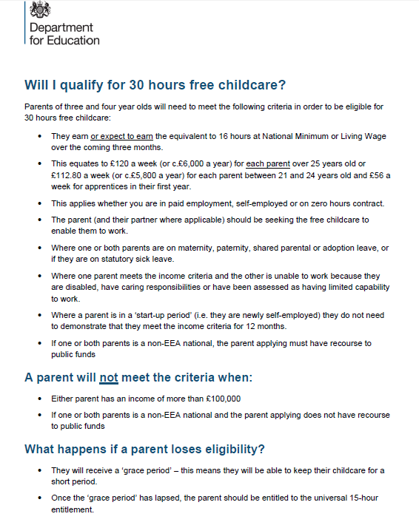
Eligibility Criteria from the DfE

If you meet this criteria you must complete the following steps to ensure your funded place at Beanstalks Pre-School.
On receipt of this information, a member of our Senior Management Team will contact you to confirm your place with us and arrange to settle your child in at a time to suit you.
If you have any questions or queries in the meantime, please feel free to give us a call on 0161-291-0545 or send an email to beanstalks@hotmail.co.uk.

Claiming 30 Hours of Funding
- Obtain an 11 digit code from HMRC by using the Childcare Choices website (https://www.childcarechoices.gov.uk/)
- Fill in the Trafford Council Early Years Declaration https://www.trafford.gov.uk/residents/children-and-families/childcare-and-early-education/secure/3-and-4-year-old-funding-declaration-2019-20.aspx naming Beanstalks as sole provider for 30 hours, or if using alongside Tyntesfield Nursery, 15 hours Universal hours for Tyntesfield and 15 extended hours at Beanstalks Pre-School
- Fill in the attached forms (where applicable.)

If you do not meet this criteria, all 3 & 4 year olds are entitled to the Universal 15 hours of free funding from the local authority. To claim these please fill out the following form on Trafford Council’s website and name Beanstalks as your sole provider. You can then email a copy of the confirmation email to saskia.beanstalks@gmail.com or show it to a member of staff at the Pre-School:
https://www.trafford.gov.uk/residents/children-and-families/childcare-and-early-education/secure/3-and-4-year-old-funding-declaration-2019-20.aspx

Dear Parent/Carer,

The following information is needed to complete your claim for The Government 15 or 30 hours funding. Could you please fill in below as requested and if you have any questions just ask.
You are also welcome to complete this information yourself, though we will need to be provided with a confirmation email so that you may use your funding with Beanstalks Pre-School.

Warmest Regards,

Saskia and the team at Coppice

30 Hour Eligibility Code (If Applicable) ……………………………………………………………………………………….

Parent’s Full Name ……………………………………………………………………………………………..

Parent’s National Insurance Number …………………………………………………………………………………………..

Parent’s Date of Birth …………………………………………………………………………………………..

Child’s Full Name ……………………………………………………………………………………………………

Child’s Date of Birth ……………………………………………………………………………………………………………………

Contact Number …………………………………………………………………………………………………….

Email Address ……………………………………………………………………………………………………………………………….

Please note that Breakfast club for nursery children can only be offered at Coppice, if you require this service please apply for an afternoon place at Tyntesfield.

Morning place at Tyntesfield
8.40 – 11.40am | Nursery at Tyntesfield | Funded
11.40 – 12.00pm | Mini bus pick up and hot lunch Beanstalks @ Coppice | £3.50
12.00-3.00pm | Pre-school afternoon session | Funded or £15
3.00-6.00pm | After school club | £12.50

8.00-9.00am | Breakfast club @ Coppice | £5.50
9.00-12.00pm | Pre-school morning session | Funded or £15
12-12.30pm | hot lunch and mini bus drop off | £3.50
12.30-3.30pm | Nursery at Tyntesfield | Funded
3.30-6.00pm | Mini bus pick up  After school club @ Coppice | £12.50

I have a morning place at Tyntesfield
Booking Form
Childs name
Parent/carer’s name
Contact number
Contact email

Services required  (Please tick) | Monday | Tuesday | Wednesday | Thursday | Friday
Mini bus pick up and funded afternoon place
11.40-3.00pm

£3.50 per session
Afternoon session
12.00-3.00pm

Lunch is not included

Parent/carer drop off
15 hrs funded
After school club
3.00-6.00pm

£12.50 per session

I have an afternoon place at Tyntesfield.
Booking Form
Childs name
Parent/carer’s name
Contact number
Contact email

Services required  (Please tick) | Monday | Tuesday | Wednesday | Thursday | Friday
Breakfast club
7.45-9.00am

£5.50
Funded morning session and mini bus drop off.
9-12.30pm

15 hrs funded
£3.50 per session
Morning session
9.00-12.00pm

Lunch is not included

Parent/carer pick up
15 hrs funded
After school club
3.00-6.00pm
£12.50

If there is anything else you need, or you think there is anything missing that we may also require, please contact us using the contact details provided above.

Contacts for funding information:

Saskia Nield – Pre-School Manager
0161-291-0545/Saskia.beanstalks@gmail.com

Emma Riley – Pre-School EYP/Director
0161-291-0545/beanstalks@hotmail.com

