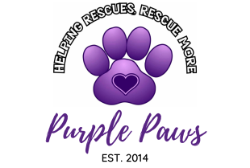

We are dedicated to raising funds to assist domestic, non-domestic, and service animal charities along with spay and neuter programs throughout Middle Tennessee.

Dear Community Supporter,

Our non-profit, Purple Paws, will be hosting a Poker Tournament Fundraising Series, Poker for Purple Paws. The profits from this event will go directly to local, vetted animal rescues, as well as spay and neuter programs. To date, we have donated in excess of $36,000.00 to local organizations within Middle Tennessee.

Sponsorship Packages

The Tournament Clock: $500.00 Your Company logo will be front and center on the time keeping play clock.
Also includes two player seats.

The Royal Flush: $500.00 / Playing Card Sponsor
Your Company logo will be printed on 100 decks of cards to be used during the tournament. The cards will be yours to keep for distributing afterwards. Also includes two player seats.

Four of a Kind: $500.00 / Bar Sponsor
Your Company logo and signage at the bar. Also includes two player seats.

The Full House: $250.00 / Registration Table Sponsor
Your Company logo and signage will be at the check in table. Also includes two player seats.

The Straight: $100.00 / Table Sponsor
Your Company logo placed on one playing table. Also includes two player seats.

Prize Sponsors: Your Company will receive acknowledgements prior, during, and after the event.

If you are interested in helping in our mission, please email the attached form to PurplePawsTN@gmail.com.
The deadline to be included for printing and promotion is 2 weeks prior to event date.

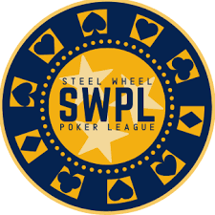

The tournament will be professionally presented by Preston McEwen with Steel Wheel Poker League.
On behalf of the Purple Paws Board of Directors, thank you for your support!

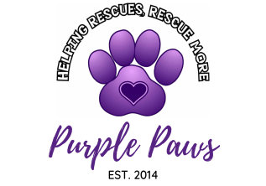

Count us in! We’d love to help local rescues by purchasing the following sponsorship:

_____ Tournament Clock: $500.00

_____ Royal Flush: $500.00 / Playing Card Sponsor

_____ Four of a Kind: $500.00 / Bar Sponsor

_____ Full House: $250.00 / Registration Table Sponsor

_____ Straight: $100.00 / Table Sponsor

_____ 1st Prize Sponsor: $500

_____ 2nd Prize Sponsor: $400

_____3rd Prize Sponsor: $300

_____ “Licker” (Liquor) Sponsor: $200

Payment:
_____ Payment is enclosed. Please make checks payable to “Purple Paws.”
_____ Pay online: PayPal is available by visiting paypal.me/purplepaws.
_____ Please invoice us.

Company Name ___________________________________________
Contact Person ____________________________________________
Address __________________________________________________
Email ________________________ Phone ______________________

I understand that by signing this form, I am agreeing to pay the sponsorship fee by 2 weeks prior to the event date.

_____________________________________ ____________________________
Signature Date

On behalf of the Purple Paws Board and all the Middle Tennessee area recues we assist, THANK YOU!

