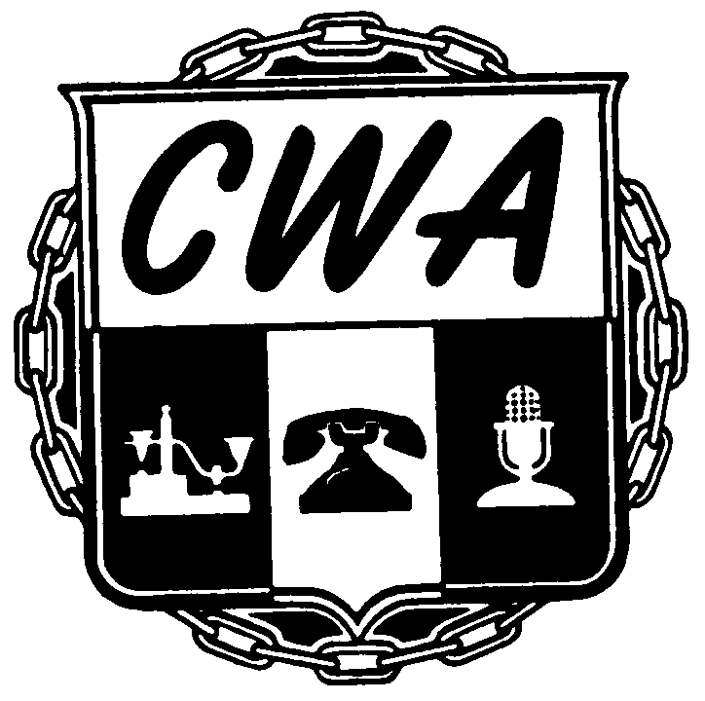
B U L L E T I N
NABET-CWA/NBCUniversal
July 21, 2022
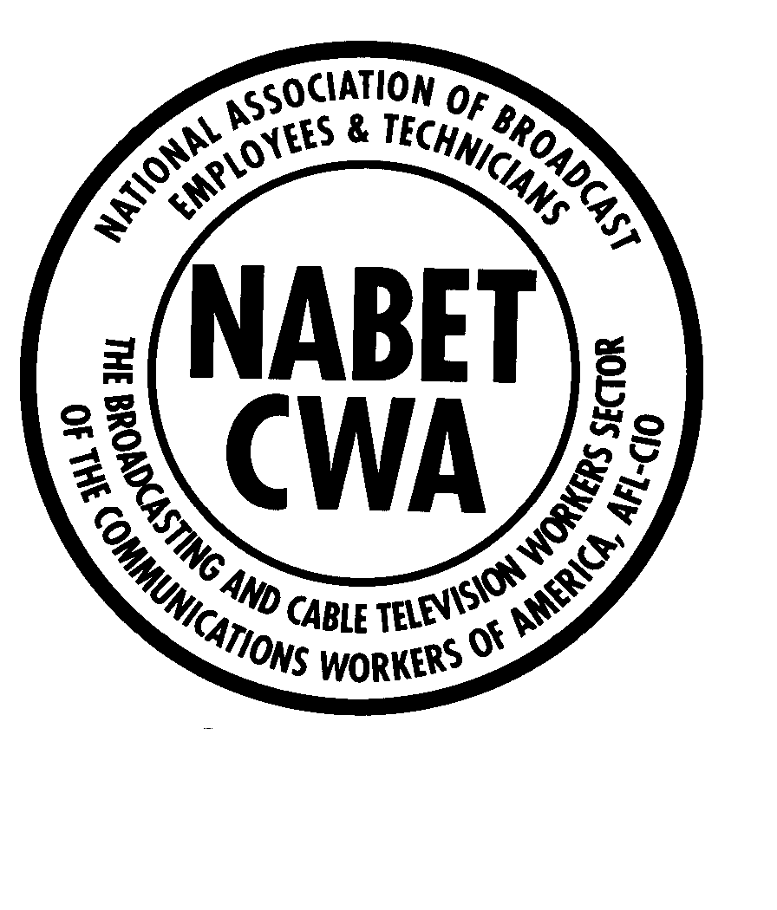

NBC Master Agreement Negotiations
Bulletin #1

The current NABET-CWA/NBCU Master Agreement was scheduled to expire on March 31, 2022. Due to several factors, including the ongoing impacts of the COVID-19 pandemic, the Union and the Company have negotiated a one-year extension of the Master Agreement. Pursuant to the terms of this extension agreement, the new expiration date of the NBC Master Agreement is March 31, 2023.

In conjunction with the contract extension, the parties negotiated a two percent (2%) base wage increase which was effective for all contracts in the Master Agreement on April 1, 2022.

Your Local Union will reach out soon with information concerning contract proposal suggestions and bargaining preparation, in advance of Master Agreement negotiations which we anticipate will begin in late October or early November 2022. Please ensure that your Local Union office has your most current contact information: mailing address, telephone number and email address.

The lead members of the NABET-CWA/NBC Network Negotiating Committee are:
- Local 11: Lou Marinaro (President)
- Local 31: Jim Long ("A" Unit Staff)
- Local 41: Ed Dabrowski (Executive Board Member)
- Local 53: Steve Ross (President)
- Local 11 General Counsel, Max Sicherman, Esq.
- NABET-CWA President, Charlie Braico

If you have questions or concerns, please reach out to your Local Union office.

In Solidarity,
The NABET-CWA/NBC Network Negotiating Committee

