El Cerrito Data in Pictures
Ira Sharenow
7/28/2021
knitr::opts_chunk$set(echo = TRUE)
library(dplyr)
library(ggplot2)
library(scales)
library(ggrepel)
theme_update(plot.title = element_text(hjust = 0.5)) # Center all titles
total_net_position =
data.frame(Year = 2016:2020,
Position = c(32326382, 31900311, 26091182, 16527366, 12064380))
ggplot(total_net_position, aes(x = Year, y = Position)) +
geom_col(fill = rgb(0.9, 0, 0), color = "black", width = 0.7) +
ggtitle("El Cerrito Total Net Position",
subtitle = "CAFR Table A-1") +
theme(plot.subtitle = element_text(hjust = 0.5)) +
geom_text(aes(label = dollar(Position)), size = 3.5, vjust = -0.5) +
scale_y_continuous(labels = dollar, limits = c(0, 35000000))
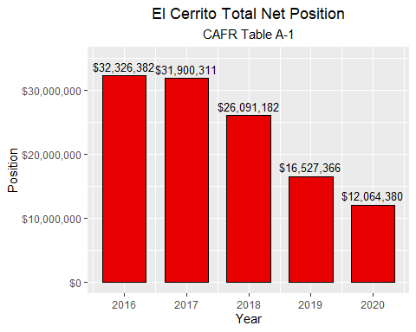
gf =
data.frame(Year = 2016:2020,
Balance = c(1893842, 818720, 87570, -56692, -110021),
pos = c(TRUE, TRUE, TRUE, FALSE, FALSE))
ggplot(gf, aes(x = Year, y = Balance, fill = pos)) +
geom_col(color = "black", width = 0.7) +
ggtitle("El Cerrito General Fund Balance",
subtitle = "CAFR Table A-3") +
theme(plot.subtitle = element_text(hjust = 0.5)) +
theme(legend.position = "none") +
geom_text(aes(label = dollar(Balance), vjust = ifelse(Balance >= 0, -0.5, 1.2)), size = 3.5)+
scale_y_continuous(labels = dollar, limits = c(-250000, 2200000))
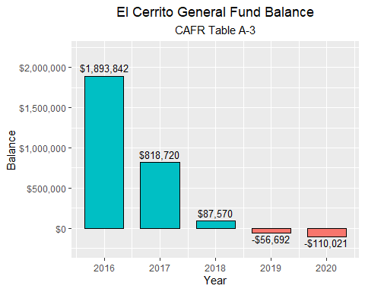
ual_pay =
data.frame(Year = factor(2020:2027), Status = c(rep("Actual", 3), rep("Projected", 5)),
Payments = c(2955657, 3306700, 3789412,
4147000, 4387000, 4625000, 4762000, 4889000))
ggplot(ual_pay, aes(x = Year, y = Payments, fill = Status)) +
geom_col(
color = "black", width = 0.7) +
ggtitle("CalPERS EC Safety Projected Employer Contributions",
subtitle = "2023-2027 is projected") +
theme(plot.subtitle = element_text(hjust = 0.5)) +
#geom_text(aes(label = dollar(Payments)), size = 3.5, vjust = -0.5) +
scale_y_continuous(labels = dollar)
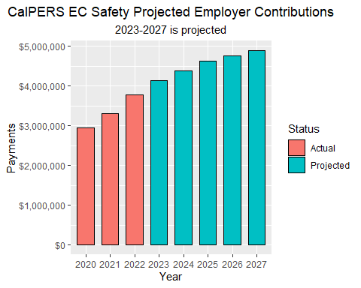
ual_liability =
data.frame(Year = factor(2016:2019),
Payments = c(40845199, 41583287, 46832465, 48830002 ))
ggplot(ual_liability, aes(x = Year, y = Payments)) +
geom_col(fill = rgb(0.9, 0, 0), color = "black", width = 0.7) +
ggtitle("CalPERS El Cerrito Safety Unfunded Accrued Liability (UAL)") +
theme(plot.subtitle = element_text(hjust = 0.5)) +
geom_text(aes(label = dollar(Payments)), size = 3.5, vjust = -0.5) +
scale_y_continuous(labels = dollar)
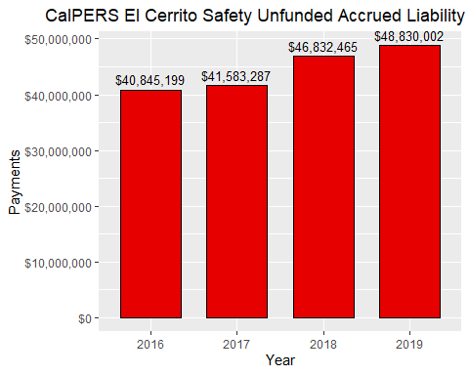
taxable =
data.frame(Year = rep(2009:2019, 2), City = c(rep("El Cerrito", 11), rep("Albany", 11)),
Revenues = c(278014000, 246574000, 253036000, 273354000, 274997000, 268591000,
263862095, 264739262, 268938478, 265240187, 264207566,
186960000, 191439000, 187052000, 193201000, 202489000,
205283000, 211703606, 222024828, 222203622, 234363028, 243449849))
ggplot(taxable, aes(x = Year, y = Revenues, color = City)) + geom_line() + geom_point() +
geom_point(data = taxable %>% filter(Year %in% c(2009,2019)), color = "black", size = 1.5) +
ggtitle("Total All Outlets: Taxable Transactions",
subtitle = "El Cerrito trending down while Albany is trending up") +
theme(plot.subtitle = element_text(hjust = 0.5)) +
scale_x_continuous(breaks = c(2009, 2011, 2011, 2013, 2015, 2017, 2019)) +
scale_y_continuous(labels = dollar) +
annotate("text", x = 2011.5, y = 278000000,
label = ("El Cerrito 2009 sales: $278,014,000")) +
annotate("text", x = 2016.5, y = 260000000,
label = ("El Cerrito 2019 sales: $264,207,566")) +
annotate("text", x = 2011.1, y = 200000000,
label = ("Albany 2009 sales: $186,960,000")) +
annotate("text", x = 2016.5, y = 245000000,
label = ("Albany 2019 sales: $243,449,849"))
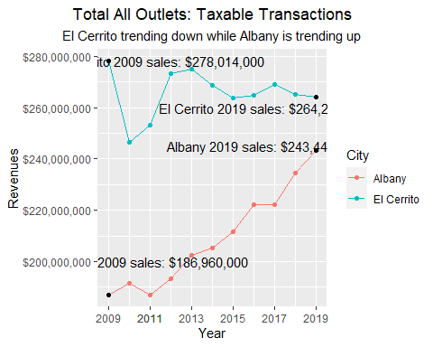
pci_3 = data.frame(Year = c(2003:2007, 2009:2019),
PCI3 = c(55, 57, 57, 53, 50, 50, 62, 73, 84, 84, 84, 84, 84, 84, 83, 82))
ggplot(pci_3, aes(x = Year, y = PCI3)) + geom_line(color = "red", size = 1.2) + geom_point() +
ggtitle("El Cerrito PCI Score", subtitle = "3-Year Moving Average")+
theme(plot.subtitle = element_text(hjust = 0.5)) +
annotate("text", x = 2011, y = 55,
label = "Funding via new tax leads to a sharp improvement in road quality",
family = "serif", fontface = "italic", color = "darkred", size = 4) +
annotate("text", x =2017, y = 79,
label = "A decline in the last few years",
family = "serif", fontface = "italic", color = "darkred", size = 4) +
annotate("text", x = 2004, y = 81,
label = "Very Good/Excellent",
family = "serif", fontface = "italic", color = "darkred", size = 4) +
annotate("text", x = 2004, y = 61,
label = "Fair/Good",
family = "serif", fontface = "italic", color = "darkred", size = 4) +
annotate("text", x = 2004, y = 51,
label = "At Risk",
family = "serif", fontface = "italic", color = "darkred", size = 4) +
geom_hline(yintercept = 80) +
geom_hline(yintercept = 60) +
geom_hline(yintercept = 50)
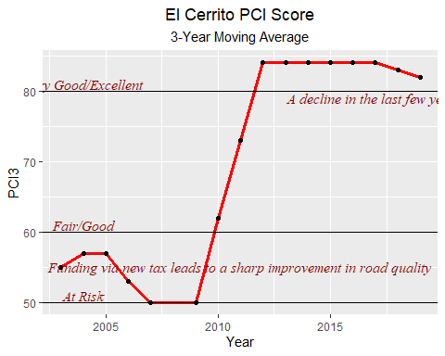
pci_1 = data.frame(Year = factor(2017:2019), PCI1 = c(83, 82, 74))
ggplot(pci_1, aes(x = Year, y = PCI1)) + geom_col(fill = rgb(0.9, 0, 0), color = "black", width = 0.5) +
ggtitle("El Cerrito PCI Score", subtitle = "1-Year Score Declining in Recent Years") +
theme(plot.subtitle = element_text(hjust = 0.5)) +
geom_text(aes(label = PCI1), vjust = -0.5) +
scale_y_continuous(limits = c(0, 88))
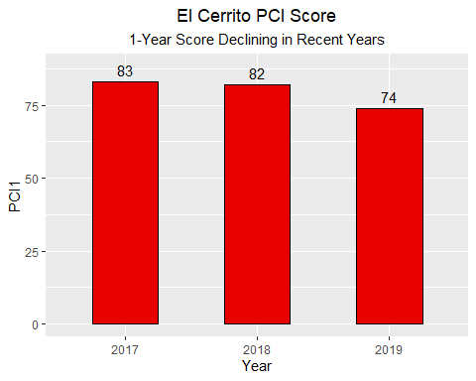
References
https://www.el-cerrito.org/232/Budget-Financial-Information
https://www.calpers.ca.gov/page/employers/actuarial-resources/public-agency-actuarial-valuation-reports
https://www.el-cerrito.org/DocumentCenter/View/15599/322021-City-of-El-Cerrito-CalPERS-Retirement-Plan-Presentation
https://www.cdtfa.ca.gov/dataportal/dataset.htm?url=TaxSalesCRCityCounty
https://www.vitalsigns.mtc.ca.gov/street-pavement-condition

