Madison Single Family Housing
Ira Sharenow
2023-03-05

Introduction
This document uses linear regression, random forests, and boosting to analyze Madison Wisconsin single family home sales, 1994-2023.
In this document, I used the R programming language for data cleaning and manipulation as well as for implementing the data science techniques.
The charts were created using the ggplot2 package. The tables were created using the flextable package.
I have also created a number of charts using Tableau and summary pivot tables and charts with Excel. Please visit my website for the links. https://irasharenow.com/
This document starts with a familiar pattern. The data is read in. Then the data is cleaned up as there are misspellings and other errors.
The data is broken down by high schools and school areas that had few sales were eliminated with the use of a user-defined R function.
First I did regression. Then random forest. Then boosting.
In each case, I created a model on the training set. Then I performed predictions on the test set.
The comparison table is at the end.
For the analyses, I broke the data up into a training set and a test set. I then performed a number of analyses. I plan on revisting this data set to do further analyses in the near future.
The R code is available in the alternate version of this document.
# ```{r setup, include=TRUE}
knitr::opts_chunk$set(echo = FALSE, ft.align="left")
# Madison housing second version
# Preliminaries
library(tidyverse)
library(scales) # Graphing
library(flextable)
library(readxl) # read Excel file
library(stringr) # string manipulation
library(lubridate) # working with dates
library(leaps) # selecting best regressions
library(tree) # basic tree function
library(randomForest) # random forest
library(gbm) # gradient boosting
library(faraway) # regression techniques
Home Sales by Decade and Size
Madison Area Home Sales
Decade | Small | Medium | Large
D1990s | 7,495 | 5,915 | 4,509
D2000s | 13,126 | 13,180 | 11,621
D2010s | 11,525 | 14,168 | 15,697
D2020s | 4,059 | 4,997 | 5,630
Years: 1994-2023
Small: < 1600 SqFt;
Medium: 1600-2160 SqFt;
Large > 2160 SqFt

Some exploratory charts
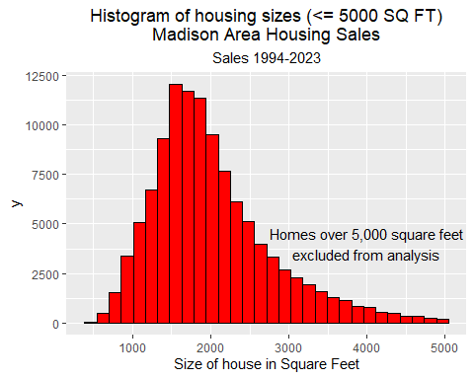
Boxplots of Sale Price by High School and Decade of Sale
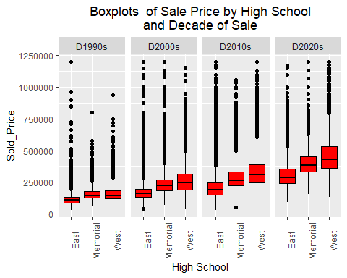
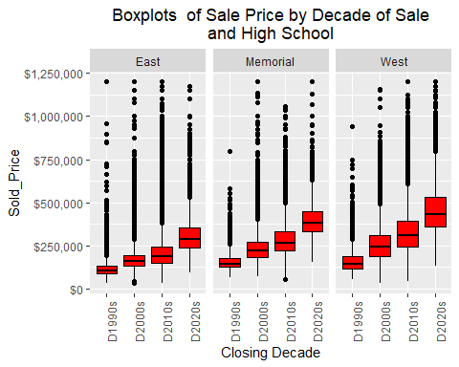
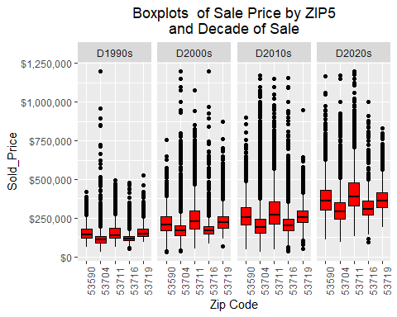

Regression
Split data in training and test sets
Then do regression on training set
and predict on the test set
## The regression formula is:lm.fit = lm(Sold_Price ~ FinSqFt + Closing_Date_year + YearBuilt1980_plus + Beds + LandAssess + Total_Full_Garage_Stalls + Total_Baths + High, data = housingTrain)
 | Estimate | Standard Error | t value | Pr(>|t|)
(Intercept) | -14,966,042.952 | 82,757.792 | -180.841 | 0.0000 | ***
FinSqFt | 90.118 | 0.799 | 112.784 | 0.0000 | ***
Closing_Date_year | 7,468.471 | 41.193 | 181.302 | 0.0000 | ***
YearBuilt1980_plus | 15,737.545 | 862.532 | 18.246 | 0.0000 | ***
Beds | -36.748 | 659.499 | -0.056 | 0.9556
LandAssess | 0.012 | 0.001 | 11.486 | 0.0000 | ***
Total_Full_Garage_Stalls | 6,753.770 | 531.820 | 12.699 | 0.0000 | ***
Total_Baths | 4,529.345 | 780.922 | 5.800 | 0.0000 | ***
HighEast | 5,041.789 | 4,371.555 | 1.153 | 0.2488
HighLafollette | -15,727.800 | 4,351.389 | -3.614 | 0.0003 | ***
HighMcFarland | 3,651.282 | 4,628.138 | 0.789 | 0.4302
HighMemorial | 4,964.116 | 4,312.594 | 1.151 | 0.2497
HighMiddleton | 69,944.538 | 4,854.691 | 14.408 | 0.0000 | ***
HighMonona Grove | 180.184 | 4,524.939 | 0.040 | 0.9682
HighOregon | 2,869.155 | 4,505.812 | 0.637 | 0.5243
HighStoughton | -13,178.824 | 4,492.255 | -2.934 | 0.0034 | **
HighSun Prairie East | -22,503.858 | 4,338.327 | -5.187 | 0.0000 | ***
HighVerona | 6,654.108 | 4,425.759 | 1.503 | 0.1327
HighWaunakee | 27,848.989 | 4,507.681 | 6.178 | 0.0000 | ***
HighWest | 59,651.492 | 4,362.233 | 13.675 | 0.0000 | ***
Signif. codes: 0 <= '***' < 0.001 < '**' < 0.01 < '*' < 0.05
Residual standard error: 7.69e+04 on 52217 degrees of freedom
Multiple R-squared: 0.6711, Adjusted R-squared: 0.671
F-statistic: 5609 on 52217 and 19 DF, p-value: 0.0000
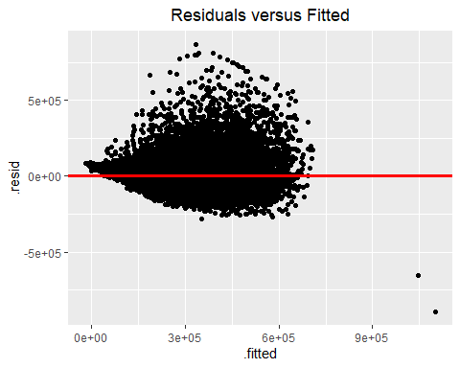
## mean square error: 5921807030
## mean absolute difference: 51887
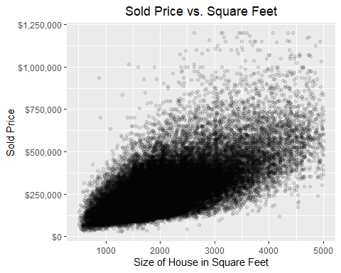

Random Forest
##
## Call:
## randomForest(formula = Sold_Price ~ FinSqFt + Closing_Date_year + YearBuilt1980_plus + Beds + Full_Baths + YearBuilt + Total_Baths + ZIP5 + High, data = housingTrain, mtry = 4, importance = TRUE, ntree = 200)
## Type of random forest: regression
## Number of trees: 200
## No. of variables tried at each split: 4
##
## Mean of squared residuals: 3273089717
## % Var explained: 82.05
## RF MSE: 3199413497.22394
## mean abs error: 32273.7294074767
## %IncMSE IncNodePurity
## FinSqFt 77.36642 3.452654e+14
## Closing_Date_year 327.82376 2.650597e+14
## YearBuilt1980_plus 26.50031 4.475491e+12
## Beds 28.77647 1.947189e+13
## Full_Baths 12.07724 2.218624e+13
## YearBuilt 134.38530 1.246365e+14
## Total_Baths 19.23591 1.114328e+14
## ZIP5 71.91995 3.139464e+13
## High 96.52026 4.368963e+13
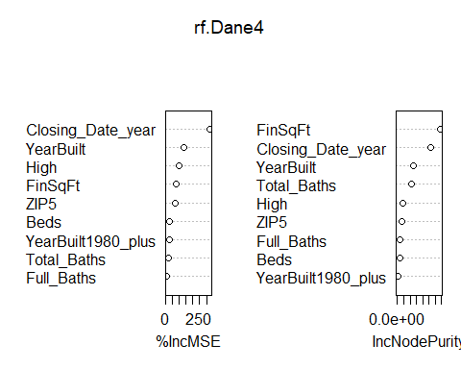

Boosting
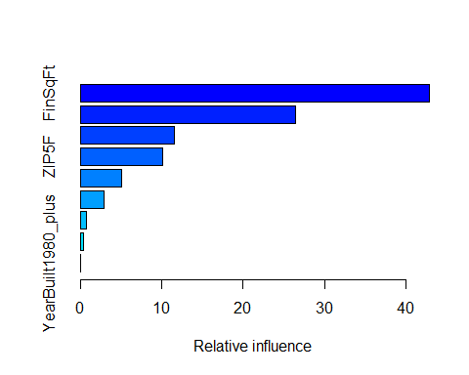
## var rel.inf
## FinSqFt FinSqFt 42.87730738
## Closing_Date_year Closing_Date_year 26.43764245
## YearBuilt YearBuilt 11.48942343
## ZIP5F ZIP5F 10.06617681
## HighF HighF 5.03125775
## Total_Baths Total_Baths 2.91438632
## Beds Beds 0.79407083
## Full_Baths Full_Baths 0.36061158
## YearBuilt1980_plus YearBuilt1980_plus 0.02912345
## MSE Boosting: 3061540248.45942
## AMAD Boosting: 31876.3971474589
## Technique VarExpl MeanAbsError
## 1 Regression 0.671 51887
## 2 RF 0.821 32773
## 3 Boosting NA 31876
Performance of the 3 Data Science Techniques
Analysis of Madison Area Home Sales
Technique | VarExpl | MeanAbsError
Regression | 0.671 | 51,887
RF | 0.821 | 32,773
Boosting |  | 31,876

