Alltech Industries Inc.
(323) 450-1268
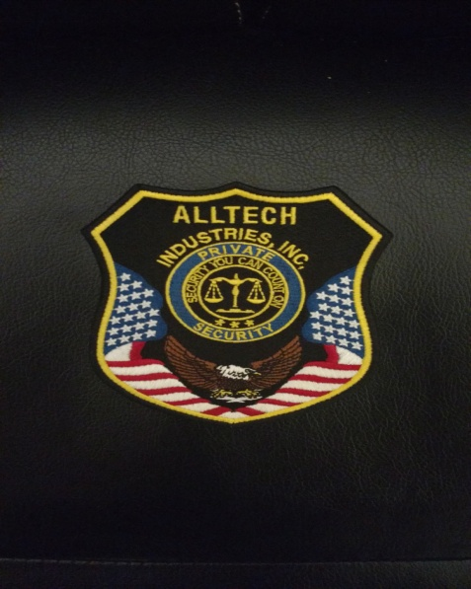

Job description:
Los Angeles County- Various Security Guard Positions Available: Standing Guard and Vehicle Patrol
Must meet ALL the following requirements:
Must have Driver’s License, Security Guard Card, Baton Permit, Tear Gas (Mace) Permit, and CPR/First-Aid Permit

Please Contact (323) 450-1268
Or
E-Mail your resume to info@aiisecuritysolutions.com
Looking to hire ASAP. Thank you.

